AI-ENABLED DIGITAL EXAMINATION SEATING MANAGEMENT SYSTEM
(SeatWise)
A project report submitted in partial fulfilment of the requirements for the award of the degree of
BACHELOR OF TECHNOLOGY
in
COMPUTER SCIENCE AND ENGINEERING (DATA SCIENCE)
Submitted by
A.SANJAY | 23K91A6702
CH.NAVEEN | 23K91A6743
D.KOTESH | 24K95A6705
A.AKSHITH | [Roll number to be confirmed]
Batch A13 (CSE - Data Science, Section A)
Under the esteemed guidance of
[GUIDE NAME]
[DESIGNATION]
[COLLEGE LOGO]
DEPARTMENT OF COMPUTER SCIENCE AND ENGINEERING (DATA SCIENCE)
[COLLEGE NAME]
[COLLEGE ADDRESS / AFFILIATING UNIVERSITY]
[ACADEMIC YEAR]

[COLLEGE LOGO]
[COLLEGE NAME]
DEPARTMENT OF COMPUTER SCIENCE AND ENGINEERING (DATA SCIENCE)
CERTIFICATE
This is to certify that the project report entitled "AI-Enabled Digital Examination Seating Management System (SeatWise)" is a bonafide record of the work carried out by A.SANJAY (23K91A6702), CH.NAVEEN (23K91A6743), D.KOTESH (24K95A6705), A.AKSHITH ([Roll number to be confirmed]), in partial fulfilment of the requirements for the award of the degree of Bachelor of Technology in Computer Science and Engineering (Data Science), during the academic year [ACADEMIC YEAR], under my supervision.

Project Guide  [GUIDE NAME]  [DESIGNATION] | Head of the Department  [HOD NAME]  Department of Computer Science and Engineering (Data Science) | External Examiner  [NAME AND SIGNATURE]
DECLARATION
We hereby declare that the project report entitled "AI-Enabled Digital Examination Seating Management System (SeatWise)", submitted to the Department of Computer Science and Engineering (Data Science), [COLLEGE NAME], in partial fulfilment of the requirements for the award of the degree of Bachelor of Technology in Computer Science and Engineering (Data Science), is a record of original work carried out by us under the guidance of [GUIDE NAME], [DESIGNATION]. The results embodied in this report have not been submitted to any other university or institution for the award of any degree or diploma.

A.SANJAY | 23K91A6702
CH.NAVEEN | 23K91A6743
D.KOTESH | 24K95A6705
A.AKSHITH | [Roll number to be confirmed]
Place: [PLACE]
Date: [DATE]
ACKNOWLEDGEMENT
We express our sincere gratitude to our project guide, [GUIDE NAME], [DESIGNATION], for valuable guidance, encouragement and constructive suggestions throughout this project.
We thank [HOD NAME], Head of the Department of Computer Science and Engineering (Data Science), for providing the facilities and support needed to complete this work, and [PRINCIPAL NAME], Principal, [COLLEGE NAME], for the encouragement given to us.
We thank the project coordinators and all faculty and staff members of the department for their help, and our families and friends for their constant support.
We also acknowledge the authors of the base paper, Yukth P, Issa Syed Mahmood, Shashank K H, Thejus S G and Darshini M S, and the authors and maintainers of the open-source software on which SeatWise is built, in particular Google OR-Tools, FastAPI, SQLAlchemy, React, ReportLab and openpyxl.

A.SANJAY
CH.NAVEEN
D.KOTESH
A.AKSHITH
ABSTRACT
Examination seating is still prepared by hand or in spreadsheets before every examination cycle. The process is slow and error-prone, and the usual shortcuts are predictable: roll-order seating puts candidates of the same paper side by side, which invites malpractice. The base paper by Yukth et al. (IJRPR, 2025) automates seating with a zipper algorithm that interleaves two subject lists, but it guarantees no rule beyond that pattern and reports no measured results.
This project builds SeatWise, an AI-enabled digital examination seating management system whose core is a constraint-optimisation engine (Google OR-Tools CP-SAT). Seats of each hall are coloured so that seats of one colour are never neighbours. Stage A shares candidates between halls and confines each paper to one colour class per hall, which makes same-paper neighbours impossible by construction; Stage B lays out the seats of each hall in parallel with a roll-number gap, accessible seats and department mixing. Seeded random objectives make the plan a random member of the valid plans, and every plan stores its seed and three SHA-256 fingerprints so that it can be reproduced and verified. An independent validator checks every plan before it is stored. Around the engine, a FastAPI and React application provides validated Excel and CSV import, a seat map with drag-and-drop swaps checked live, seating charts, invigilator sheets and QR seat slips, a public seat lookup, tablet attendance, analytics and an audit trail.
No model is trained, so the engine is evaluated by a benchmark rather than by accuracy metrics. On 8 seeded synthetic scenarios of 150 to 2,000 candidates with 3 seeds each, all 24 SeatWise plans met every hard rule, with no same-paper neighbours, against 1,253 for roll-order seating, 281 for round-robin interleaving and 265 for a random shuffle in a 600-candidate sitting. A 600-candidate sitting was seated in 2.4 s and a 2,000-candidate sitting in 4.8 s; the correlation between roll number and seat was 0.065. Fifty-eight automated tests pass. The evidence comes from synthetic data and one machine, and no user-acceptance test has yet been carried out.
Keywords: examination seating, constraint programming, CP-SAT, malpractice prevention, optimisation, web application.
TABLE OF CONTENTS
CHAPTER 1 INTRODUCTION 1
1.1 Introduction to the Project Domain 1
1.2 Background and Motivation 1
1.3 Problem Statement 2
1.4 Need for the Proposed System 3
1.5 Project Objectives 3
1.6 Scope of the Project 3
1.7 Novelty and Key Contributions 5
1.8 Limitations and Assumptions 6
1.9 Organisation of the Report 6
CHAPTER 2 LITERATURE SURVEY 8
2.1 Overview of the Survey 8
2.2 Base Paper Analysis 8
2.3 Related Work 10
2.4 Datasets and Algorithms Used in the Literature 12
2.5 Strengths and Limitations of Existing Work 12
2.6 Research Gap 13
CHAPTER 3 FEASIBILITY STUDY 14
3.1 Technical Feasibility 14
3.2 Economic Feasibility 14
3.3 Operational Feasibility 15
3.4 Schedule Feasibility 15
3.5 Advantages and Constraints 16
CHAPTER 4 SYSTEM REQUIREMENTS AND ANALYSIS 17
4.1 Existing System and its Limitations 17
4.2 Proposed System and its Advantages 17
4.3 Functional Requirements 18
4.4 Non-Functional Requirements 18
4.5 Hardware and Software Requirements 19
4.6 User Roles and Constraints 19
CHAPTER 5 SYSTEM DESIGN 21
5.1 Overall System Architecture 21
5.2 High-Level Workflow 22
5.3 Data Flow Diagrams 23
5.4 UML Diagrams 25
5.5 Entity-Relationship Diagram and Database Schema 29
5.6 Module Design 31
5.7 User Interface Design 32
CHAPTER 6 METHODOLOGY AND SOFTWARE IMPLEMENTATION 34
6.1 Overall Methodology 34
6.2 Dataset 35
6.3 Data Preprocessing 37
6.4 Algorithm Choice and Justification 37
6.5 Mathematical Formulation 38
6.6 Model Architecture, Configuration and Tuning 40
6.7 Application Architecture and Implementation 41
6.8 Key Code Walkthroughs 42
6.9 Implementation Decisions and their Reasoning 44
6.10 API Design 45
6.11 Security and Error Handling 46
6.12 Installation and Execution 46
CHAPTER 7 SYSTEM TESTING 48
7.1 Test Strategy 48
7.2 Unit Tests 48
7.3 Integration Tests 49
7.4 Functional Testing: the Scripted Scenario 50
7.5 Security Testing 50
7.6 Validation and Edge Cases 51
7.7 Performance Testing 51
7.8 User Acceptance Testing 52
7.9 Limits of the Testing Done 52
CHAPTER 8 RESULTS AND OUTPUT SCREENS 54
8.1 Output Screens 54
8.2 Engine Performance (Benchmark Results) 58
8.3 Product Measurements 63
8.4 Comparison with the Base Paper 63
8.5 Sample Inputs and Outputs 64
8.6 Analysis of Successful and Failure Cases 65
8.7 Discussion of Limitations 66
8.8 Objectives versus Outcomes 66
CHAPTER 9 CONCLUSION 68
9.1 Summary of the Work 68
9.2 Objectives Achieved and Main Contributions 68
9.3 Key Findings 68
9.4 Practical Applications 69
9.5 Known Limitations 69
CHAPTER 10 FUTURE SCOPE 70
10.1 Improvements 70
10.2 Additional Features 70
10.3 Scalability and Deployment 70
10.4 Further Research 71
REFERENCES 72
APPENDIX A IMPORTANT CODE 74
A.1 Roll numbers and the roll-gap rule 74
A.2 Pre-checks 75
A.3 Stage A: greedy packing and the two passes (excerpt) 75
A.4 Independent validator (excerpt) 77
A.5 Password hashing and tokens 77
APPENDIX B INSTALLATION AND USER GUIDE 79
B.1 Requirements 79
B.2 Set up, start and stop 79
B.3 A five-minute tour 79
B.4 User guide by role 80
B.5 Tablets, phones and useful commands 80
APPENDIX C ADDITIONAL SCREENS 81

LIST OF FIGURES
Fig. 5.1: System architecture of SeatWise 21
Fig. 5.2: High-level workflow from data import to analysis 22
Fig. 5.3: Data-flow diagram, level 0 (context diagram) 23
Fig. 5.4: Data-flow diagram, level 1 24
Fig. 5.5: Data-flow diagram, level 2: expansion of process 3 (generate seating plan) 25
Fig. 5.6: Use-case diagram 26
Fig. 5.7: Sequence diagram: generate a plan, publish it, and a candidate finds the seat 27
Fig. 5.8: UML class diagram: domain entities and the seating engine 28
Fig. 5.9: Entity-relationship diagram of the SeatWise database (16 tables) 30
Fig. 6.1: Flowchart of the core seating algorithm 35
Fig. 6.2: Budget tuning: session solve time against department mix 41
Fig. 7.1: Backend tests by module 48
Fig. 7.2: API response times on a logarithmic scale 52
Fig. 8.1: Public home page 54
Fig. 8.2: Sign-in page 54
Fig. 8.3: Administrator dashboard after three plans and one register 55
Fig. 8.4: Validation report for the sample workbook 55
Fig. 8.5: Sittings and plans 55
Fig. 8.6: Plan page with scorecard 55
Fig. 8.7: Verify: reproduced exactly 56
Fig. 8.8: Seat map with a candidate picked up 56
Fig. 8.9: An illegal move is refused with the reason 56
Fig. 8.10: Exports page 56
Fig. 8.11: Analytics: engine performance 57
Fig. 8.12: Audit trail 57
Fig. 8.13: Seat lookup result 57
Fig. 8.14: Tablet attendance: list view 57
Fig. 8.15: Generated seating chart (PDF, hall EW-205) 58
Fig. 8.16: Same-paper neighbour pairs by method and sitting size 60
Fig. 8.17: Violations left by each method at 600 candidates (the equivalent of a confusion matrix for an optimisation engine) 60
Fig. 8.18: Solve time by sitting size 60
Fig. 8.19: Roll-to-seat correlation by method 61
Fig. 8.20: Neighbour pairs repeated across seeds 61
Fig. 8.21: Department mix by method 62
Fig. 8.22: Hall utilisation by method 62
Fig. C.1: Request an account 81
Fig. C.2: Import page before upload 81
Fig. C.3: Data page: candidates 81
Fig. C.4: Seat map of a hall 81
Fig. C.5: Analytics: plan figures 82
Fig. C.6: Team page 82
Fig. C.7: Settings: default seating rules 82
Fig. C.8: Find my seat 82
Fig. C.9: Plan page in the dark theme 82
Fig. C.10: My halls (invigilator) 82
Fig. C.11: Tablet attendance: seat-map view 83
Fig. C.12: Generated invigilator sheet (PDF) 83
Fig. C.13: Generated seat slips with QR codes (PDF) 83

LIST OF TABLES
Table 1.1: Organisation of the report 6
Table 2.1: Base paper compared with SeatWise 9
Table 2.2: Seating algorithms in the literature and in SeatWise 12
Table 2.3: Strengths and limitations of the surveyed work 12
Table 3.1: Resources and cost 14
Table 3.2: Project schedule by review phase 15
Table 4.1: Advantages of the proposed system 17
Table 4.2: Functional requirements 18
Table 4.3: Non-functional requirements 18
Table 4.4: Hardware requirements 19
Table 4.5: Software requirements 19
Table 4.6: User roles and permissions 19
Table 5.1: Layers of the architecture 22
Table 5.2: Database tables 31
Table 5.3: Modules and their size 31
Table 5.4: Screens of the application 33
Table 6.1: The sample dataset 35
Table 6.2: Import file schema 36
Table 6.3: Benchmark scenarios 36
Table 6.4: Candidate methods for seat allocation 38
Listing: colour classes of the seat grid 38
Listing: Stage A constraints 39
Listing: Stage B model 39
Table 6.5: Engine configuration 40
Table 6.6: Tuning the per-hall budget 41
Listing: neighbours of a seat (graph.py) 42
Listing: colour class of a seat (graph.py) 42
Listing: Stage B model, assignment and roll-gap clauses (stage_b.py) 43
Listing: retry loop of the engine (engine.py) 43
Listing: storing a plan (plans.py) 44
Listing: rule check of one seat after a move (swap.py) 44
Table 6.7: Implementation decisions 44
Table 6.8: API areas 45
Table 6.9: Security controls 46
Table 7.1: Test levels 48
Table 7.2: Unit-level checks (test_engine.py) 49
Table 7.3: Integration tests 49
Table 7.4: Scripted scenario results 50
Table 7.5: Security checks 50
Table 7.6: Edge cases and validation 51
Table 7.7: API response times 51
Table 8.1: Measures used in the benchmark 58
Table 8.2: Headline benchmark results 59
Table 8.3: SeatWise results by scenario (mean of 3 seeds) 59
Table 8.4: Violations left by the baselines (mean of 3 seeds; every baseline run failed at least one hard rule) 59
Table 8.5: Unpredictability of each method (600 candidates, 6 seeds) 61
Table 8.6: Plans generated in the demonstration scenario 63
Table 8.7: SeatWise compared with the base paper 63
Table 8.8: courses.csv 64
Table 8.9: candidates.csv (e-mail and date of birth columns omitted) 64
Table 8.10: halls.csv 64
Table 8.11: timetable.csv 64
Table 8.12: Scorecard of a generated plan 65
Table 8.13: Failure and boundary cases 65
Table 8.14: Objectives against outcomes 66
Listing: rolls.py 74
Listing: prechecks.py 75
Listing: stage_a.py: greedy_pack 75
Listing: stage_a.py: the two passes 76
Listing: validator.py: neighbour checks 77
Listing: security.py 77
Table B.1: Installation requirements 79
Table B.2: Demo accounts (change the demo password before sharing the PC) 79
Table B.3: Tasks by role 80
Listing: useful commands 80

LIST OF ABBREVIATIONS
Abbreviation | Expansion
AI | Artificial Intelligence
API | Application Programming Interface
CP-SAT | Constraint Programming - Satisfiability (OR-Tools solver)
CSV | Comma-Separated Values
DFD | Data-Flow Diagram
ER | Entity-Relationship
FK | Foreign Key
FR | Functional Requirement
HTTP | Hypertext Transfer Protocol
JSON | JavaScript Object Notation
JWT | JSON Web Token
NFR | Non-Functional Requirement
ORM | Object-Relational Mapping
PDF | Portable Document Format
QR | Quick Response (code)
REST | Representational State Transfer
SHA-256 | Secure Hash Algorithm, 256-bit
SQL | Structured Query Language
UI | User Interface
UML | Unified Modeling Language
URL | Uniform Resource Locator
XLSX | Microsoft Excel Open XML spreadsheet

CHAPTER 1
INTRODUCTION

1.1 Introduction to the Project Domain
Examinations are the main way in which colleges and universities certify what students have learnt, and every examination cycle begins with an administrative task that is easy to underestimate: deciding who sits where. For each sitting the examination cell has to turn a list of candidates, a list of courses, the layouts of the available halls and a timetable into a seating plan that every invigilator can follow and every candidate can find. A sitting of five hundred candidates writing eight different papers in a dozen halls already contains more than two hundred seat decisions per hall, and the cell usually prepares several sittings per day.
The domain of this project is therefore examination management, and more precisely the seat-allocation problem. Seat allocation sits between two well-studied areas of computer science. It resembles examination timetabling [12], where events must be assigned to slots without clashes, and it resembles graph colouring [11], because candidates who must not sit next to one another form the edges of a conflict graph. Unlike timetabling, however, the unit of decision is a physical seat in a grid, and the conflicts that matter are geometric: who is in front, behind, beside or diagonal to whom.
In practice, most institutions still solve this problem by hand or with spreadsheets. Software that automates it exists, but, as the literature survey in Chapter 2 shows, it mostly applies a fixed sort or interleaving pattern. This project, SeatWise, treats seat allocation as a constraint-optimisation problem and solves it with a constraint-programming solver, which allows several rules to be guaranteed at the same time. The title of the project, AI-Enabled Digital Examination Seating Management System, should be read in that sense: the artificial-intelligence component is combinatorial optimisation with controlled randomness. No machine-learning model is trained in this project, and the report says so wherever evaluation is discussed.

1.2 Background and Motivation
Three observations motivated the project. First, preparing seating by hand is slow and error-prone. The base paper [1] describes examination committees collecting student lists from several departments, counting the capacity of each room and assigning roll numbers one by one, a process that it says takes days for thousands of students and that produces duplicated or missing seats. Any late change, such as a broken bench or an added candidate, forces much of the plan to be redone.
Second, the usual shortcuts are predictable. Seating in roll-number order, which is what a spreadsheet sorted by roll number produces, puts friends and classmates next to one another and, in a sitting where several courses are examined together, puts candidates of the same paper side by side. Our own measurements (Chapter 8) show how large the effect is: in a synthetic sitting of 600 candidates writing eight papers, roll-order seating leaves 1,253 pairs of neighbours who write the same paper. Interleaving subjects in a repeating cycle, the usual improved manual method, still leaves 281 such pairs, and it repeats the same neighbours every time it is run, so the pattern can be learnt.
Third, an examination day involves more than a seating chart. Candidates need to find their seats, invigilators need a register, and the examination cell needs to know afterwards what was planned, what was changed by hand and who attended. These tasks are usually handled by separate notices, printed sheets and phone calls. A system that creates the plan can also provide these outputs from the same data, which removes a source of inconsistency.

1.3 Problem Statement
Manual and spreadsheet-based seating is slow and prone to errors. Predictable seating patterns allow malpractice. Several constraints have to hold at once, namely hall capacity, the papers that share a sitting, roll-number spacing, department distribution and accessible seating, and they are difficult to satisfy by hand. Candidates and staff have no reliable digital way to find or track seat allocations.
Formal statement. Given a set of candidates, each with a roll number, a department, a set of registered courses and an accessibility need; a timetable that groups courses into sittings and may declare that some courses share one question paper; and a set of halls, each a grid of seats with blocked seats, accessible seats and aisles, produce for every sitting an assignment of every candidate to exactly one seat such that (i) no seat holds two candidates, (ii) no two neighbouring seats hold candidates who write the same paper, (iii) neighbouring candidates of the same roll-number prefix differ by at least a configured gap, and (iv) every candidate who needs an accessible seat has one. Among all such assignments the system must choose one in a way that cannot be predicted, record how it was chosen so that it can be reproduced, and deliver the result, together with seat lookup, attendance and reports, through a secure web application.

1.4 Need for the Proposed System
- Correctness by guarantee, not by inspection. A plan that merely looks mixed is not enough: the examination controller needs an assurance that no neighbour writes the same paper, and a way to check it.
- Speed. Generating a plan in seconds instead of days allows the cell to try several plans, change halls and respond to late changes.
- Unpredictability with accountability. Candidates must not be able to guess their neighbours, yet the controller must be able to show that the plan was not hand-picked. A recorded random seed gives both.
- One source of truth. The chart, the hall list, the invigilator sheet, the QR slip, the public lookup and the attendance register should all come from the same stored plan.
- Low cost and offline operation. The system should run on an ordinary office PC with free software and without an internet connection, because colleges cannot always rely on one on examination day.

1.5 Project Objectives
1. Automate seat allocation from uploaded student, course, hall and timetable data.
2. Satisfy capacity, subject-combination and roll-number constraints using optimisation.
3. Enforce anti-cheating spacing and randomise seating.
4. Generate exportable seating charts and hall-wise reports.
5. Provide real-time seat lookup and attendance tracking.
6. Reduce the time and errors of manual seating preparation.
Two further engineering objectives were added during design: to make every plan reproducible and auditable, and to evaluate the engine against the manual methods it replaces with measurements rather than claims. How far each objective was met is reported in the results chapter, under objectives versus outcomes.

1.6 Scope of the Project

1.6.1 In scope
- Validated import of courses, halls, candidates and the timetable from Excel or CSV files, with row-level error reports.
- Constraint-optimised seating for each sitting: capacity, no same-paper neighbours (8-neighbour or 4-neighbour adjacency), a configurable roll-number gap, accessible seats, department mix, and compact or balanced use of halls.
- Seeded randomisation, reproducibility, fingerprints, a Verify action, and an append-only audit trail.
- A seat map with drag-and-drop swaps that checks every move against the same rules.
- Outputs: seating charts and invigilator sheets (PDF), hall lists and attendance report (Excel), seat slips with QR codes (PDF).
- Tablet-friendly attendance, a public seat-lookup page, analytics, team management with two roles, and editable default rules.
- An evaluation harness (benchmark) that compares the engine with sequential, round-robin and random seating.

1.6.2 Out of scope
- Timetabling itself: the timetable is an input; SeatWise does not decide which papers share a sitting.
- Invigilator duty rostering beyond an even, automatic assignment of one invigilator per hall.
- Online or remote proctoring, face recognition, biometric attendance, and result processing.
- Cloud hosting, multi-institution tenancy, e-mail or SMS delivery, and payment or fee features.
- Training machine-learning models: the engine is a constraint model, and nothing is learnt from data.

1.6.3 Assumptions
- A candidate's neighbours are the seats directly in front, behind, beside and (in 8-neighbour mode) diagonal to the candidate's seat. Aisles break adjacency across them. Cheating beyond that distance is outside the model.
- A roll number is a text prefix followed by a number (for example ACF24017); the roll-gap rule compares numbers that share a prefix.
- Two courses that share a question paper are declared as one paper group in the timetable, are examined in the same sitting, and count as one paper for separation.
- The system runs on one machine for one institution; the administrator is trusted to import correct data.

1.7 Novelty and Key Contributions
The base paper [1] allocates seats with a zipper algorithm that interleaves two subject lists. SeatWise keeps the idea of a data-driven, rule-based allocation but changes how the rules are enforced. The points below are new relative to the base paper and the systems reviewed in Chapter 2; we do not claim that they are new to the field as a whole, since constraint programming and graph colouring are established techniques [11]-[14].
1. Rules guaranteed by construction. A hall's seats are coloured so that seats of one colour class are never neighbours. Stage A confines each paper to one colour class per hall, which makes same-paper neighbours impossible before any seat is chosen. This works for any number of papers and for diagonals, where a two-subject zipper does not.
2. Two-stage constraint optimisation. Stage A (hall and colour-class allocation) and Stage B (seat layout per hall) are both modelled and solved with OR-Tools CP-SAT [14], with halls laid out in parallel and a bounded retry strategy.
3. Controlled randomness. Among all valid plans the engine returns one chosen by a seeded random objective. Measured unpredictability matches a pure random shuffle (roll-to-seat correlation 0.065; 1.0% repeated neighbour pairs), while every hard rule still holds.
4. Reproducibility and audit. Every plan stores its seed, rules, engine version and three SHA-256 fingerprints. The Verify action re-runs the engine and proves that the plan was not hand-picked. Every move, publication and download is logged.
5. An independent validator. A plain-Python checker, which shares no code with the solver model, scores every plan and backs the live swap checks, so the seat map, the exports and the benchmark agree.
6. Live, explained editing. The seat map shows every possible target seat as green or red and gives the reason for each red seat, so manual changes cannot break a rule unnoticed.
7. A complete workflow. Validated import, QR seat slips, a public lookup page, tablet attendance with a lock, analytics and team management are built around the engine, so one stored plan serves the whole examination day.
8. A measured, honest evaluation. A seeded benchmark of 8 scenarios and three manual baselines gives 24 of 24 plans meeting every hard rule, 2.4 s for 600 candidates and 4.8 s for 2,000, and reports its own limits, such as a front-row bias of 4.7 percentage points.

1.8 Limitations and Assumptions
The limitations below are properties of the delivered system and of the evidence for it. They are repeated, with measurements, in Chapters 7 and 8.
- Synthetic data only. All data used for development, testing and evaluation was generated by a seeded script. No real examination data and no real users were involved, so real-world performance is not established.
- No user-acceptance testing. The interface was exercised by automated tests, scripted scenarios and manual walkthroughs, but not by real invigilators or examination staff.
- Single machine, one benchmark run. The benchmark was run once on a 12-thread Windows desktop. Other hardware, memory use and many simultaneous users were not measured. SQLite is suited to one office, not to many institutions.
- Front-row bias. Because each paper occupies one colour class per hall and only two of the four classes include the front row, departments are slightly unevenly spread over the front row (4.7 percentage points, against 1.6 for a random shuffle).
- Four-neighbour mode is slower (6.0 s against 2.4 s for 600 candidates) because each class covers half the hall.
- Capacity limit per paper. A single paper cannot occupy more than the largest colour class of each hall; the engine refuses larger requests with an explanation rather than breaking a rule.
- No machine learning. There is no accuracy, precision, recall or F1 to report, because nothing is trained.
- Camera scanning works only where the browser allows camera access (localhost or HTTPS); otherwise a hand-held scanner or typing is used.

1.9 Organisation of the Report
Table 1.1: Organisation of the report
Chapter | Content
1 Introduction | Domain, motivation, problem statement, need, objectives, scope, contributions, limitations.
2 Literature Survey | Base paper analysis, related work by theme, algorithms used in the literature, research gap.
3 Feasibility Study | Technical, economic, operational and schedule feasibility.
4 System Requirements and Analysis | Existing and proposed systems, functional and non-functional requirements, hardware, software, roles.
5 System Design | Architecture, workflow, data-flow diagrams, UML, database and module design, user interface.
6 Methodology and Software Implementation | Method, dataset, algorithm and its formulation, application, API, security, installation.
7 System Testing | Test strategy and the unit, integration, functional, security, performance and edge-case results.
8 Results and Output Screens | Output screens, benchmark results, comparison with the base paper, analysis, objectives versus outcomes.
9 Conclusion | Summary, achievements, findings, applications, limitations.
10 Future Scope | Improvements, features, deployment and research directions.
References, Appendices | IEEE references; important code; installation and user guide; additional screens.

CHAPTER 2
LITERATURE SURVEY

2.1 Overview of the Survey
The survey covers the base paper, the five works listed in the batch literature survey, and the systems that the base paper itself reviews. Where we could retrieve a source (the base paper, Adetona and Akintoye [4], Kashyap et al. [6]) we describe what it reports. Where we could not retrieve the source, we say so and do not describe its method or results. Three of the five works in the batch survey, [2], [3] and [5], could not be found by title in a web search made on 15 October 2026; they are listed for completeness and characterised by their titles only. The works that the base paper summarises, [7]-[10], are described as the base paper describes them and are marked as such.
The works fall into four groups: web-based seating management systems, randomisation approaches, graph-colouring and metaheuristic approaches, and the older research on examination timetabling and constraint programming. Seating is a smaller problem than timetabling, but it shares its structure of hard rules, soft preferences and the need for a solution that can be explained to the people affected by it.

2.2 Base Paper Analysis
The base paper is P. Yukth, I. S. Mahmood, K. H. Shashank, S. G. Thejus and M. S. Darshini, "Exam Seating Arrangement System," International Journal of Research Publication and Reviews (IJRPR), vol. 6, no. 12, pp. 2093-2105, Dec. 2025. It was written by students and a guide at ATME College of Engineering, Mysuru, and describes a web application called ExamSeater.

2.2.1 What the base paper does
- Architecture. A Flask application with Jinja2 templates in a Model-View-Controller arrangement, SQLite through SQLAlchemy, pandas for reading uploaded lists, PyPDF2 for PDF text, and ReportLab for output.
- Algorithm. The zipper method: two subject lists are sorted (alphabetically, or by branch when a branch constraint is on) and interleaved with itertools.zip_longest, so that seat 1 holds a student of subject A, seat 2 a student of subject B, and so on. Seats marked blocked are skipped.
- Features. Login for administrators and staff with PBKDF2-hashed passwords; management of rooms, exams and staff; a visual grid of the room; a PDF seating chart; a history of earlier arrangements; and a public page where students search for a seat by USN or name.
- Evidence. Screenshots of the working application. The paper states one performance requirement, that a batch of 100 students should be processed in under 3 seconds, but it reports no measurement, no dataset and no comparison.
- Future work named by the authors. A mobile application, e-mail and SMS notification, facial-recognition attendance, cloud deployment and a drag-and-drop seat map.

2.2.2 Strengths
- A complete, understandable system that a college can run on a single PC with free software.
- A public lookup page, which removes crowding at notice boards.
- Blocked seats and multiple exam types are supported, and the output is printable.

2.2.3 Limitations
- Interleaving covers two subjects at a time. With three or more papers in a sitting, or with diagonal neighbours, the pattern does not by itself prevent same-paper neighbours.
- The seating pattern is fixed and therefore predictable; no randomness is used.
- There are no roll-number spacing rules, no accessible-seat handling and no department balancing beyond a sort order.
- No measured results are reported, so the claims cannot be compared quantitatively.
- No attendance, no audit trail, no reproducibility mechanism and no live validation of manual changes.

2.2.4 What SeatWise adopts and what it changes
Table 2.1: Base paper compared with SeatWise
Aspect | Base paper [1] | SeatWise
Data input | CSV or PDF student list, manual entry | Excel or CSV templates for four data kinds, validated row by row
Allocation | Zipper interleave of two subjects | Two-stage CP-SAT optimisation for any number of papers
Neighbour rule | Alternate subjects in a line | No same-paper neighbour in 8 or 4 directions, aisles respected
Other rules | Optional branch rule, blocked seats | Roll gap, accessible seats, department mix, capacity, shared papers
Randomness | None (fixed pattern) | Seeded random choice among valid plans
Reproducibility | Not addressed | Seed, three SHA-256 hashes, Verify, audit trail
Manual edits | Re-run the generator | Drag-and-drop with live rule check and reasons
Outputs | On-screen grid, PDF chart | Charts, invigilator sheets, hall lists, QR slips, attendance report
Seat lookup | Public search by USN or name | Public lookup by candidate ID with hall map and QR slip
Attendance | Future work | Tablet register with scan, lock and report
Evaluation | Screenshots; 3 s target | Benchmark: 8 scenarios, 3 baselines, 24 of 24 plans valid
Back end | Flask, SQLite | FastAPI, SQLite, React front end

2.3 Related Work

2.3.1 Web-based seating management systems
Several systems automate the clerical side of seating. Jitha and Fathima [7] propose a central web portal in which administrators upload student lists as CSV files and students view a static table of seats before the examination to avoid crowding at notice boards; the base paper notes that this system does not interleave subjects, so students of one branch are often seated sequentially. An AI-powered hall-allocation system published in IJSART in 2025 [10] is described in the base paper as a Flask and MySQL application that allocates students to halls and assigns invigilation duties with a deterministic constraint-based algorithm, with a weakness in dividing students across several partly used rooms. Patel [8] is described as a smart system that integrates biometric attendance and QR-code seat lookup, at a hardware cost that the base paper considers too high for typical colleges and with a requirement for internet access on every student device.
Three further works appear in the batch survey: an automated seating arrangement and hall allocation system (2026) [2], a machine-learning-based system for hall seating in universities (2026) [3], and an automated seating arrangement for conducting examinations (2025) [5]. We could not retrieve their abstracts, so we use them only as evidence that the problem is active; we make no claim about their methods.

2.3.2 Randomisation
The base paper summarises a study that uses a linear congruential generator to shuffle seats completely at random to prevent cheating [9]. Complete randomisation removes predictability but, as the base paper notes, confuses invigilators who collect scripts, because roll numbers are no longer in any order. It also gives no guarantee about neighbours: a random shuffle of a 600-candidate sitting leaves 265 same-paper neighbour pairs in our own benchmark. SeatWise keeps randomness but restricts it to plans that satisfy the rules, and it records the seed so that the choice can be reproduced.

2.3.3 Graph colouring and metaheuristics
Adetona and Akintoye [4] describe a web application, built with Laravel and Vue.js, that seats students so that those enrolled in the same course are not adjacent. It uses a greedy graph-colouring algorithm over a connection matrix, and it sends text messages through the Termii API five minutes before the examination with the venue and required materials. The abstract reports testing in a university with a selected group of students; we read only the abstract and cannot comment on the size of the test or on its figures. The work is the closest to ours in method, since both use a colouring idea; SeatWise differs in modelling the whole allocation, including roll-number spacing, accessibility and department mix, as a constrained optimisation, in returning a random valid solution, and in making the result reproducible.
Kashyap et al. [6] use a genetic multi-objective algorithm to allocate examination seats so as to reduce the chance of cheating, taking into account subject similarity, physical distancing and seat visibility. Genetic algorithms handle soft objectives well but give no guarantee that every hard rule is satisfied, which is why SeatWise uses an exact solver for the hard rules and uses optimisation only for the preferences.
The theoretical background is the classical graph-colouring bound of Welsh and Powell [11], originally applied to timetabling. SeatWise uses a much simpler, explicit colouring of the seat grid: with 8-neighbour adjacency the four classes defined by (row parity, column parity) form a proper colouring.

2.3.4 Examination timetabling and constraint programming
Qu et al. [12] survey search methodologies and automated systems for examination timetabling, distinguishing hard constraints that must hold from soft constraints that should be minimised, which is the same division SeatWise uses. Constraint programming [13] provides general solvers for such problems, and Google's OR-Tools CP-SAT solver [14] is a free, high-performance implementation that supports Boolean and integer models, objectives, hints and a deterministic time limit. These properties made it the natural choice for a seating engine that must also be reproducible.

2.4 Datasets and Algorithms Used in the Literature
None of the seating papers we could read uses a public benchmark dataset. The base paper works with institutional student, hall and exam lists; Adetona and Akintoye [4] test on a group of university students. Seating research therefore lacks a common dataset, which is one reason this project built a seeded generator and published its own benchmark scenarios.
Table 2.2: Seating algorithms in the literature and in SeatWise
Algorithm | Used in | Idea | Guarantee on neighbours
Sorting by roll number | Manual and spreadsheet practice | Fill seats in order | None
Zipper interleave | Base paper [1] | Alternate two subject lists | Two subjects in a line only
Linear congruential shuffle | [9] via [1] | Pseudo-random permutation | None
Greedy graph colouring | [4]; theory in [11] | Colour conflict graph so adjacent nodes differ | Same-course separation (as reported)
Genetic multi-objective search | [6] | Evolve seat assignments against several objectives | Not guaranteed
Constraint programming (CP-SAT) | SeatWise; background [13], [14] | Declare hard rules, solve exactly, optimise preferences | All hard rules, or a proof that none exists

2.5 Strengths and Limitations of Existing Work
Table 2.3: Strengths and limitations of the surveyed work
Work | Strengths | Limitations
Base paper [1] | Complete, simple, public lookup, PDF output | Two-subject interleave; fixed pattern; no measured results
Adetona and Akintoye [4] | Colouring keeps same-course students apart; SMS reminders | Single rule family reported; abstract only read
Kashyap et al. [6] | Several objectives, including seat visibility | No guarantee for hard rules (metaheuristic)
Jitha and Fathima [7] | Central upload; online seat table | No interleaving (per [1])
Patel [8] | QR lookup, biometric attendance | High hardware cost; needs internet (per [1])
LCG allocation [9] | Unpredictable | Confuses invigilators; no rule guarantee (per [1])
IJSART system [10] | Hall allocation and staff duty assignment | Weak room-overflow handling (per [1])
Batch survey [2], [3], [5] | Evidence that the problem is current | Not retrieved; not assessed

2.6 Research Gap
Existing seating systems follow fixed sorting rules; few apply constraint optimisation to guarantee anti-cheating spacing across courses and adjacent roll numbers. Reading the surveyed work against the needs of an examination cell, we identify five gaps.
1. Rules. No reviewed system guarantees that no neighbour, diagonals included, writes the same paper for any number of papers.
2. Spacing and access. Roll-number spacing and accessible-seat needs are rarely enforced together with paper separation.
3. Controlled randomness. Fixed patterns are predictable, and complete shuffling breaks the rules; randomness that respects the rules is missing.
4. Evidence. The reviewed work reports no measured conflict counts, solve times or comparisons with manual methods.
5. Application. No single tool combines validated import, optimisation, reproducibility, live checked editing, QR slips, attendance and an audit trail.
SeatWise is designed to close these gaps, and the benchmark in Chapter 8 supplies the missing measurements for the engine.

CHAPTER 3
FEASIBILITY STUDY

3.1 Technical Feasibility
Technical feasibility asks whether the required capability can be built with available technology. The central risk of this project was whether a constraint solver could produce a valid, randomised plan for hundreds or thousands of candidates fast enough for interactive use. The benchmark in Chapter 8 answers that: every one of 24 benchmark plans met every hard rule, a 600-candidate sitting took 2.4 s on average and a 2,000-candidate sitting 4.8 s, on an ordinary 12-thread desktop.
The remaining components use mature, widely documented open-source technology: FastAPI and SQLAlchemy for the service layer, SQLite for storage, React and Vite for the interface, and ReportLab, openpyxl and qrcode for the outputs. All of them run on Windows 10 and 11 with Python 3.11 and Node.js LTS. The team's skills (Python, SQL, JavaScript and optimisation basics) cover the stack, and each component can be tested separately. The project is therefore technically feasible, and it was built.

3.2 Economic Feasibility
SeatWise needs no licence fees and no cloud subscription. Every library and tool used is free and open source, and no API key is required because the system works offline once installed. The only hardware needed is an ordinary office PC that an examination cell already owns; tablets for attendance are optional, since a hand-held scanner or typing also works. The development effort was student time. We did not record or estimate a monetary cost of that effort, and we therefore give no rupee figure; the table lists what would otherwise have to be bought.
Table 3.1: Resources and cost
Resource | Used for | Licence (to our knowledge) | Cost
Python 3.11, Node.js LTS | Back end and build tools | PSF; MIT | Free
FastAPI, SQLAlchemy, Pydantic | API, ORM, validation | MIT | Free
OR-Tools (CP-SAT) | Seating engine | Apache 2.0 | Free
SQLite | Database | Public domain | Free
React, Vite, Tailwind CSS | Front end | MIT | Free
ReportLab, openpyxl, qrcode | PDF, Excel and QR outputs | BSD / MIT | Free
pytest, Playwright | Tests and screenshots | MIT; Apache 2.0 | Free
Office PC (existing) | Server and administrator console | - | Already owned
Tablet or hand-held scanner | Attendance (optional) | - | Optional

Against these costs, the benefit is the staff time saved on each sitting, the reduction in duplicate or missing seats, and the removal of separate paper processes for notices, registers and lookups. We have not measured time saved in a real examination cell, so we state the benefit qualitatively.

3.3 Operational Feasibility
The system has two kinds of staff users and one public audience. The examination controller imports data, generates and publishes plans, and reviews analytics. The invigilator opens an assigned hall and takes attendance. Candidates use a public page without an account. The workflows follow the existing process (collect lists, make plan, print, supervise) so the change for staff is mainly that the plan-making step is done by the software.
Usability measures built into the product include a first-run checklist on the dashboard, Excel templates with a how-to sheet, plain-language validation messages that name the sheet, row and column, and explanations for impossible requests. The interface works from a 360 px phone to a desktop, supports light and dark themes, and the seat map can be operated from the keyboard. We did not test usability with real staff; this is recorded as a limitation and as the first item of future work.

3.4 Schedule Feasibility
The work followed the three review phases of the project. The dated milestones that we can evidence are the engine benchmark run of 21 September 2026 and the documentation and screenshot capture of 15 October 2026; the other dates were not recorded, so the table lists phases and outputs only.
Table 3.2: Project schedule by review phase
Phase | Activities | Outputs
Review 1: problem and research | Problem identification, base paper study, literature survey, research gap, objectives, proposed approach | Abstract, literature survey, objectives and problem statement, Review 1 slides
Review 2: design and progress | Architecture, data model, engine design, importer, plans, seat map, exports, attendance, analytics, tests, benchmark | Working product, 58 tests, benchmark run, Review 2 slides
Final: evaluation and documentation | Re-run tests and demo scenario, latency measurements, screenshots, diagrams, report | Final report and documents, Final slides

3.5 Advantages and Constraints

3.5.1 Advantages
- Guaranteed rule compliance, checked by an independent validator.
- Seconds instead of days; any plan can be regenerated or compared.
- Reproducible and auditable plans; one stored plan serves charts, slips, lookup and attendance.
- Free software, offline operation, simple Windows setup (setup.bat, run.bat).

3.5.2 Constraints
- One machine and one SQLite database: suitable for one institution, not for many.
- Solve time grows with the number of halls and is higher in 4-neighbour mode.
- A single paper larger than the colour-class capacity of the selected halls cannot be seated; more halls are needed.
- Evidence is from synthetic data; real-world validation is future work.

CHAPTER 4
SYSTEM REQUIREMENTS AND ANALYSIS

4.1 Existing System and its Limitations
In the existing process the examination cell collects candidate lists from departments, sorts them by roll number in a spreadsheet, fills halls row by row and prints a chart for the notice board. Some institutions use software that alternates subjects or branches in a fixed pattern, as in the base paper [1].
- Manual allocation is time-consuming and error-prone; duplicates and omissions occur.
- Sequential and fixed patterns are predictable and allow malpractice: roll-order seating leaves 1,253 same-paper neighbour pairs in a 600-candidate benchmark sitting, and interleaving still leaves 281.
- Constraints such as subject clashes, spacing, accessible seats and department mix are hard to satisfy by hand.
- Any change requires redoing much of the plan, and manual changes are not checked or recorded.
- Candidates cannot look up seats digitally, and attendance is recorded on paper.

4.2 Proposed System and its Advantages
SeatWise replaces the plan-making step with a constraint-optimisation engine and wraps it in a web application. The examination controller uploads four files, sets the rules and presses Generate plan. The engine seats every candidate so that no two neighbours write the same paper, roll numbers are spaced, accessible seats are honoured and departments are mixed, and it chooses one such plan at random from a recorded seed. The controller reviews the seat map, moves seats with live checks, publishes, and prints charts and slips. On the day, candidates look up their seat, invigilators take attendance on a tablet, and analytics and the audit trail summarise what happened.
Table 4.1: Advantages of the proposed system
Advantage | How it is achieved | Evidence
Rule compliance | Colour-class construction plus Stage B constraints; independent validator | 0 same-paper pairs in 24 of 24 benchmark plans
Speed | Parallel per-hall solving, tuned budget | 2.4 s at 600 candidates; 4.8 s at 2,000
Unpredictability | Seeded random objective | Roll-to-seat correlation 0.065; 1.0% repeated neighbour pairs
Reproducibility | SHA-256 sub-seeds and fingerprints; Verify | Same seed gives the same plan (tests)
Safe editing | Swap checker with reasons | Illegal move refused with a reason (tests)
Complete workflow | Import, exports, QR slips, lookup, attendance, analytics, audit | Demo scenario passes end to end

4.3 Functional Requirements
Table 4.2: Functional requirements
ID | Requirement | Role
FR1 | Import courses, halls, candidates and the timetable from Excel or CSV, with downloadable templates and samples | Admin
FR2 | Validate every row and report errors and warnings with sheet, row and column; block the import while errors remain | Admin
FR3 | Generate a seating plan for a sitting from selected halls, rules and an optional seed | Admin
FR4 | Guarantee capacity, no same-paper neighbours, roll-number gap and accessible seats for every candidate | System
FR5 | Explain in plain language why a plan is impossible and suggest a change | System
FR6 | Keep plan versions; publish a plan (archiving the previous one); delete only drafts and archived versions | Admin
FR7 | Verify a plan by re-running the engine with the stored seed and comparing fingerprints | Admin
FR8 | Show a colour-coded seat map and let the administrator move or swap candidates with a live rule check and reasons | Admin
FR9 | Export seating charts and invigilator sheets (PDF), hall lists and attendance report (Excel), and QR seat slips (PDF) | Admin
FR10 | Take attendance per hall: tap, scan, mark remaining absent, submit and lock; administrators may reopen | Invigilator
FR11 | Provide a public seat lookup by candidate ID showing published seats only, a shortened name and a hall map | Candidate
FR12 | Provide dashboard and analytics, including the engine benchmark | Admin
FR13 | Record every plan, seed, move, publication, import, download and attendance action in an append-only audit trail | System
FR14 | Authenticate users; two roles; account requests approved by an administrator; never leave the system without an administrator | All
FR15 | Edit default rules; reset the workspace only after typed confirmation | Admin
FR16 | Assign invigilators automatically and evenly, one hall per invigilator per sitting | System

4.4 Non-Functional Requirements
Table 4.3: Non-functional requirements
Attribute | Requirement | Status (see Chapters 7 and 8)
Performance | Generate a plan in seconds; interactive pages respond within about 100 ms | 2.4 s at 600 candidates; data endpoints 2-11 ms median
Correctness | Never store a plan that breaks a hard rule | Validator runs before storage; 24 of 24 plans valid
Reproducibility | Same data, rules, seed and engine give the same plan | Tested; Verify action
Security | Hashed passwords, signed tokens, role checks, rate-limited public endpoints, minimal public data | bcrypt, JWT, 429 after 30 lookups a minute
Reliability | Validate inputs, explain failures, recover from a failing hall | Retry at 4x budget, then re-balance (max 5)
Usability | Work from 360 px phones to desktops; light and dark themes; keyboard operation of the seat map | Checked by walkthrough; no user study
Portability | Run on Windows 10 and 11 with one setup script | setup.bat completed on a clean copy in 108 s
Maintainability | Modular code, automated tests, documented configuration | 58 tests; 11 guides in docs/
Offline operation | No internet or API key needed after installation | Yes

4.5 Hardware and Software Requirements

4.5.1 Hardware
Table 4.4: Hardware requirements
Item | Requirement
Computer | A Windows 10 or 11 (64-bit) PC. The benchmark and the measurements in this report were taken on a 12-thread Intel desktop; a minimum specification was not measured
Disk | About 1.5 GB free for the Python environment, web packages and data
Network | Internet only for the first installation; a local network for tablets and phones, if used
Optional | Tablet for attendance; hand-held QR scanner; printer for charts and slips

4.5.2 Software
Table 4.5: Software requirements
Component | Version used | Purpose
Python | 3.11 | Back end and engine
Node.js | LTS (20 or newer) | Front-end tools and development server
FastAPI / Uvicorn | 0.141 / 0.53 | REST API server
SQLAlchemy / SQLite | 2.0 / bundled | Persistence
OR-Tools | 9.15.6755 | CP-SAT solver
NumPy, pandas, openpyxl | 2.4, 3.0, 3.1 | Numerics and Excel import and export
ReportLab, qrcode | 5.0, 8.2 | PDF and QR generation
React / Vite / TypeScript | 18.3 / 6.3 / 5.8 | Front end
Tailwind CSS, Recharts | 3.4, 3 | Styling and charts (with shadcn/ui and dnd-kit)
pytest, httpx | 9.1, 0.28 | Back-end tests
Browser | Current Chrome or Edge | Client

4.6 User Roles and Constraints
Table 4.6: User roles and permissions
Role | Can do | Cannot do
Exam controller (administrator) | Everything: import, rules, generate, verify, swap, publish, exports, attendance (all halls), analytics, audit, team, settings | Disable or demote the last active administrator
Invigilator | See assigned halls in published plans; open hall maps read-only; mark attendance; submit the register; download their hall's chart or sheet | Import, generate, swap, publish, see analytics or audit, manage accounts
Candidate (public) | Look up a published seat by candidate ID; download a QR slip | See any other data; see unpublished plans

- Data constraints. Every course in the timetable appears once; no candidate may have two papers in one sitting; courses sharing a paper must be in the same sitting.
- Seat constraints. Hall layouts are rectangles of at most 26 rows and 30 columns, with blocked seats, accessible seats and aisles.
- Operational constraints. One administrator console at a time is expected; the lookup endpoints allow 30 requests a minute per client.

CHAPTER 5
SYSTEM DESIGN

5.1 Overall System Architecture
SeatWise is a single-machine web product: a FastAPI back end with an SQLite database and a React front end served by Vite. Everything runs offline once installed.
The architecture has four layers. Users work in a browser on a PC, tablet or phone: the examination controller on the administrator console, the invigilator on a tablet, and the public on the home and lookup pages. The React front end (port 5113) provides the pages, the seat map and the charts, and it reaches the back end through a data layer that sends the JWT in the Authorization header. The Vite development server forwards /api to the back end, so tablets and phones only need one address.
The FastAPI back end (port 8113) exposes a REST API with JWT authentication, role checks and a rate limit on public endpoints. Behind it sit eight services: the importer, the seating engine, an independent validator, the swap checker, the exports, the attendance service, analytics and the audit service. The back end owns every rule: the front end never decides whether a seat move is legal; it asks the API, so the seat map, the exports and the benchmark all apply identical checks. SQLite stores 16 tables, and a small profile file records the tuned solver budget and the latest benchmark results.
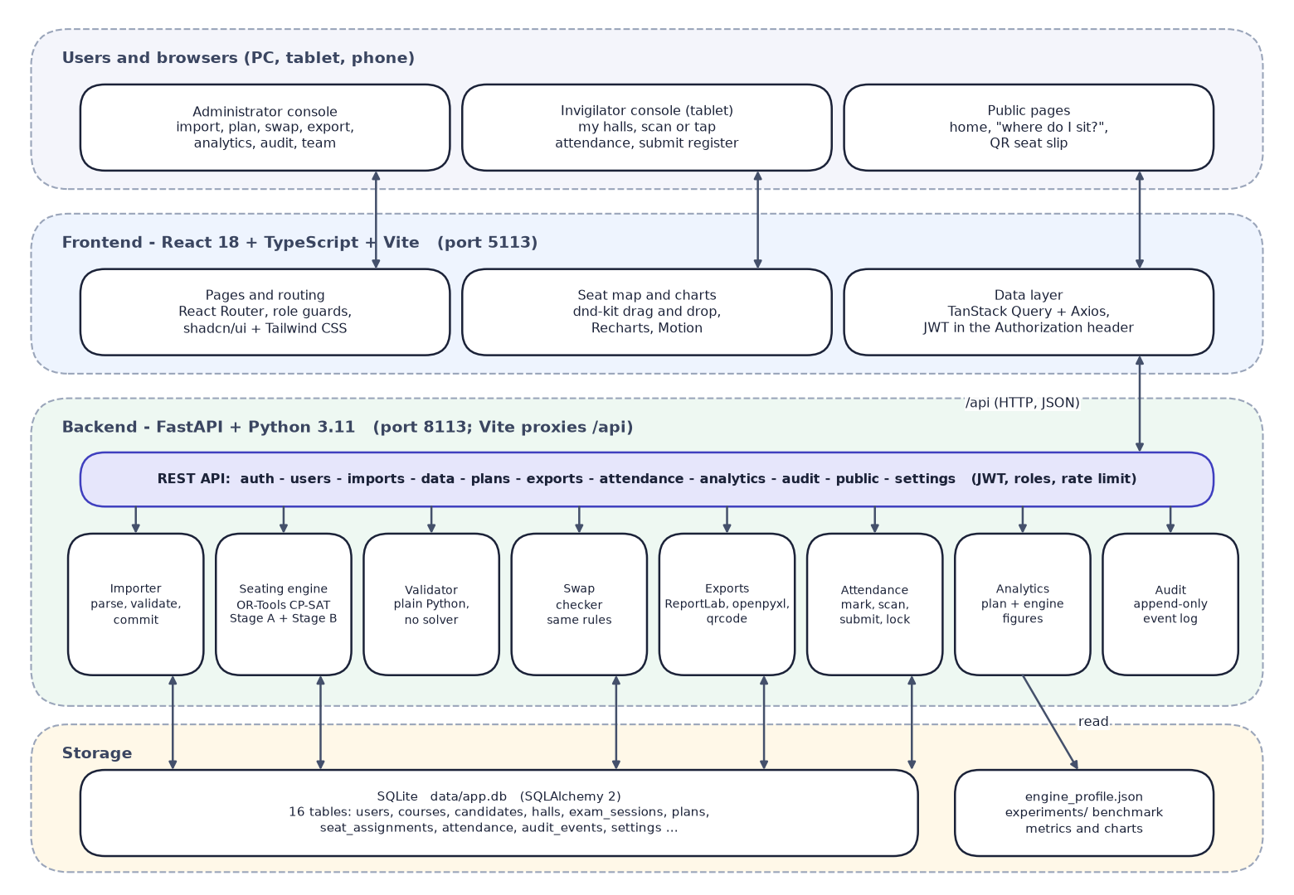
Fig. 5.1: System architecture of SeatWise
Table 5.1: Layers of the architecture
Layer | Technology | Responsibility
Browser | Chrome or Edge on PC, tablet or phone | Administrator console, invigilator register, public lookup
Front end | React 18, TypeScript, Vite, Tailwind CSS, shadcn/ui, TanStack Query, dnd-kit, Recharts | Pages, seat map, charts, role guards, API calls
API | FastAPI, Pydantic v2, JWT (PyJWT), bcrypt | REST endpoints, authentication, authorisation, errors
Services | Importer, engine, validator, swap checker, exports, attendance, analytics, audit | All business rules and outputs
Solver | Google OR-Tools CP-SAT 9.15 | Stage A and Stage B optimisation
Storage | SQLite through SQLAlchemy 2 | 16 tables; created automatically on first start

5.2 High-Level Workflow
The workflow has ten steps. The administrator imports the four data files, which are validated row by row before anything is saved, sets the seating rules, and asks the engine for a plan. An independent validator scores the plan and computes a roll-order baseline for comparison. The administrator reviews the seat map, optionally moves seats with live checks, and publishes the plan, which archives the previous version. Published plans feed the printed outputs, the public lookup and the tablet attendance, and analytics and Verify close the loop.
An impossible request does not fail silently: the pre-check explains the cause (not enough seats, too few accessible seats or one paper larger than the halls can separate) and suggests a fix. Every step writes to the append-only audit trail.
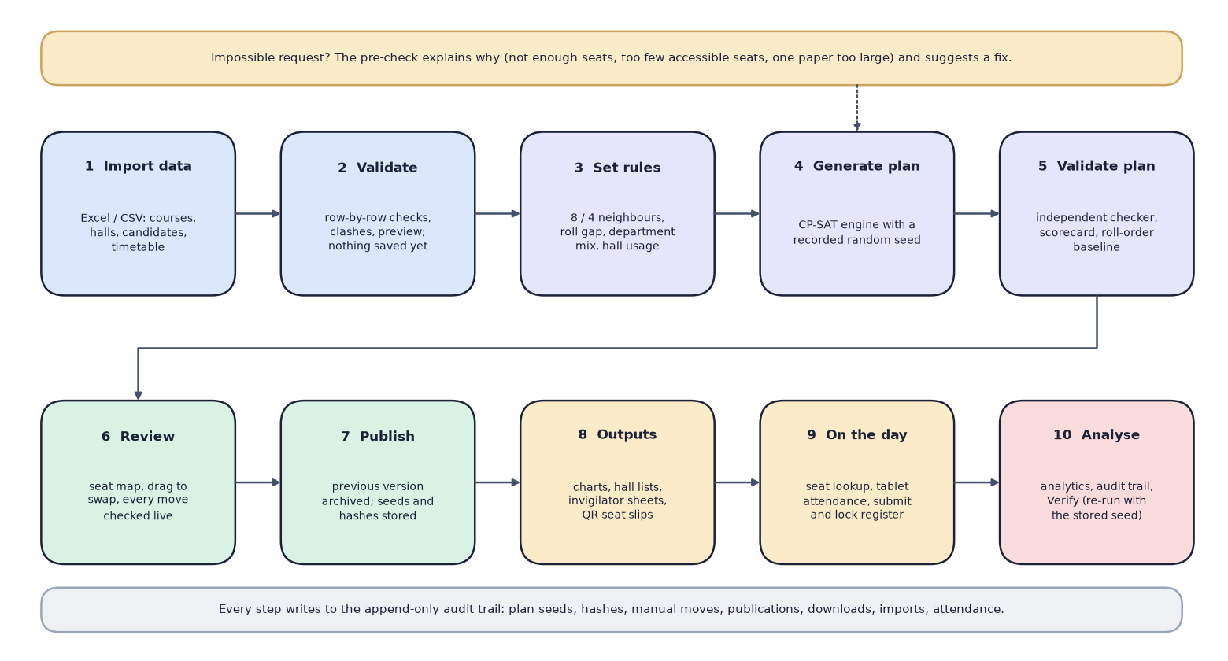
Fig. 5.2: High-level workflow from data import to analysis

5.3 Data Flow Diagrams
Data-flow diagrams describe how data moves between the users, the processes and the data stores at three levels of detail.

5.3.1 Level 0
The context diagram shows SeatWise as a single process with three external entities. The exam controller sends data files, rules, a seed and swap or publish commands, and receives validation reports, plans, scorecards, charts, lists, analytics and the audit trail. The invigilator sends attendance marks and scanned slips and receives hall lists, seat maps and register counts. The candidate sends a candidate ID and receives the hall, the seat, a hall map and a QR slip.
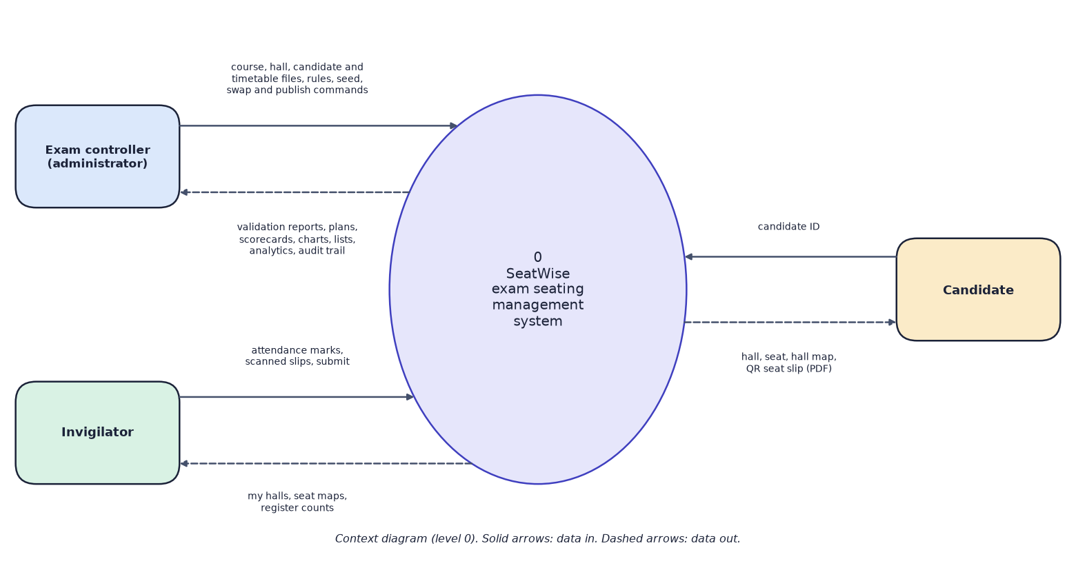
Fig. 5.3: Data-flow diagram, level 0 (context diagram)

5.3.2 Level 1
Level 1 opens the system into eight processes and five data stores. Process 1 authenticates users and reads the user and settings store D1. Process 2 imports and validates data and maintains the reference data D2 (courses, candidates, halls, timetable). Process 3 generates a plan from D2 and the rules and writes it to the plans store D3. Process 4 reviews, swaps and publishes plans in D3. Process 5 produces the outputs from published plans. Process 6 answers candidate lookups from published seats. Process 7 records attendance in D4, using the seat lists in D3. Process 8 presents analytics and the audit trail by reading D3, D4 and D5. Processes 2 to 7 append their events to the audit store D5.
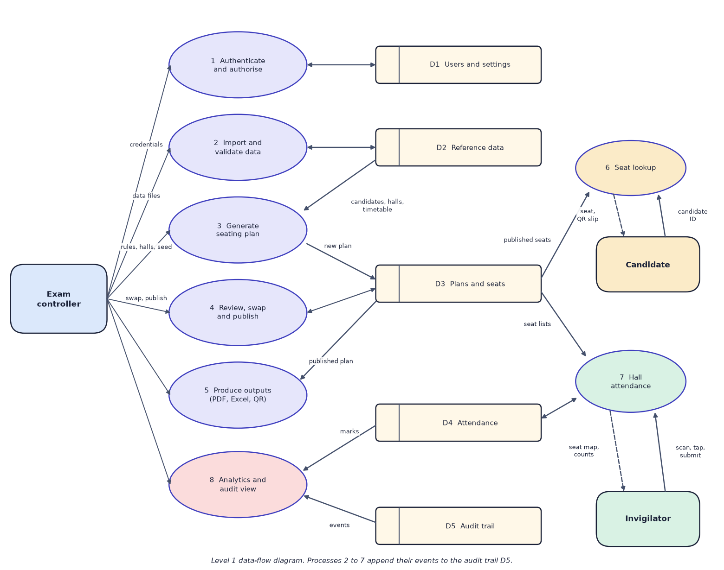
Fig. 5.4: Data-flow diagram, level 1

5.3.3 Level 2
Level 2 opens the plan-generation process into seven steps. Sitting data is loaded from the reference data (3.1) and pre-checked (3.2); an impossible request returns plain-language reasons to the controller. Stage A (3.3) allocates groups of candidates to halls and gives each paper a colour class; candidates are then split between halls with a seeded shuffle (3.4), laid out seat by seat in each hall in parallel (3.5), and validated and scored (3.6). The plan, its seats and an audit event are stored with the seed and three fingerprints (3.7). If a hall fails within its budget, the loop returns to Stage A to re-balance.
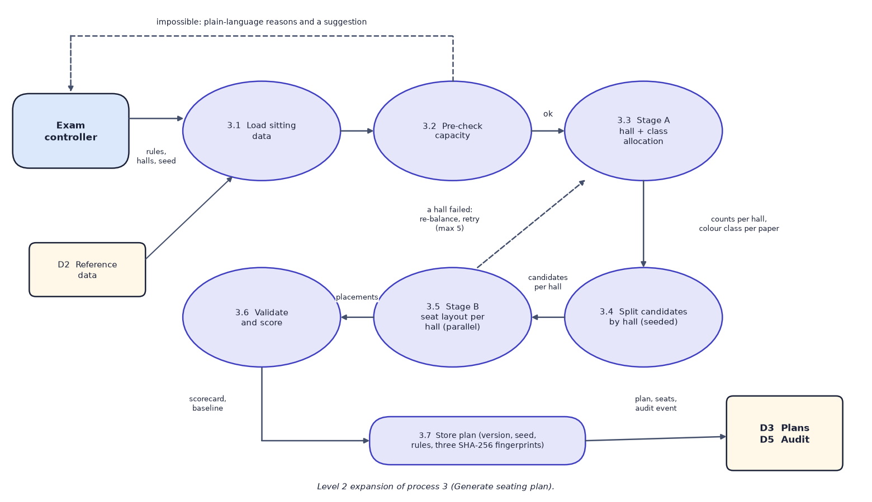
Fig. 5.5: Data-flow diagram, level 2: expansion of process 3 (generate seating plan)

5.4 UML Diagrams

5.4.1 Use-case diagram
The administrator can import and validate data, set rules, generate, verify, swap, publish and export plans, view analytics and the audit trail, and manage the team. The invigilator can request an account, view assigned halls, mark attendance, submit and lock the register, and print the chart or sheet of an assigned hall. The candidate needs no account and can look up a seat and download a QR slip. Everyone who is signed in must first sign in.
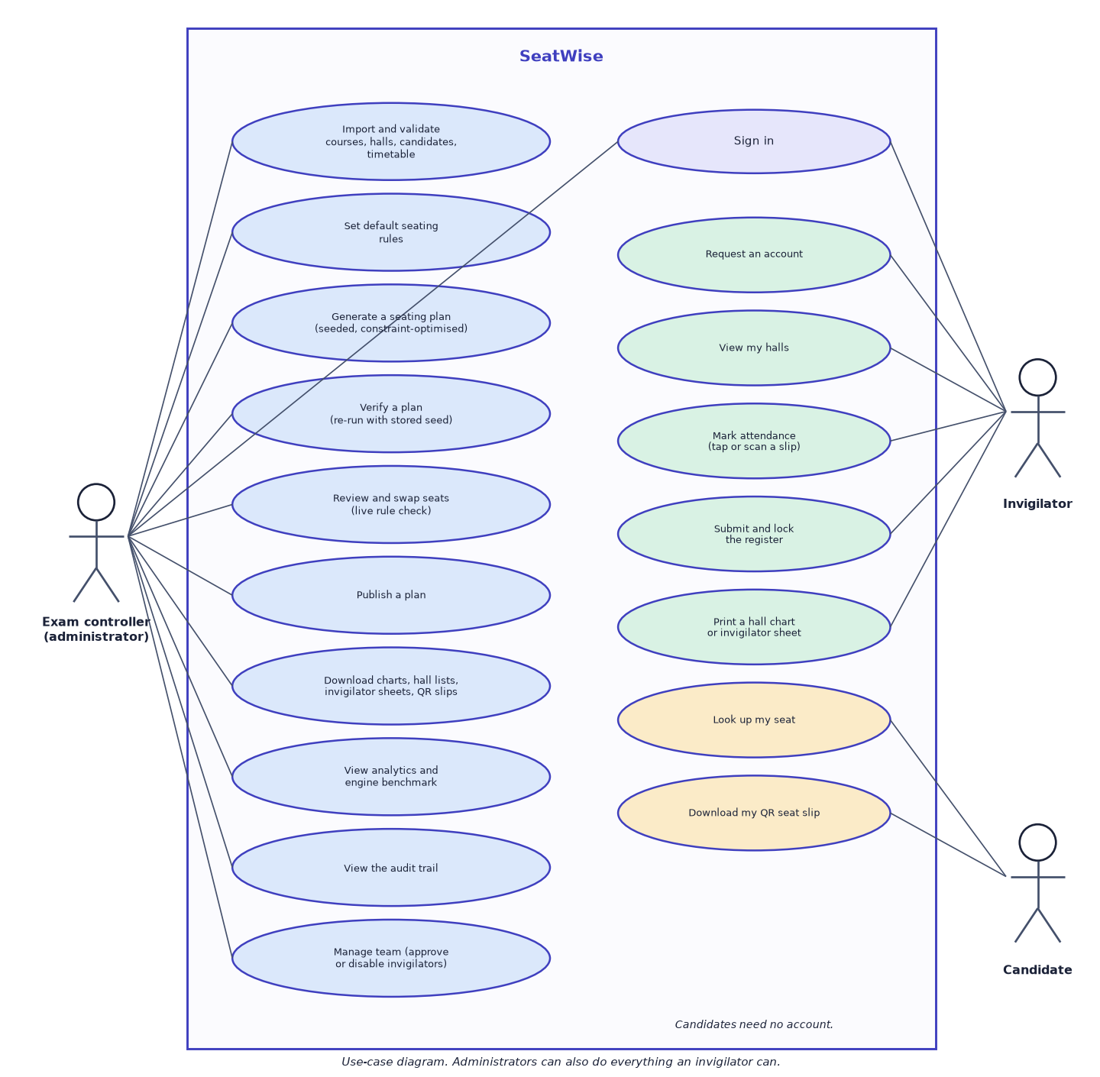
Fig. 5.6: Use-case diagram

5.4.2 Sequence diagram
The sequence follows the main flow. The administrator chooses a sitting, rules and a seed in the web UI, which sends POST /api/sessions/{id}/plans. The plan service loads candidates, halls and the timetable, calls the engine, validates the result, saves the plan with its seed and fingerprints, and returns the plan and its scorecard. Publishing sets the status, archives the previous version and records an audit event. Later, a candidate enters a candidate ID on the public lookup page, which calls the rate-limited public endpoint and receives the published seat.
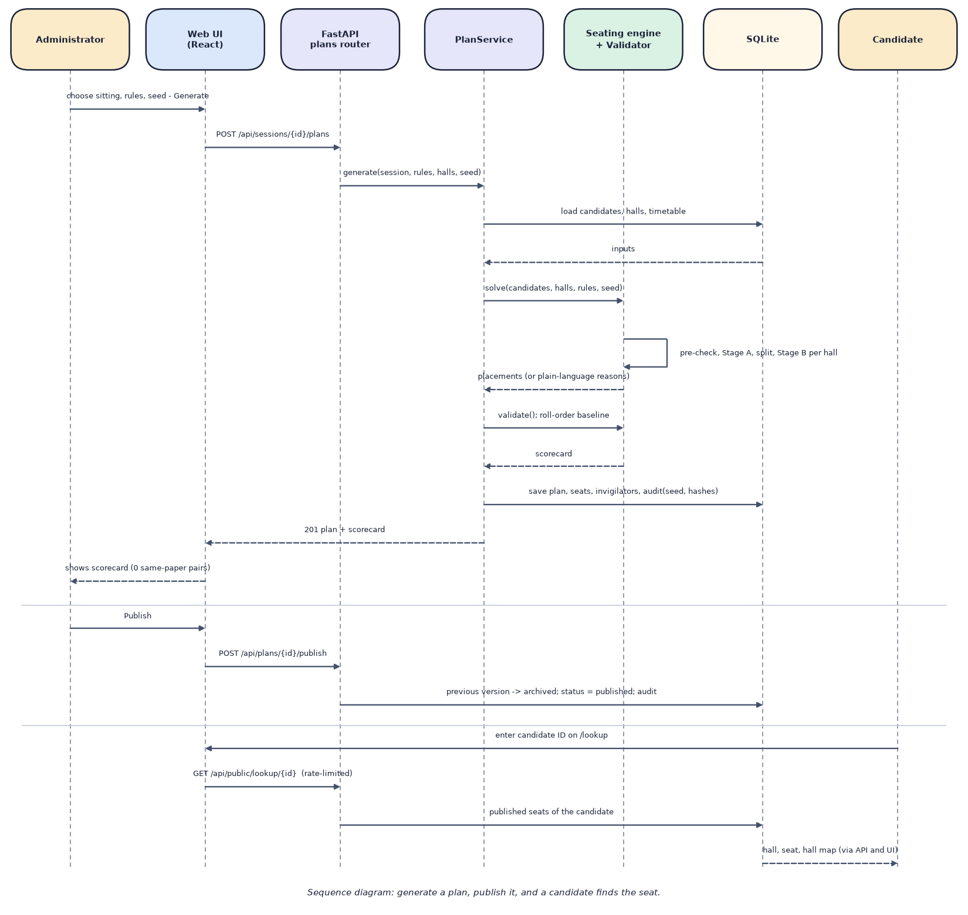
Fig. 5.7: Sequence diagram: generate a plan, publish it, and a candidate finds the seat

5.4.3 Class diagram
The class diagram has two groups. The domain model on the left shows the persistent entities and their associations: a department has courses and candidates, candidates register for courses, an exam session schedules papers (courses) and has plans, and a plan owns seat assignments that link a candidate to a hall seat and attendance marks. The group on the right shows the engine's plain data types (rules, candidates, halls, placements and results) and the modules and services that use them: the plan service maps entities to engine types, calls the seating engine, which runs Stage A and Stage B over the seat graph, and checks the result with the validator; the swap checker applies the same rules to manual moves.

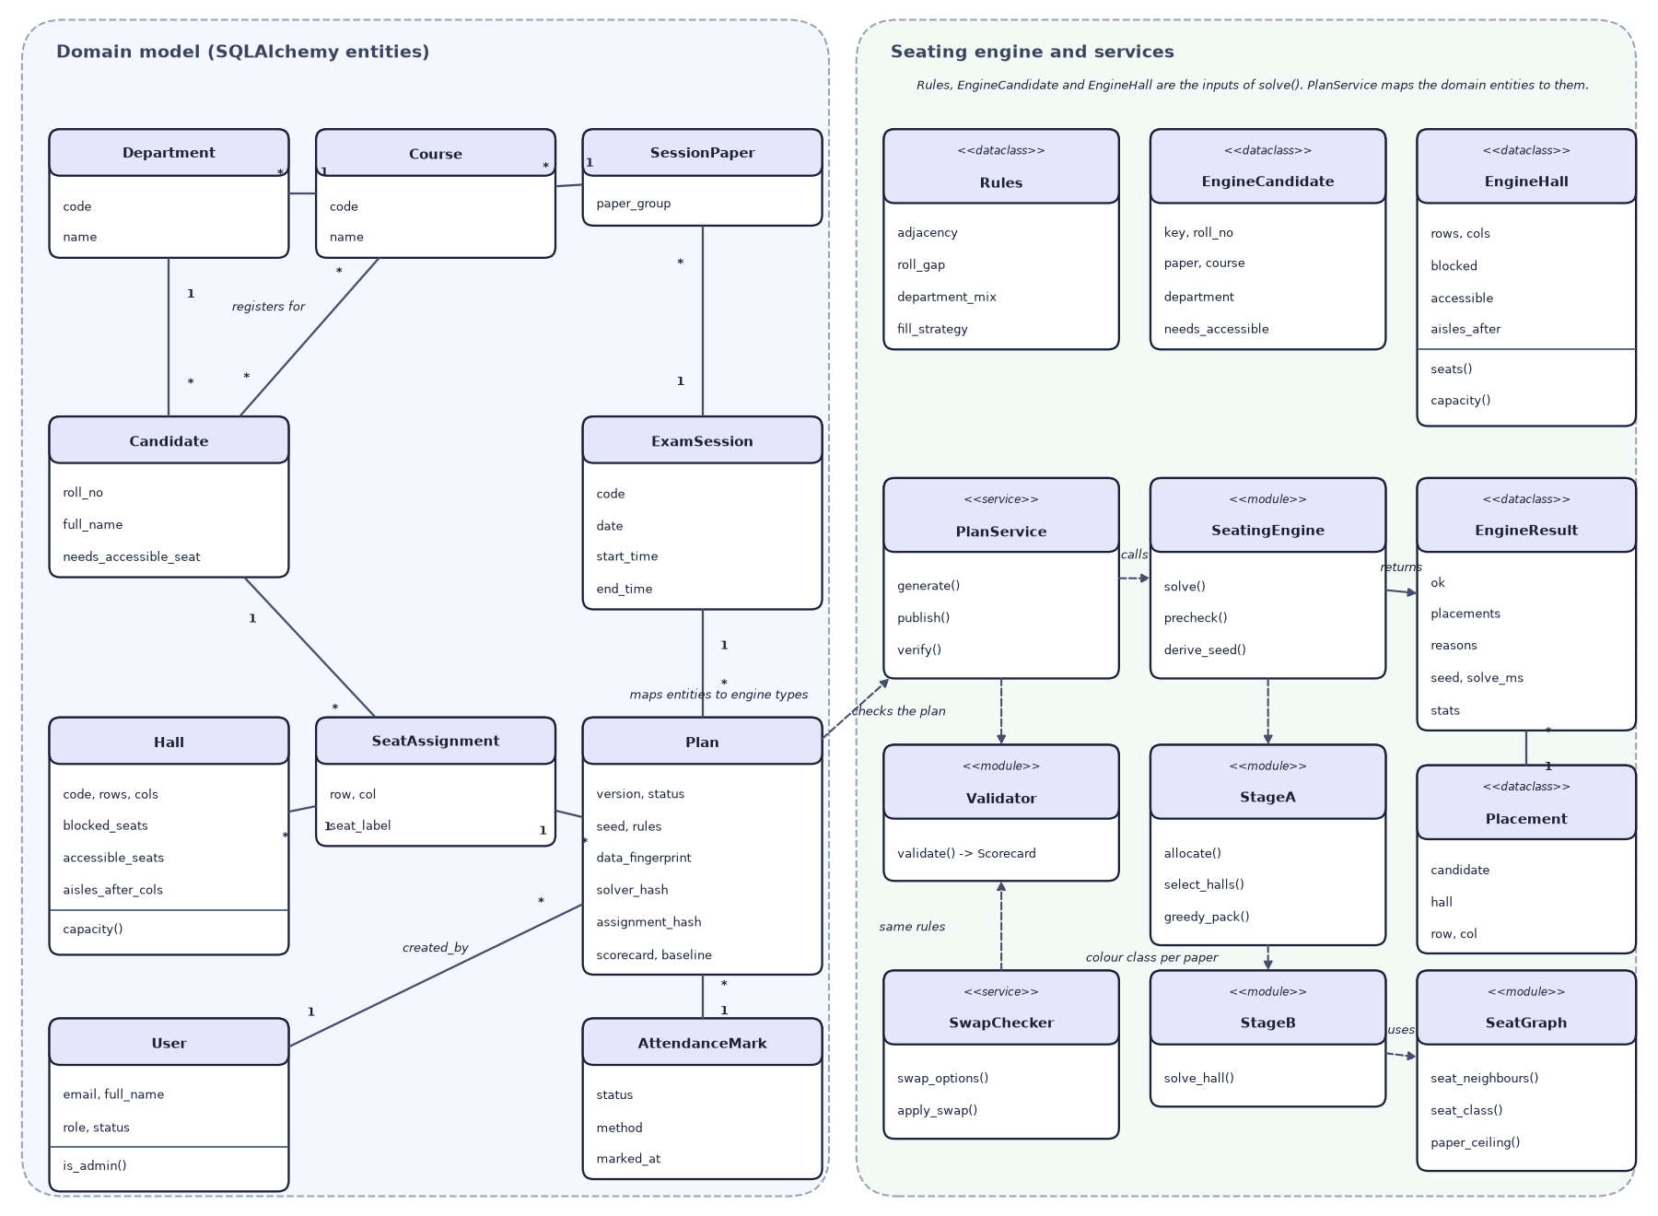
Fig. 5.8: UML class diagram: domain entities and the seating engine

5.5 Entity-Relationship Diagram and Database Schema
The database has 16 tables. Reference data comprises departments, courses, candidates, registrations (the many-to-many link between candidates and courses), halls and the timetable (exam sessions and session papers). A plan belongs to an exam session and owns its seat assignments, invigilator assignments, attendance marks and hall submissions. Users, audit events, import batches and settings support the application. Every foreign key is marked in its table; only the principal relationships are drawn so that the diagram stays readable.

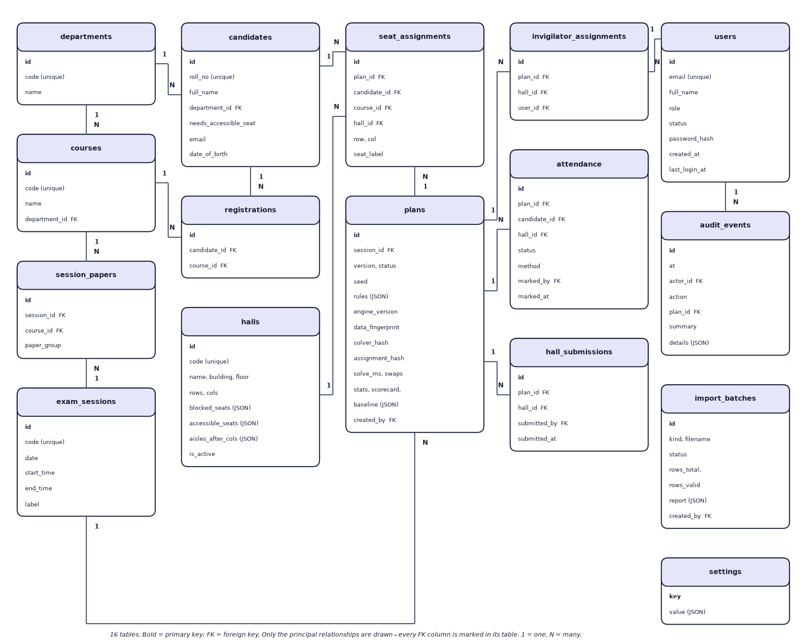
Fig. 5.9: Entity-relationship diagram of the SeatWise database (16 tables)

The tables are created by SQLAlchemy when the application starts, so no separate migration step is needed for a first install. Unique constraints protect the main invariants: one registration per candidate and course, one seat per candidate in a plan, one candidate per seat of a hall in a plan, one attendance mark per candidate and plan, and one version number per sitting.
Table 5.2: Database tables
Table | Purpose | Key columns
users | Administrators and invigilators | email (unique), role, status (active, pending, disabled), password_hash
departments, courses | Course catalogue | code (unique), name, department_id
candidates | Candidates | roll_no (unique), department_id, needs_accessible_seat, email, date_of_birth
registrations | Courses a candidate sits | candidate_id, course_id (unique pair)
halls | Hall layouts | rows, cols, blocked_seats, accessible_seats, aisles_after_cols (JSON), is_active
exam_sessions | Sittings | code, date, start_time, end_time, label
session_papers | Courses examined in a sitting | session_id, course_id, paper_group (shared question paper)
plans | A version of a sitting's seating | status, seed, rules, engine_version, data_fingerprint, solver_hash, assignment_hash, solve_ms, scorecard, baseline
seat_assignments | Candidate to seat | plan_id, candidate_id, course_id, hall_id, row, col, seat_label
invigilator_assignments | Who supervises a hall in a plan | plan_id, hall_id, user_id
attendance | Marks per candidate | plan_id, candidate_id, hall_id, status, method, marked_by, marked_at
hall_submissions | Register lock | plan_id, hall_id, submitted_by, submitted_at
import_batches | Every upload and its report | kind, filename, status, rows_total, rows_valid, report, payload
audit_events | Append-only log | at, actor_id, action, plan_id, summary, details (JSON)
settings | Default rules | key, value (JSON)

5.6 Module Design
The code is organised so that rules live in one place and every layer can be tested separately. Package sizes are the actual line counts of the delivered code.
Table 5.3: Modules and their size
Package | Files | Lines | Responsibility
backend/app/api | 13 | 899 | One router per area: auth, users, imports, data, plans, exports, attendance, analytics, audit, public, settings, health
backend/app/core | 7 | 292 | Settings from .env, database session, security, dependencies, error types, logging
backend/app/models | 7 | 308 | SQLAlchemy entities for the 16 tables
backend/app/schemas | 5 | 362 | Pydantic request and response models
backend/app/services/engine | 10 | 1,023 | Seat graph, pre-checks, roll numbers, Stage A, Stage B, engine loop, validator, baselines
backend/app/services/importer | 6 | 1,031 | Parse CSV or XLSX, validate each kind, cross-checks, commit, templates
backend/app/services/exports | 7 | 747 | Seating charts, invigilator sheets, QR slips (PDF); hall lists and attendance (Excel)
backend/app/services (other) | 12 | 1,006 | Plans, swap, attendance, analytics, audit, hall map, sessions, rate limit, seed data
ml (benchmark) | 6 | 726 | Scenario generator, baselines, benchmark runner, predictability and plots
backend/tests | 11 | 813 | 58 pytest tests
frontend/src/pages | 19 | 4,872 | Public, authentication and 13 application pages
frontend/src/components, lib | 52 | 3,787 | Layout, seat map, charts, UI kit, API client, auth, theme
scripts | 24 | 3,662 | Setup checks, sample data, demo scenario, and the documentation tools of this report

5.6.1 Engine modules
- graph.py builds each hall's seat graph and its colour classes (the key geometric idea).
- prechecks.py produces plain-language reasons for impossible requests.
- stage_a.py allocates candidate groups to halls and colour classes with CP-SAT in two passes.
- stage_b.py lays out the seats of one hall with CP-SAT.
- engine.py runs the loop: pre-check, Stage A, split, Stage B in parallel, retry.
- validator.py is the independent checker and scorecard; rolls.py parses roll numbers; baselines.py creates the manual baselines.

5.7 User Interface Design
The interface was designed around the three audiences. Administrators get a sidebar with Prepare (import, data), Seating (sittings and plans, exports, attendance, analytics, audit trail) and Workspace (team, settings). Invigilators see only their halls and the attendance screen. Candidates see a public home page and a lookup page. Principles applied throughout: every list has a loading state, an empty state and a Try again action; every chart has a table view; colours carry a second cue (icons, labels) so that they are not the only signal; the layout works from 360 px to desktop; and a sun or moon button switches between light, dark and system themes.
The seat map is the central screen. The front of the hall is at the top, rows are lettered from the front and seats are numbered from the left. Each seat shows its label, roll number and course, with a coloured top edge for the paper. Picking up a candidate turns every other seat green (the move keeps every rule) or red (with the reason on hover or focus).
Real captures of the seat map and the dashboard are shown in Chapter 8.
Table 5.4: Screens of the application
Screen | Route | Audience | Purpose
Home | / | Public | Overview, headline benchmark figures, links to lookup and sign-in
Sign in, Request account | /login, /register | Public | Authentication; demo workspace buttons
Dashboard | /app | All staff | Getting-started steps, figures, charts, sittings, busiest halls
Import data | /app/import | Admin | Upload, validation report, preview, commit, templates
Data | /app/data | Admin | Candidates, courses, halls, timetable
Sittings and plans | /app/sessions, /app/sessions/:id | Admin | Generate, versions, scorecard, publish, verify, invigilators
Seat map | /app/plans/:plan/halls/:hall | Admin; invigilator (read-only) | View and edit seats with live checks
Exports | /app/exports | Admin | Charts, lists, sheets, QR slips, attendance report
Attendance | /app/attendance, /app/attendance/:plan/:hall | Staff | Take and submit attendance
Analytics | /app/analytics | Admin | Plan comparison charts; engine performance
Audit trail | /app/audit | Admin | Filterable event log
Team, Settings | /app/team, /app/settings | Admin | Accounts and default rules
Find my seat | /lookup, /lookup/:id | Public | Seat lookup and QR slip

CHAPTER 6
METHODOLOGY AND SOFTWARE IMPLEMENTATION

6.1 Overall Methodology
The method turns the seating problem into three smaller, separately checkable problems and wraps them in a pipeline. The first is data preparation: uploaded files are parsed and validated, and the accepted rows become plain data types. The second is allocation (Stage A), which decides which candidates go to which hall and which colour class of the hall's seat grid each paper uses. The third is layout (Stage B), which decides the exact seat of each candidate inside the class that Stage A gave to the candidate's paper. An independent validator then re-checks the whole plan.
The key design decision is to enforce the most important rule, that no two neighbours write the same paper, structurally rather than by search. If seats are coloured so that seats of one colour are never neighbours, and each paper in a hall is confined to a single colour, then two candidates of one paper can never be neighbours, whatever Stage B does. The remaining rules (roll-number gap, accessible seats, one candidate per seat) are constraints of the Stage B model, and the department mix is a soft objective. Randomness enters in both stages through seeded random weights in the objectives, so the returned plan is one random member of the set of valid plans.
The flowchart is the control flow of the engine's solve function. After loading the sitting, the pre-checks reject impossible requests with reasons. Stage A runs in two passes, the first finding the best allocation and the second choosing among equally good allocations with seeded random weights. Candidates are split between halls with a seeded shuffle, and Stage B lays out every hall in parallel. A hall that finds nothing within its time budget is retried with four times the budget; if it still fails, its capacity is eased and Stage A is re-run, at most five times. A successful result is re-checked by the independent validator and stored with the seed, rules and three SHA-256 hashes.
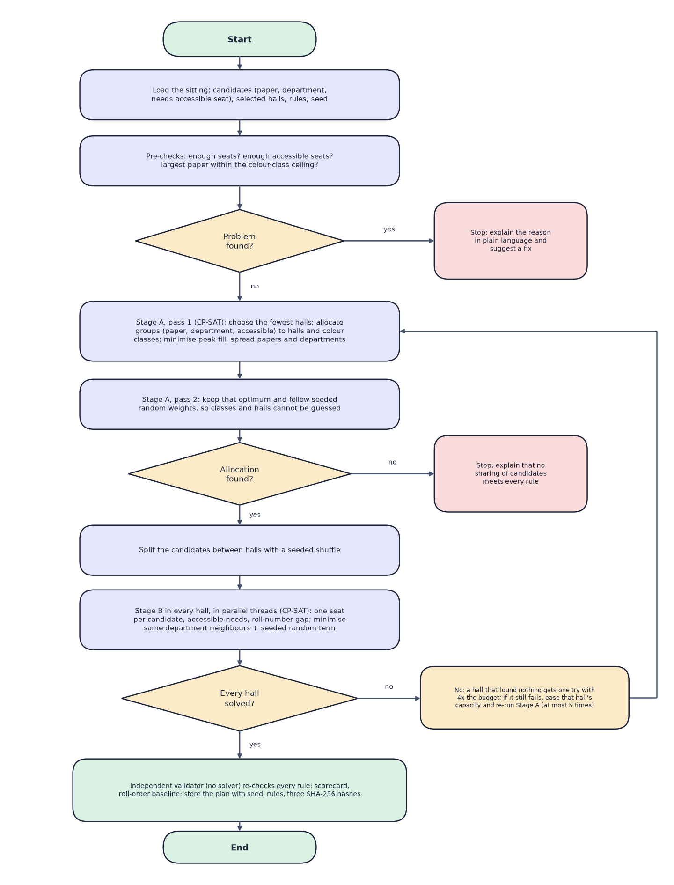
Fig. 6.1: Flowchart of the core seating algorithm

6.2 Dataset
SeatWise does not depend on any external dataset. It ships with a seeded, synthetic sample dataset so that the product can be demonstrated and tested end to end, and with empty import templates for real data. The sample was generated by scripts/generate_sample_data.py with seed 2026. No real person, organisation or record is involved: names are random combinations of common first and last names and e-mail addresses use the reserved example.com domain. The data is produced by the project itself and may be used and modified with it. The same seed always reproduces byte-identical files.
Table 6.1: The sample dataset
Item | Value
Source and licence | Generated by the project (seed 2026); free to use with the product
Departments and courses | 7 departments (ACF, SWE, DAN, MCD, ELS, BMG, HCA); 49 courses, 7 per department
Candidates | 908 candidates; roll numbers such as ACF24017; about 1% (10 candidates) need an accessible seat
Registrations | 2,724 (each candidate sits three courses)
Halls | 14 halls in 3 buildings, 6 x 6 to 10 x 12 seats; 871 usable seats; aisles and blocked seats; 4 halls list accessible seats
Timetable | 6 sittings over 3 days; 397 to 511 candidates and 7 to 9 papers per sitting; SWE-202 and DAN-202 share one question paper
Size on disk | About 145 KB of CSV and Excel files
Train, validation, test split | Not applicable: nothing is trained

The sample is built so that it exercises every rule. Each department has exactly one examination in every sitting, which produces sittings of seven to nine papers. Second-year candidates choose one of two electives, so candidates of one department with neighbouring roll numbers write different papers in the same sitting, which exercises the roll-gap rule. The two courses that share a paper exercise the subject-combination rule.
Table 6.2: Import file schema
File | Required columns | Optional columns
courses | course_code, course_name, department_code | department_name (needed the first time a department appears)
candidates | roll_no, full_name, department_code, course_codes | needs_accessible_seat, email, date_of_birth
halls | hall_code, hall_name, rows, columns | building, floor, blocked_seats, accessible_seats, aisles_after_columns
timetable | session_date, start_time, end_time, course_code | paper_group

6.2.1 Benchmark scenarios
The engine benchmark uses eight seeded scenarios generated in memory by ml/scenarios.py, so they are rebuilt identically from their seeds and are not stored as files. Each scenario has roughly 1% of candidates needing an accessible seat and a target hall fill of 80%.
Table 6.3: Benchmark scenarios
Scenario | Candidates | Papers | Depts | Halls | Seats | Adjacency | Roll gap
xs-150 | 150 | 4 | 3 | 3 | 212 | 8 | 5
s-300 | 300 | 6 | 4 | 6 | 398 | 8 | 5
m-600 | 600 | 8 | 6 | 12 | 752 | 8 | 5
l-1000 | 1,000 | 10 | 7 | 19 | 1,359 | 8 | 5
xl-2000 | 2,000 | 14 | 8 | 39 | 2,522 | 8 | 5
m-600-adj4 | 600 | 8 | 6 | 12 | 752 | 4 | 5
m-600-gap0 | 600 | 8 | 6 | 12 | 752 | 8 | 0
m-600-gap10 | 600 | 8 | 6 | 12 | 752 | 8 | 10

6.3 Data Preprocessing

6.3.1 Import parsing and validation
Uploads are read from CSV or XLSX with flexible header names (for example Roll No, roll_number and candidate_id are all accepted for roll_no). Lists are split on ;, , or |, and dates are accepted in two formats. A combined workbook with four sheets, or a single file of one kind, can be uploaded. Every row is then checked, and nothing is saved until the administrator confirms the import; the data is checked again at that moment in case something changed in between.
- required columns present and values well formed (times, dates, integers, yes or no);
- duplicate codes and roll numbers; unknown departments or courses;
- seat labels outside the hall layout, a seat both blocked and accessible, aisle positions outside the grid;
- end time not after start time; a shared-paper group split across sittings;
- a candidate registered for two papers in the same sitting (a timetable clash); a sitting larger than all halls together (a warning).
Errors block the import; warnings do not. For example, a hall that lists no accessible seats receives two front-row seats by default and a warning, which is why the sample import reports 10 warnings and 0 errors for its 1,020 rows.

6.3.2 Preparation of the engine inputs
For each sitting, the plan service builds the engine's inputs. Candidates become EngineCandidate records with a paper key, which is the paper group when courses share a question paper and the course code otherwise, a department and an accessibility flag. Each hall becomes an EngineHall with its dimensions and the sets of blocked seats, accessible seats and aisle positions. Candidates are then grouped by (paper, department, accessible need), and these groups are the units that Stage A allocates to halls. Roll numbers are split into a prefix and a trailing number (ACF24017 becomes ACF and 24017), and only numbers with the same prefix are compared by the roll-gap rule.

6.4 Algorithm Choice and Justification
Several families of methods can produce seating plans. The table compares them against the needs of the project.
Table 6.4: Candidate methods for seat allocation
Method | Hard-rule guarantee | Randomness | Reproducible | Verdict
Sort by roll number | None | None | Yes | Fails the main rule (measured: 1,253 violations at 600 candidates)
Zipper or round-robin interleave | Only for two subjects in a line | None | Yes | Predictable; leaves 281 violations at 600 candidates
Random shuffle | None | Full | With a seed | Leaves 265 violations at 600 candidates
Greedy graph colouring | Same-course neighbours, heuristically | Limited | Yes | No proof of success; hard to add other rules
Genetic or annealing search | None (soft penalties) | Full | With a seed | May end with violations; slow to converge
CP-SAT (constraint programming) | Exact, or a proof of infeasibility | Seeded objective | Deterministic budget | Chosen

CP-SAT was chosen for four reasons. It returns either a plan that satisfies every hard constraint or a proof that none exists, which lets the system explain impossible requests honestly. Adding a rule means adding a constraint, not redesigning a heuristic. Its objective supports lexicographic goals (first spread papers and departments, then follow random weights). And a deterministic time limit, together with a fixed number of workers per hall and a fixed order of candidates, makes a run reproducible from its seed, which was one of the project's objectives.
A single monolithic model over all seats of all halls would be large and slow. Splitting the problem into an allocation stage and a per-hall layout stage keeps each model small, lets the halls be solved in parallel, and is what makes the colour-class construction possible.

6.5 Mathematical Formulation
Notation. Let C be the candidates of a sitting and H the selected halls. Candidate c has a paper p(c), a department d(c), a roll number r(c) with prefix and number, and a flag a(c) that is true when an accessible seat is needed. Hall h is a grid of rows and columns whose usable seats form the set S(h); A(h) is the set of accessible seats.

6.5.1 Seat graph and colour classes
Two usable seats of a hall are neighbours if they are adjacent in a row, a column or, in 8-neighbour mode, a diagonal, and no aisle lies between them. Blocked seats and aisles only remove edges. The seat at row i and column j receives the colour class
Listing: colour classes of the seat grid
kappa(i, j) = 2 * (i mod 2) + (j mod 2) (8 neighbours: 4 classes)
kappa(i, j) = (i + j) mod 2 (4 neighbours: 2 classes)

Lemma. Two different seats of the same class are never neighbours. Proof. In 8-neighbour mode, two seats of one class have the same row parity and the same column parity, so their row difference and their column difference are both even; since the seats differ, at least one difference is 2 or more, and neighbours differ by at most 1 in each direction. In 4-neighbour mode, seats of one class have the same parity of i + j, whereas neighbours differ by exactly 1 in i + j. Removing edges (aisles, blocked seats) cannot create adjacency. The class sizes are therefore the largest sets of seats that can safely hold one paper, and the per-paper ceiling of a hall is its largest class.

6.5.2 Stage A: allocation
Group candidates by g = (paper, department, accessible need) and let N(g) be the size of group g. The variables are integers n(h, g) with 0 <= n(h, g) <= min(N(g), capacity(h)), booleans z(h, p, k) meaning that paper p uses class k in hall h, and integers m(h, p, k) for the number of candidates of paper p seated in class k of hall h. The constraints are:
Listing: Stage A constraints
sum_h n(h,g) = N(g) -- every group is fully placed
sum_g n(h,g) <= capacity(h) -- no hall is over capacity
sum_k z(h,p,k) <= 1 -- one class per paper per hall
m(h,p,k) <= |S(h,k)| * z(h,p,k) -- class size bounds the share
sum_k m(h,p,k) = sum_{g in p} n(h,g) -- shares add up to the paper
sum_p m(h,p,k) <= |S(h,k)| -- classes are not over-filled
accessible candidates in class k <= |A(h) in k|
100 * occupancy(h) <= capacity(h) * peak -- peak fill bound

The first pass minimises a lexicographic objective, with the peak fill weighted most heavily, followed by the largest paper share and the largest department share of each hall, and a penalty on each (hall, department, class) triple that a department spans in several classes. The second pass keeps the optimum (primary <= best) and maximises a weighted sum of the z variables with seeded random integer weights in the range 0 to 999, so which class and hall each paper receives cannot be predicted. The compact strategy first selects the fewest, largest halls into which a greedy best-fit packing can place every paper.

6.5.3 Stage B: seat layout of one hall
After a seeded shuffle gives each hall its candidates, the layout of hall h is a boolean model. Let K(c) be the seats of the class that Stage A assigned to p(c), intersected with A(h) if a(c) is true. The variable x(c, s) is 1 when candidate c sits on seat s in K(c):
Listing: Stage B model
sum_s x(c,s) = 1 -- one seat per candidate
sum_c x(c,s) <= 1 -- one candidate per seat
for each pair (i,j): same roll prefix, |r(i)-r(j)| < gap,
different classes, and every seat s of i:
x(i,s) + sum_{t in N(s)} x(j,t) <= 1 -- roll-gap clause
minimise W * sum(penalties) - sum w(c,s) * x(c,s)
penalty = 1 when two neighbours share a department
w(c,s) = random integer in [0,20), W = |C(h)| * 20 + 1

Pairs of candidates in the same class need no roll-gap constraint, because their seats are never neighbours. The weight W makes department mixing take precedence over the random term, which then chooses among equally good layouts. The model is seeded with a random hint and solved with one deterministic worker and a deterministic time budget, so the result depends only on the seed and inputs.

6.5.4 Why every hard rule holds
1. No seat has two candidates and every candidate has one seat (Stage B constraints).
2. Same-paper neighbours are impossible: all candidates of one paper in a hall sit in one class (Stage A), and seats of one class are never neighbours (Lemma). A shared question paper is one paper key, so it is covered.
3. Roll-number gaps hold for candidates in different classes by the Stage B clauses, and for the same class by the Lemma.
4. Accessible needs hold because K(c) contains only accessible seats for such candidates.
5. Independently of this argument, the validator re-checks all four rules on the finished plan, and a plan that fails is never stored.
Reproducibility follows from deterministic components: sub-seeds are derived from the plan seed with SHA-256, candidates are processed in a fixed order, and each solver call uses one worker with a deterministic time limit. The plan stores a fingerprint of the inputs, a hash of the solver result and a hash of the current seating.

6.6 Model Architecture, Configuration and Tuning
The seating engine is a constraint model, not a neural network, and it has no trained parameters. There is therefore no training set, validation set, test set, loss curve or epoch count. What can be configured and tuned is the solver, and the benchmark tunes the one setting that affects speed, the per-hall time budget.
Table 6.5: Engine configuration
Setting | Value | Where
Solver | OR-Tools CP-SAT 9.15.6755 | requirements.txt
Per-hall deterministic budget (Stage B) | 0.15, tuned | models/engine_profile.json; override SOLVER_HALL_BUDGET
Stage A budget | 0.3 (pass 2: half; a stretch to 4x if no allocation is found) | engine.py
Workers per hall | 1 (deterministic) | engine.py
Halls solved in parallel | all CPU threads | SOLVER_THREADS
Random weight range | 0-19 per candidate-seat (Stage B); 0-999 per class variable (Stage A) | stage_b.py, stage_a.py
Re-balancing retries | 5 | SOLVER_MAX_RETRIES
Hall retry factor | 4x budget once, then ease and re-balance | engine.py

The budget trades department mix, a soft preference, against speed. The benchmark tried five budgets on the 600- and 1,000-candidate scenarios with two seeds each and chose the fastest budget whose department mix is within 10% of the best seen. Every budget met every hard rule. The smallest budget is slower overall because some halls run out of time and are solved again with a larger budget.
Table 6.6: Tuning the per-hall budget
Per-hall budget | Same-department pairs (mean) | Session solve (s) | Hard rules
0.1 | 127.2 | 3.72 | all met
0.15 (chosen) | 123.2 | 2.63 | all met
0.25 | 119.2 | 3.56 | all met
0.4 | 116.0 | 5.01 | all met
0.6 | 114.0 | 6.58 | all met

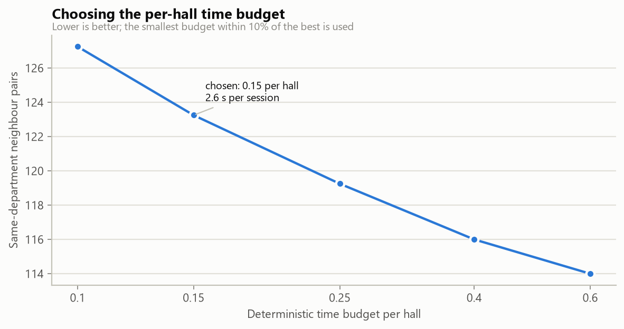
Fig. 6.2: Budget tuning: session solve time against department mix

6.7 Application Architecture and Implementation
Request flow. The browser calls /api/... on the Vite server, which forwards the request to Uvicorn. A FastAPI router validates the request with a Pydantic model, a dependency decodes the JWT and checks the role, and the router calls a service function with a SQLAlchemy session. Services raise typed errors (AppError, NotFound), which a handler converts to a JSON body {detail, details} with the matching HTTP status. Plan generation is a synchronous request that typically takes two to three seconds; the interface shows progress stages while it waits.
Front end. Pages are loaded on demand. TanStack Query caches server state and refreshes attendance every few seconds so that several devices stay in step. The seat map uses dnd-kit for drag and drop and also supports tap-then-tap and keyboard operation; while a candidate is picked up it calls the swap-check endpoint and colours every seat from the answer. Charts are drawn with Recharts and each has a table view.
Outputs. ReportLab draws one landscape page per hall for the seating chart, with the colour legend, the invigilator and a stamp of plan version, seed and seating fingerprint. Invigilator sheets list papers and a seat-by-seat table with present and signature columns. Seat slips (six per page) carry a QR code whose URL opens the candidate's lookup page. openpyxl writes the hall lists (a summary sheet, one sheet per hall, and a door list in roll order) and the attendance report.
Attendance. The attendance service marks candidates by tap, by scanned slip or by typed roll number. A scan of a candidate who sits in another hall reports where the candidate sits. A register can be submitted only when every candidate is marked, and a submitted register is locked until an administrator reopens it.

6.8 Key Code Walkthroughs
The excerpts below are copied from the delivered source; Appendix A lists further code.

6.8.1 Seat graph and colour classes
graph.py defines neighbours, the colouring and the per-paper ceiling. Aisles and blocked seats only remove edges.
Listing: neighbours of a seat (graph.py)
def neighbours_of(hall: EngineHall, seat: Seat, adjacency: int) -> list[Seat]:
r, c = seat
out = []
for dr, dc in _OFFSETS[adjacency]:
nr, nc = r + dr, c + dc
if 0 <= nr < hall.rows and 0 <= nc < hall.cols and (nr, nc) not in hall.blocked \
and not _crosses_aisle(c, nc, hall.aisles_after):
out.append((nr, nc))
return out

Listing: colour class of a seat (graph.py)
def seat_class(seat: Seat, adjacency: int) -> int:
"""Colour of a seat in a proper colouring of the seat graph.

8 neighbours: four classes by (row parity, column parity) - two seats of one
class differ by at least two rows or two columns, so they are never
neighbours. 4 neighbours: the two chessboard colours. Aisles and blocked
seats only remove edges, so the colouring stays valid.
"""
r, c = seat
return (r % 2) * 2 + (c % 2) if adjacency == 8 else (r + c) % 2

6.8.2 Stage B constraints
Stage B declares one boolean variable per candidate and allowed seat. The roll-gap rule is expressed as at-most-one clauses, and the objective combines the department penalty with the seeded random term.
Listing: Stage B model, assignment and roll-gap clauses (stage_b.py)
model = cp_model.CpModel()
x: dict[tuple[int, int], cp_model.IntVar] = {}
by_seat: dict[int, list] = defaultdict(list)
for ci, options in enumerate(allowed):
row = []
for s in options:
var = model.NewBoolVar("")
x[ci, seat_index[s]] = var
by_seat[seat_index[s]].append(var)
row.append(var)
model.AddExactlyOne(row)
for vars_on_seat in by_seat.values():
if len(vars_on_seat) > 1:
model.AddAtMostOne(vars_on_seat)

# Roll-number spacing. Pairs in the same class can never be neighbours, so only
# pairs in different classes need a constraint.
for i, j in close_pairs([c.roll_no for c in cands], rules.roll_gap):
if paper_class[cands[i].paper] == paper_class[cands[j].paper]:
continue
for s in allowed[i]:
around = [x[j, seat_index[t]] for t in neighbours[s] if (j, seat_index[t]) in x]
if around:
model.AddAtMostOne([x[i, seat_index[s]], *around])

6.8.3 The engine loop
solve runs the pre-check, Stage A, the seeded split and Stage B per hall, and handles retries as described in the flowchart.
Listing: retry loop of the engine (engine.py)
for attempt in range(max_retries + 1):
allocation = None
for stretch in (1, 4):
allocation = allocate(candidates, halls, rules, capacity=capacity,
seed=derive_seed(seed, f"stage-a-{attempt}"), budget=STAGE_A_BUDGET * stretch)
if allocation is not None:
break
if allocation is None:
return done(False, [], [
"No way to share the candidates between the selected halls satisfies every rule. "
"Select more halls, or relax the rules (4-neighbour adjacency or a smaller roll-number gap)."])

rng = np.random.default_rng(derive_seed(seed, f"split-{attempt}"))
per_hall = _split_by_hall(candidates, allocation.counts, halls, rng)
stage_b_started = time.perf_counter()

def run(keys: list[str], hall_budget: float) -> dict[str, HallSolve]:
with ThreadPoolExecutor(max_workers=min(threads, max(1, len(keys)))) as pool:
futures = {
key: pool.submit(solve_hall, hall_by_key[key], per_hall[key], allocation.paper_class[key], rules,
seed=derive_seed(seed, f"hall-{key}-{attempt}"), budget=hall_budget,
workers=workers_per_hall)
for key in keys
}
return {key: f.result() for key, f in futures.items()}

results = run(sorted(per_hall), budget)
slow = sorted(k for k, r in results.items() if r.status == "no_solution_in_budget")
if slow:
results.update(run(slow, budget * SLOW_HALL_BUDGET_FACTOR))

6.8.4 Plan generation and storage
generate in plans.py refuses to store a plan that the validator rejects, and records the seed, the rules and the fingerprints.
Listing: storing a plan (plans.py)
card = validate(candidates, halls, sequential(candidates, halls, rules), rules)
except ValueError:
return {}
return {"method": "sequential roll order", "same_paper_pairs": card.same_paper_pairs,
"roll_gap_violations": card.roll_gap_violations, "same_department_pairs": card.same_department_pairs,
"accessible_violations": card.accessible_violations, "neighbour_pairs": card.neighbour_pairs}
...
plan = Plan(
session_id=session.id, version=version, status=PLAN_DRAFT, seed=seed, rules=rules_in.model_dump(),
hall_ids=hall_ids, engine_version=ENGINE_VERSION,
data_fingerprint=data_fingerprint(candidates, halls, rules, budget),
solver_hash=solver_hash, assignment_hash=solver_hash, solve_ms=result.solve_ms,
stats={**result.stats, "hall_budget": budget}, scorecard=_card_summary(card),
baseline=_baseline(candidates, halls, rules), created_by=user.id,
)

6.8.5 Live swap check
The swap checker applies the same neighbour graph and roll-gap functions to a hypothetical move and returns reasons.
Listing: rule check of one seat after a move (swap.py)
def check_seat(seat: tuple[int, int], who: Occupant) -> None:
label = seat_label(*seat)
if who.needs_accessible and seat not in accessible:
reasons.append(f"{who.roll_no} needs an accessible seat and {label} is not one.")
for n in neighbours.get(seat, []):
near = after.get(n)
if near is None or near is who:
continue
if near.paper == who.paper:
reasons.append(f"{who.roll_no} would sit next to {near.roll_no} ({seat_label(*n)}) - both write {who.paper}.")
if violates_gap(who.roll_no, near.roll_no, rules.roll_gap):
reasons.append(f"Roll numbers {who.roll_no} and {near.roll_no} ({seat_label(*n)}) are only "
f"{roll_distance(who.roll_no, near.roll_no)} apart (minimum {rules.roll_gap}).")
if rules.department_mix and near.department == who.department and near.paper != who.paper:
notes.append(f"{who.roll_no} and {near.roll_no} are both from {who.department}.")

6.9 Implementation Decisions and their Reasoning
Table 6.7: Implementation decisions
Decision | Alternatives considered | Reasoning
Constraint programming (CP-SAT) for the engine | Sorting, zipper interleave, greedy colouring, genetic search | Exact on hard rules; can prove infeasibility; rules are added as constraints; seeded objective gives controlled randomness
Two stages (allocation, then layout) | One model over all seats of all halls | Smaller models, parallel halls, and the colour-class construction that makes same-paper neighbours impossible
Colour classes by (row parity, column parity) | Search for a colouring per hall | Explicit, provably proper colouring; no search; works with aisles and blocked seats because they only remove edges
Deterministic time budget, one worker per hall | Wall-clock limits, many workers | A wall-clock limit would make results depend on machine load; determinism makes plans reproducible
Sub-seeds derived by SHA-256 | Python's built-in hash or sequential seeds | Stable across runs and machines (Python hash randomisation would break reproducibility)
Independent validator | Trust the solver | A plan is never stored unless a solver-free check agrees; the same checks serve the swap map and the benchmark
Backend owns the rules | Check moves in the browser | One set of rules for the map, the exports and the benchmark; no rule drift
FastAPI with Pydantic and SQLAlchemy | Flask (the base paper's choice), Django | Typed request models, automatic OpenAPI documentation, simple tests with a test client
SQLite | PostgreSQL or MySQL | No server to install for one office; created on first start; adequate for the measured load. A server database is future work
JWT with bcrypt | Server-side sessions | Stateless API suitable for tablets and phones; short-lived tokens; passwords never stored in clear
React with TanStack Query and dnd-kit | Server-rendered pages (the base paper's Jinja2) | Responsive seat map with drag, tap and keyboard operation and live checks
Vite proxy for /api | Direct calls to the API port | One address for tablets and phones; no CORS configuration for users
Synthetic seeded data | Real student data | No privacy risk; reproducible; exercises every rule (shared papers, clashes, accessibility)
Benchmark with baselines instead of accuracy metrics | Reporting accuracy-style numbers | Nothing is trained; violations and speed are the honest measures

6.10 API Design
The API is a JSON REST interface under /api, documented interactively by FastAPI at /docs. It has 57 operations. Access is public (no token), signed-in (any active account) or admin; invigilators may use hall-level endpoints only for halls they are assigned to in published plans.
Table 6.8: API areas
Area | Representative endpoints | Access
Health and authentication | GET /health; POST /auth/login; POST /auth/register; GET /auth/me | Public; signed-in
Team | GET, POST /users; PATCH /users/{id} | Admin
Settings | GET, PUT /settings/rules; POST /settings/reset-workspace | Signed-in; admin
Import | GET /imports/templates/{kind}; POST /imports/{kind}/validate; POST /imports/{id}/commit | Admin
Data | GET /data/summary, /candidates, /courses, /halls, /sessions | Signed-in; admin
Plans | POST /sessions/{id}/plans; GET /plans/{id}; POST /plans/{id}/publish; POST /plans/{id}/verify; DELETE /plans/{id} | Admin
Seat maps | GET /plans/{id}/halls/{hall}; GET .../swap-check?seat=C4; POST /plans/{id}/swap | Admin; assigned invigilator (read)
Exports | GET /plans/{id}/exports/seating-charts.pdf, invigilator-sheets.pdf, hall-lists.xlsx, qr-slips.pdf, attendance.xlsx | Admin; invigilator for own hall
Attendance | GET /attendance/assignments; PUT .../attendance/{candidate}; POST .../scan, .../mark-remaining-absent, .../submit, .../reopen | Signed-in; admin to reopen
Public | GET /public/lookup/{id}; GET /public/slip/{id}/{plan}.pdf; GET /public/engine-summary | Public, rate-limited
Analytics and audit | GET /analytics/overview, /analytics/plans/{id}, /analytics/engine; GET /audit | Admin

Errors use consistent codes: 400 bad input, 401 not signed in or expired, 403 not allowed for the role, 404 not found, 409 conflict with the current state (a blocked move, a locked register), 422 validation failed or no plan is possible, and 429 rate limited. Examples of real responses are in the API reference in the project documentation.

6.11 Security and Error Handling
Table 6.9: Security controls
Concern | Control in SeatWise
Passwords | bcrypt hashes through passlib; minimum length enforced on registration; demo password changeable
Sessions | Signed HS256 JWT with 12-hour expiry; secret generated by setup.bat and kept only in .env, which is never committed
Authorisation | Role dependency on every router; invigilators limited to assigned halls of published plans; the last active administrator cannot be demoted or disabled
Account creation | Self-registration creates a pending invigilator account that an administrator must approve
Public data | Public endpoints return published seats only, a shortened name (for example Maya F.), no e-mail or date of birth, and are rate-limited per client (30 a minute by default)
Input validation | Pydantic models on every request; import files validated row by row; upload size limit; path-traversal attempts on served chart files refused
Integrity | Plans that fail the validator are never stored; imports are applied once; published plans cannot be deleted; registers lock after submission
Auditability | Append-only audit events for imports, plans, seeds, moves, publications, downloads and attendance
Errors | Typed application errors become readable JSON messages; unexpected errors are logged and return a generic 500 without internals

Limits of the security work: no penetration test was carried out, HTTPS is not configured by default (a deployment concern), and the demo accounts are for demonstration only.

6.12 Installation and Execution
SeatWise targets Windows 10 and 11 with Python 3.11 and Node.js LTS. The full steps are in Appendix B; in outline:
1. Run setup.bat once (about five minutes on a clean machine; 108 s was measured on a clean copy). It creates the virtual environment, installs the packages, creates .env with a random login secret, installs the web packages, creates the database and runs a checklist.
2. Run run.bat. It starts the API on port 8113 and the web app on port 5113, waits until both answer, and opens http://localhost:5113. It refuses to start if a port is busy.
3. Sign in with a demo account, import the sample workbook, generate and publish a plan.
4. Run stop.bat to stop both servers.
The backend tests run with pytest in the backend folder, the engine benchmark with python -m ml.benchmark (about seven minutes), and the scripted scenario with scripts/demo_scenario.py.

CHAPTER 7
SYSTEM TESTING

7.1 Test Strategy
SeatWise is checked at four levels, from the smallest unit to the whole installation. The levels are complementary: the first proves that each rule behaves as specified, the second that the pieces work together through the real API, the third that a complete examination scenario succeeds on a running installation, and the fourth that the engine meets its targets at scale.
Table 7.1: Test levels
Level | Tool | What it checks | Result
1 Backend tests | pytest with a throw-away SQLite database | Engine rules, importer, plans, exports, attendance, public lookup, analytics, authentication | 58 passed, 0 failed
2 Front end | TypeScript strict type check and production build; walkthrough in Chrome | No type errors; the application builds; every screen was captured with real data | No errors; screens captured (Chapter 8)
3 Scripted scenario | scripts/demo_scenario.py against a running server | Import, three plans, illegal swap, downloads, lookup, attendance | Passed in 11.4 s
4 Engine benchmark | python -m ml.benchmark | 8 scenarios, 3 seeds, 3 baselines; predictability; tuning | 24 of 24 plans met every hard rule

The backend tests use a throw-away SQLite database (see tests/conftest.py), so developer data is never touched, and they import the committed sample workbook through the real API. The results quoted in this chapter were obtained on 15 October 2026 by re-running the tests and the scenario on the delivered code.
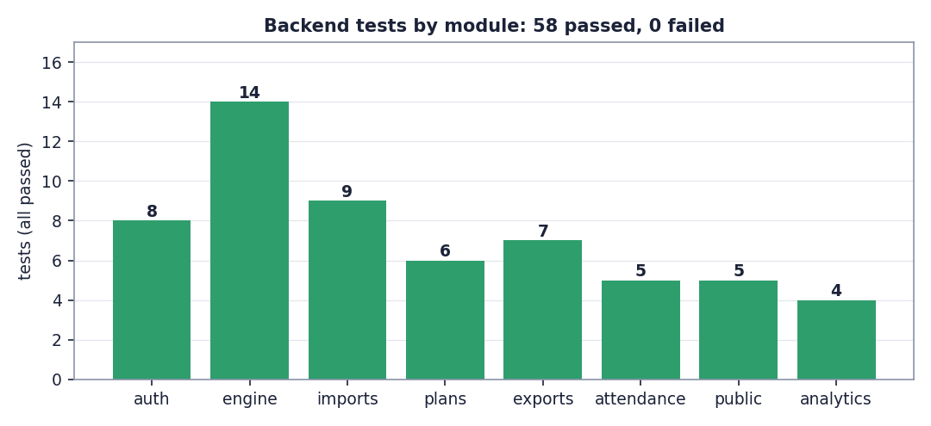
Fig. 7.1: Backend tests by module

7.2 Unit Tests
The engine tests (14) exercise the smallest units and the rules they implement, without a database.
Table 7.2: Unit-level checks (test_engine.py)
Unit under test | Checks
Seat labels | Labels round-trip, including multi-letter rows (A1 ... AA1)
Seat graph | Neighbours respect aisles and blocked seats; colour classes never touch, for 4 and 8 neighbours
Roll numbers | Parsing into prefix and number; the gap rule; a custom gap is honoured
Engine | Every hard rule is met; the same seed reproduces the plan; different seeds give different plans; 4-neighbour and balanced fill work; compact uses fewer halls
Pre-checks | Impossible inputs are explained: too few seats, a paper larger than the ceiling, too few accessible seats
Validator | Catches every kind of violation it is designed to catch
Baselines | Roll-order seating creates conflicts that the engine avoids

7.3 Integration Tests
The remaining tests call the real API through FastAPI's test client with the sample workbook imported, so they cover routers, services, database and file generation together.
Table 7.3: Integration tests
Test file | Tests | What is covered
test_auth.py | 8 | Health; sign-in and /me; wrong password; protected routes need a token; registration waits for approval, duplicates are refused, an administrator approves; invigilators cannot manage the team; the last administrator cannot be disabled; default rules and rule validation
test_imports.py | 9 | Templates and samples download; candidates without courses are refused; the sample workbook imports cleanly (908 candidates, 49 courses, 14 halls, 6 sittings); re-import updates instead of duplicating and a batch cannot be applied twice; row-level errors with row numbers; hall layout errors; timetable clash and split paper group; unreadable files; invigilators cannot import
test_plans.py | 6 | A generated plan meets every rule and avoids more than 500 conflicts, with invigilators assigned; same seed gives the same result and Verify confirms it; publishing archives the previous version and published plans cannot be deleted; hall map, illegal swap refused with a reason, legal swap applied and audited, fingerprints updated; invigilators see only their halls; an impossible request explains why and is audited
test_exports.py | 7 | Seating charts, invigilator sheets and QR slips are valid PDFs with one chart page per hall; single-hall chart; hall-lists workbook with one sheet per hall and a complete roll-ordered door list; attendance workbook; invigilators cannot export everything
test_attendance.py | 5 | My halls; marking and scanning (URL and lower-case roll number, already present); scanning a candidate of another hall says where they sit; submit needs everyone marked, locks the register and only administrators reopen; unassigned halls are forbidden
test_public.py | 5 | Lookup shows published seats only, a shortened name and no private fields; unknown ID and unpublished plan; slip PDF and QR PNG; home-page benchmark summary; rate limiting (429)
test_analytics.py | 4 | Overview figures match the plan; plan analytics add up; the benchmark and its charts are served and path tricks are refused; invigilators cannot see analytics

In total the suite has 8 + 14 + 9 + 6 + 7 + 5 + 5 + 4 = 58 tests. On 15 October 2026 all 58 passed; the slowest test (the same seed giving the same plan, with Verify) takes 7.1 s.

7.4 Functional Testing: the Scripted Scenario
The scenario script performs the definition-of-done flow through the API of a running installation and stops at the first failure. It was run on 15 October 2026 against an empty database.
Table 7.4: Scripted scenario results
Step | Action | Result
1 | Import the sample workbook | Validation passed: 1,020 rows, 10 warnings; imported 908 candidates, 49 courses, 14 halls, 6 sittings
2 | Generate and publish plans for three sittings | Mon 12 Oct 2026 Morning: 451 candidates in 6 halls, 0 same-paper neighbours, 1,099 avoided, 2.1 s; Mon 12 Oct 2026 Afternoon: 457 candidates in 7 halls, 0 same-paper neighbours, 1,175 avoided, 1.8 s; Tue 13 Oct 2026 Morning: 451 candidates in 7 halls, 0 same-paper neighbours, 1,105 avoided, 2.2 s
3 | Try an illegal swap (A1 to A2) | Blocked: the candidate would sit next to a neighbour who writes the same course (reason shown)
3 | Download outputs | seating-charts.pdf 135 KB; invigilator-sheets.pdf 147 KB; qr-slips.pdf 1,666 KB; hall-lists.xlsx 47 KB; attendance.xlsx 28 KB
4 | Seat lookup and QR slip | BMG24064 (Zoe A.) sits in EW-205 seat A2; slip PDF of 64 KB downloaded
4 | Attendance as an invigilator | Two candidates marked present in EW-205 (2 present, 72 to mark)
 | Whole scenario | Passed in 11.4 s

7.5 Security Testing
Security behaviour is covered by the authentication, public and analytics tests and by the scenario.
Table 7.5: Security checks
Check | Observed
Wrong password | 401 with a readable message; no token
Protected routes without a token | 401
Pending account sign-in | 403 explaining that approval is awaited
Duplicate registration | Refused
Invigilator calling administrator endpoints (import, team, analytics, full exports) | 403
Invigilator opening an unassigned hall | 403
Demoting or disabling the last administrator | 409, refused
Public lookup response | Published seats only; shortened name; no e-mail or date of birth
Public lookup flood | 429 after 30 requests in a minute from one client (observed during measurement on 15 October 2026)
Path tricks on served chart files | Refused

Not performed: a penetration test, a dependency vulnerability audit and HTTPS configuration. These are deployment tasks and are listed under future scope.

7.6 Validation and Edge Cases
Edge cases were tested by the suite and by deliberate requests to the running system. Two of the latter are recorded here verbatim, because they show what a user sees.
Table 7.6: Edge cases and validation
Case | System behaviour
Too few seats | 422: A plan could not be generated: 457 candidates but only 424 usable seats in the selected halls. Select halls with at least 33 more seats.
A paper larger than the ceiling | 422 with, for each paper, the number of candidates and the most that the halls can seat without neighbours writing it (for example 73 candidates but at most 18 in two small halls), advising more halls or 4-neighbour adjacency
Bad import file (3 rows) | Status failed: roll number appears more than once; unknown department XXX; unknown course code ACF-999; needs_accessible_seat must be yes or no, not 'maybe' - each with its row and column
Illegal seat move | 409 with reasons such as would sit next to ... both write ACF-101
Timetable clash | Error: two papers of one sitting taken by the same candidates are named with the number of candidates affected
Split paper group | Error: courses sharing a paper must be in the same sitting
Submitting an incomplete register | 409 while anyone is unmarked
Deleting a published plan | Refused
Re-applying an import batch | Refused; the batch is applied once
Roll gap 0, 4-neighbour mode | Benchmark scenarios m-600-gap0 and m-600-adj4 were solved with every hard rule met
Seat label arithmetic | Round-trips through A1 ... AA1

7.7 Performance Testing
Solve time was measured by the engine benchmark (Chapter 8). API latencies were measured on 15 October 2026 against the development server on the benchmark machine with the sample data loaded: thirty calls per endpoint after one warm-up (five for the file downloads and Verify, twenty for the public lookup, which is rate-limited to thirty requests a minute).
Table 7.7: API response times
Endpoint | Median (ms) | 95th percentile (ms)
GET /health | 1.9 | 2.6
GET /data/summary | 4.0 | 4.6
GET /plans/1 | 4.1 | 4.7
GET seat map (hall) | 7.2 | 10.8
GET swap-check (one seat) | 8.0 | 11.4
GET /candidates?q=ACF | 9.3 | 12.9
GET /sessions | 10.7 | 12.1
GET public lookup | 2.8 | 3.2
GET seating-charts.pdf | 96.0 | 96.0
GET hall-lists.xlsx | 314 | 354
GET qr-slips.pdf | 3,208 | 3,236
POST verify plan | 2,178 | 2,191

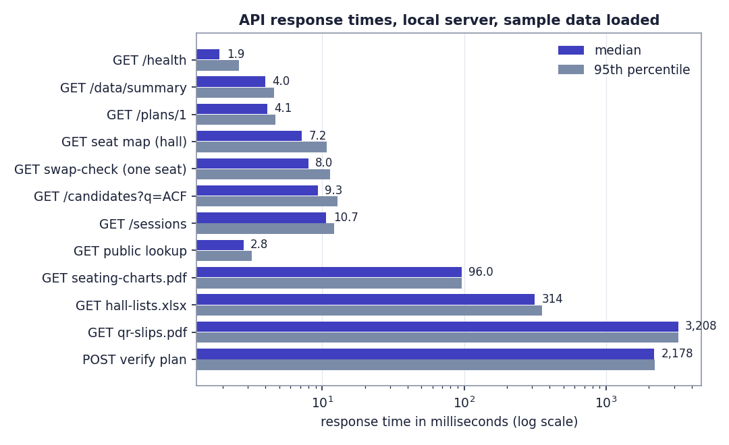
Fig. 7.2: API response times on a logarithmic scale
Interactive endpoints answer in 2 to 11 ms. File generation is slower, as expected: the QR-slip PDF (76 pages for the first plan) takes 3.2 s, and Verify, which re-runs the engine, takes 2.2 s. Not measured: memory use, behaviour under many simultaneous users, and other hardware.

7.8 User Acceptance Testing
User-acceptance testing with real users was not carried out. The interface was exercised by the team through the scripted scenario, automated tests and walkthroughs of the screens (recorded in the project's testing notes for desktop, tablet and phone widths and for the light and dark themes; for this report the screens were re-captured at 1440 x 900). This is a limitation: the team cannot yet say how examination staff or invigilators will find the product. Collecting that feedback, and piloting the system on a real anonymised sitting, is the first item of future work.

7.9 Limits of the Testing Done
- All test data is synthetic; real examination data may contain cases that the generator does not.
- The front end has no automated component or end-to-end test suite; it is checked by a strict type check, a production build and manual walkthroughs.
- The benchmark was run once on one machine; variation between machines and between runs was not studied beyond three seeds.
- No load, memory, security-penetration or accessibility-audit tests were carried out.
- The 58 tests check behaviour that the team thought of; they cannot prove the absence of defects.

CHAPTER 8
RESULTS AND OUTPUT SCREENS

8.1 Output Screens
All screens below are real captures of the running application at 1440 x 900 with the sample dataset imported, three plans published and attendance marked for one hall. Nothing is mocked up. The same screens are described in the user guide.
The public front page: a hero with an example seat grid, the Get started and Find my seat actions, and the headline results of the engine benchmark read from the stored run: 1,253 same-paper neighbours avoided in a 600-candidate sitting compared with roll order, 2.36 s to seat 600 candidates (2,000 take 4.8 s), a roll-to-seat correlation of 0.065, and 24 benchmark runs, every one meeting every hard rule.
Email and password sign-in, with Demo workspace buttons for the exam controller and the invigilator, and links to request an account and to find a seat without signing in.
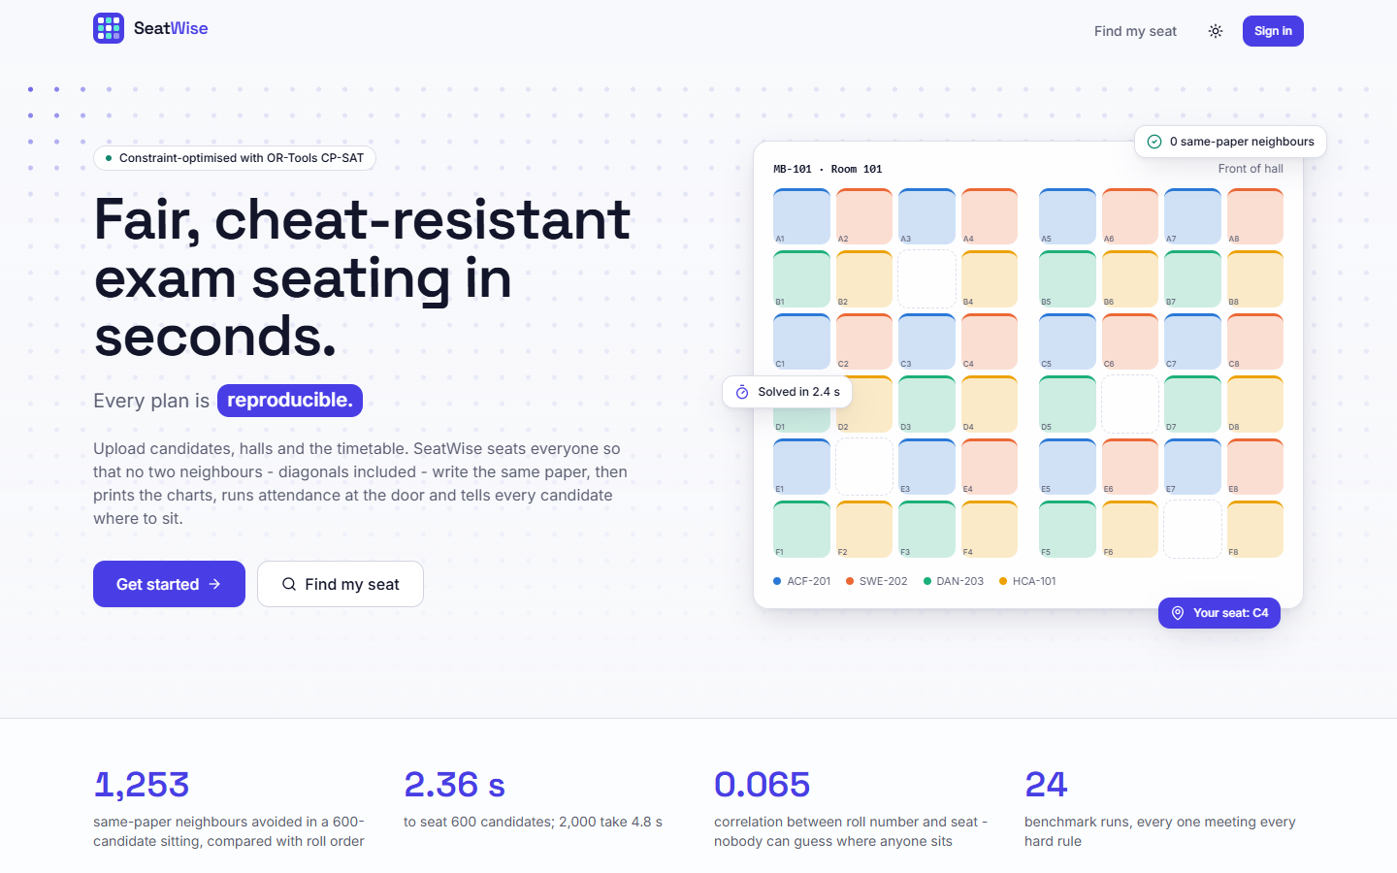  Fig. 8.1: Public home page | 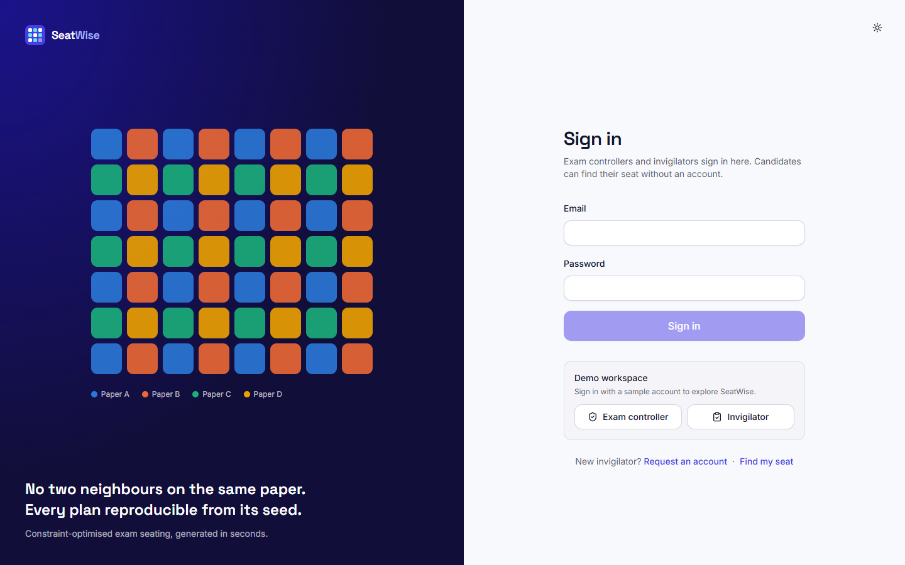  Fig. 8.2: Sign-in page

The hero tile shows 3,379 same-paper neighbours avoided across three published sittings compared with roll-order seating (remaining: 0). The tiles show 1,359 candidates seated, 3 of 6 sittings published, an average solve time of 2.0 s (slowest 2.2 s), attendance at 95% (57 present, 3 absent, 1,299 still to mark), 100% of plans meeting every rule, and 14 halls, 7 of them used. The charts show attendance by sitting and solve time per plan.
Validation passed: 1,020 of 1,020 rows are valid with 10 warnings. The sheet summaries show 49 courses, 14 halls (10 warnings), 908 candidates and 49 timetable rows. The problems table lists each warning with its sheet, row and column; here every warning says that no accessible seats were given and the front-row seats A1 and A2 were used. Nothing is saved until Import is pressed.
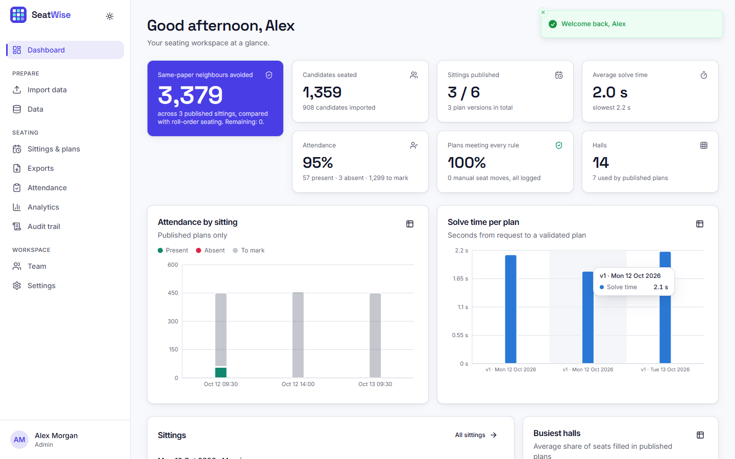  Fig. 8.3: Administrator dashboard after three plans and one register | 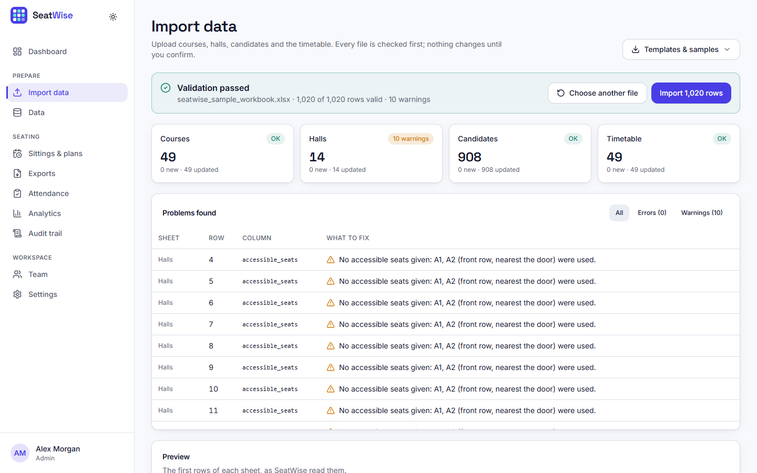  Fig. 8.4: Validation report for the sample workbook

The six sittings of the sample timetable with their candidates, papers and plan status: three are published, three show Plan seating.
Version 1 of Mon 12 Oct 2026 (morning), published, with its seed. The scorecard shows 0 same-paper neighbours, 0 roll-gap violations, 1,099 conflicts avoided compared with roll order, accessible seating honoured for everyone who needs it, a solve time of 2.1 s, and 6 halls used with 92% of their seats filled. The halls table lists seats used, papers and the assigned invigilator of each hall.
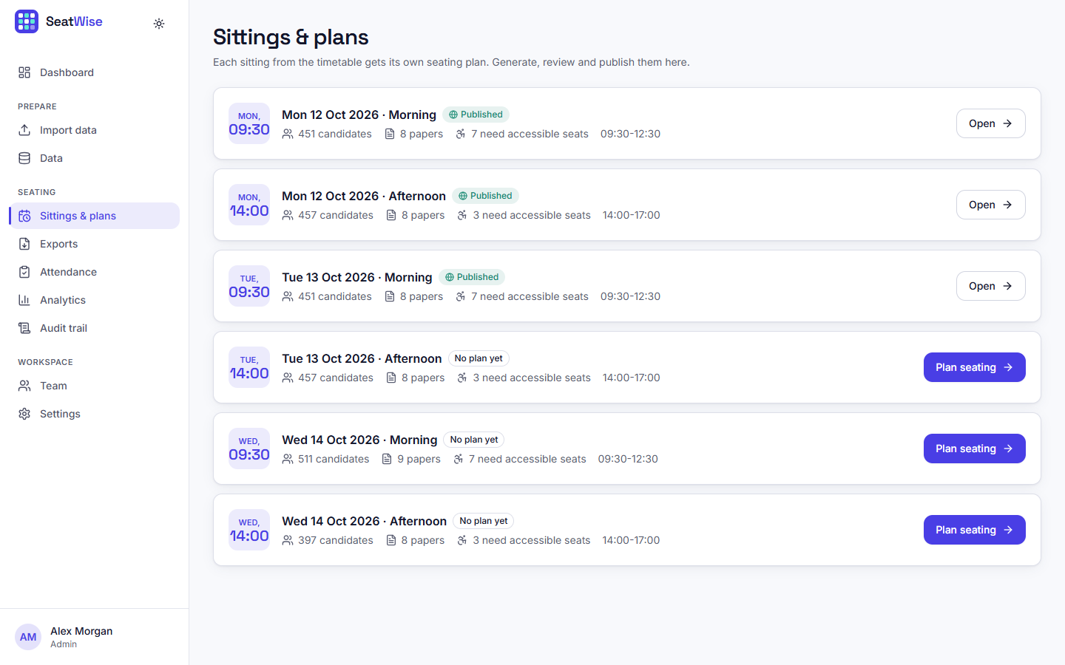  Fig. 8.5: Sittings and plans | 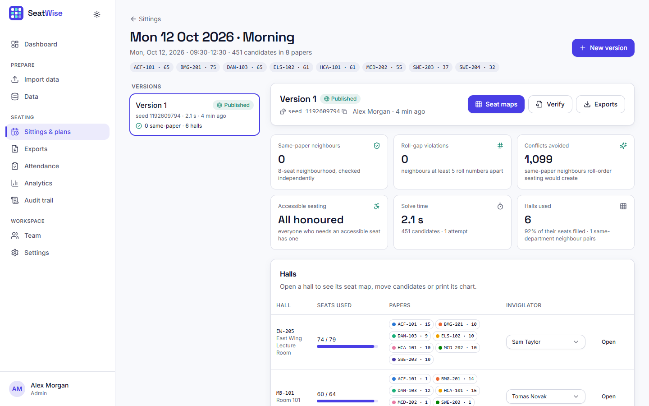  Fig. 8.6: Plan page with scorecard

Running the engine again with the stored seed on unchanged data gives an identical result: the stored engine result and the recomputed one have the same hash, so the plan was not hand-picked.
After picking up the candidate on seat A1, every other seat is outlined green (the move keeps every rule) or red (it does not). The side panel names the candidate being moved and shows the verdict for the seat under the pointer.
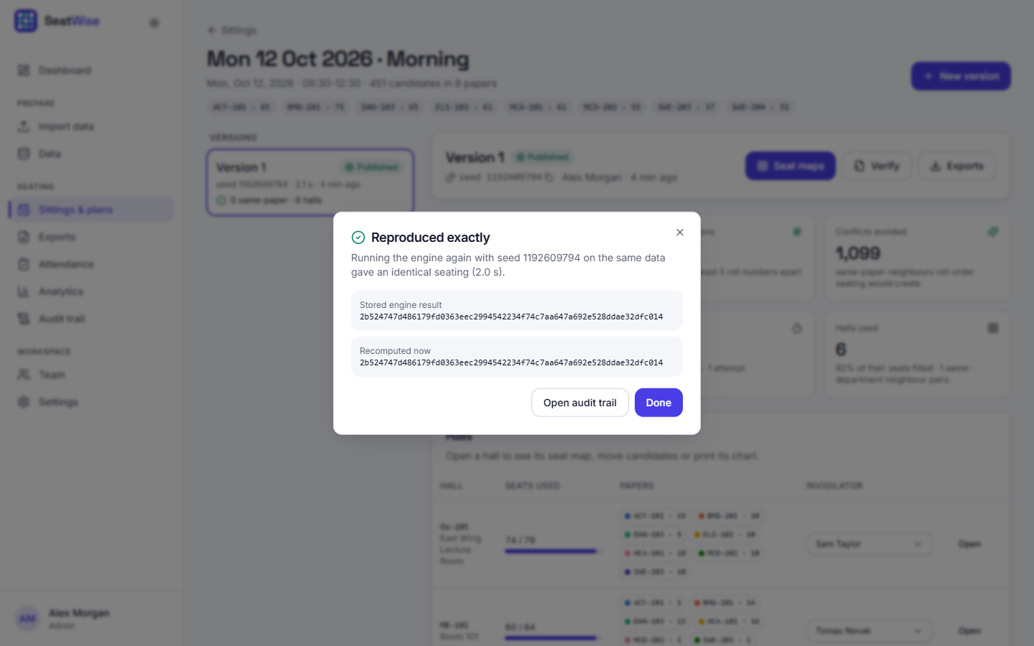  Fig. 8.7: Verify: reproduced exactly | 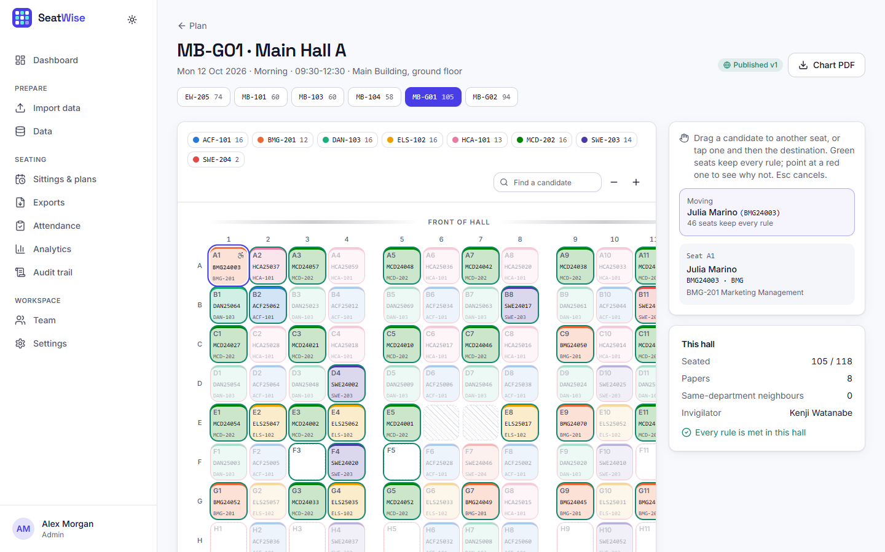  Fig. 8.8: Seat map with a candidate picked up

Dropping the candidate on a red seat is refused. The message reads: HCA25059 would sit next to HCA25037 (A2) - both write HCA-101. The refusal is the live rule check working on the same code as the engine.
A plan and a hall (or all halls) are chosen, and five files can be downloaded: seating charts (PDF), hall-wise lists (Excel), invigilator sheets (PDF), seat slips with QR codes (PDF) and the attendance report (Excel).
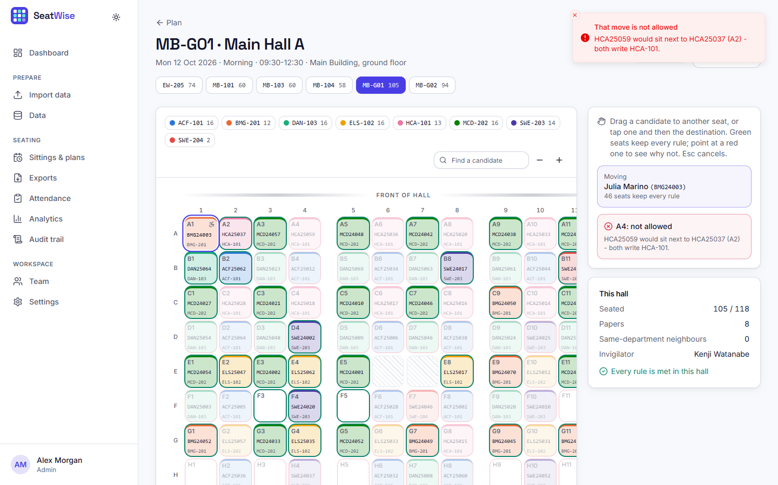  Fig. 8.9: An illegal move is refused with the reason | 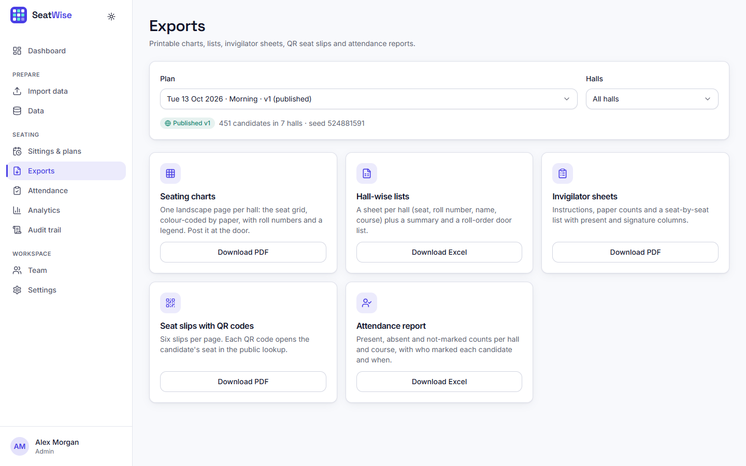  Fig. 8.10: Exports page

The benchmark as seen by the administrator: 100% of plans satisfy every hard rule across 8 scenarios and 3 seeds, 2.4 s for 600 candidates, 1,253 conflicts avoided compared with roll order, and a roll-to-seat correlation of 0.06, with charts of solve time by session size and same-paper pairs by method.
A filterable, append-only log: plan versions with their seeds and results, publications, downloads and verifications, each with the person, the time and a link to the plan.
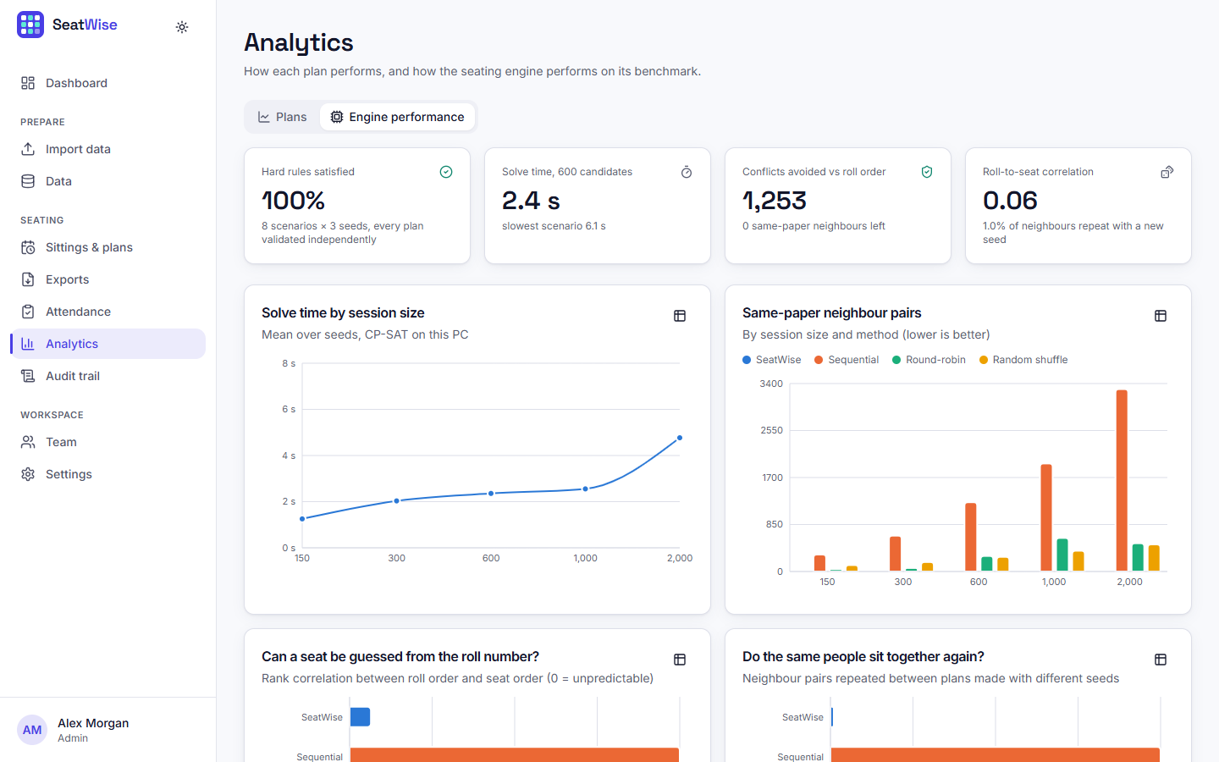  Fig. 8.11: Analytics: engine performance | 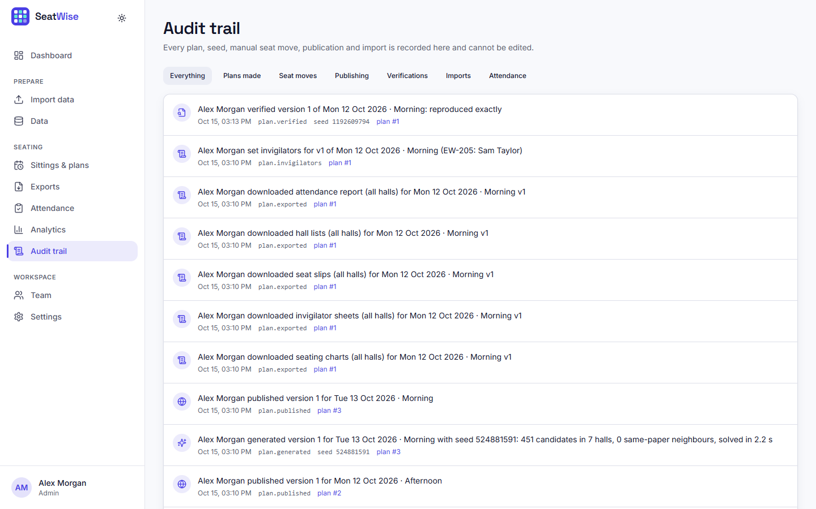  Fig. 8.12: Audit trail

For candidate BMG24003 the page greets "Julia M." (a shortened name), shows the sitting, the course, the hall, the seat A1 and a mini map of the hall with the seat marked, and offers the seat slip (PDF) and the QR code. No e-mail or date of birth is shown.
Counters for present (57), absent (3) and to mark (14); a scan or type box; filters and search; a Present and an Absent button for every seat; and a bottom bar with Mark remaining absent and Submit (enabled only when everyone is marked).
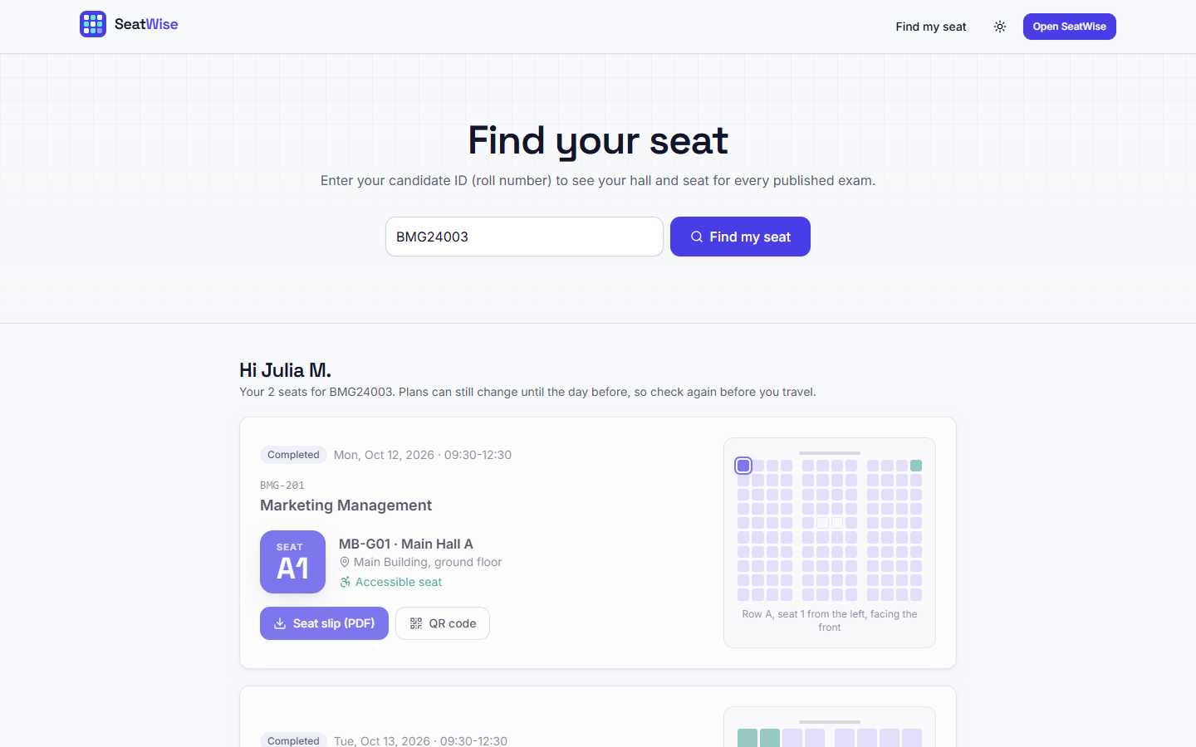  Fig. 8.13: Seat lookup result | 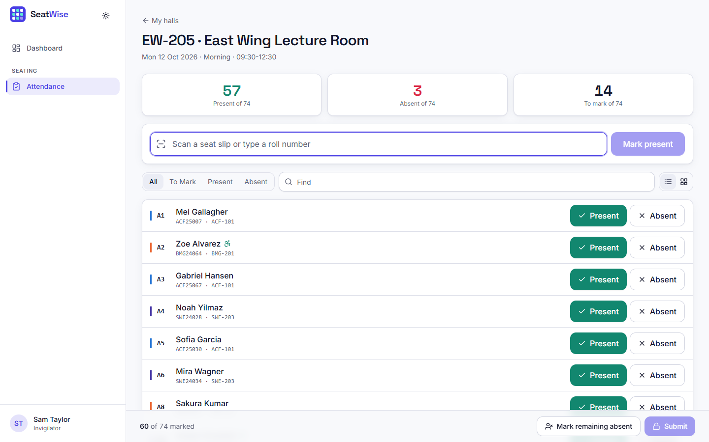  Fig. 8.14: Tablet attendance: list view

One landscape page per hall: the grid colour-coded by paper with roll numbers and course codes, the paper legend with counts, the invigilator, and a footer with the plan version, the seed and the seating fingerprint.
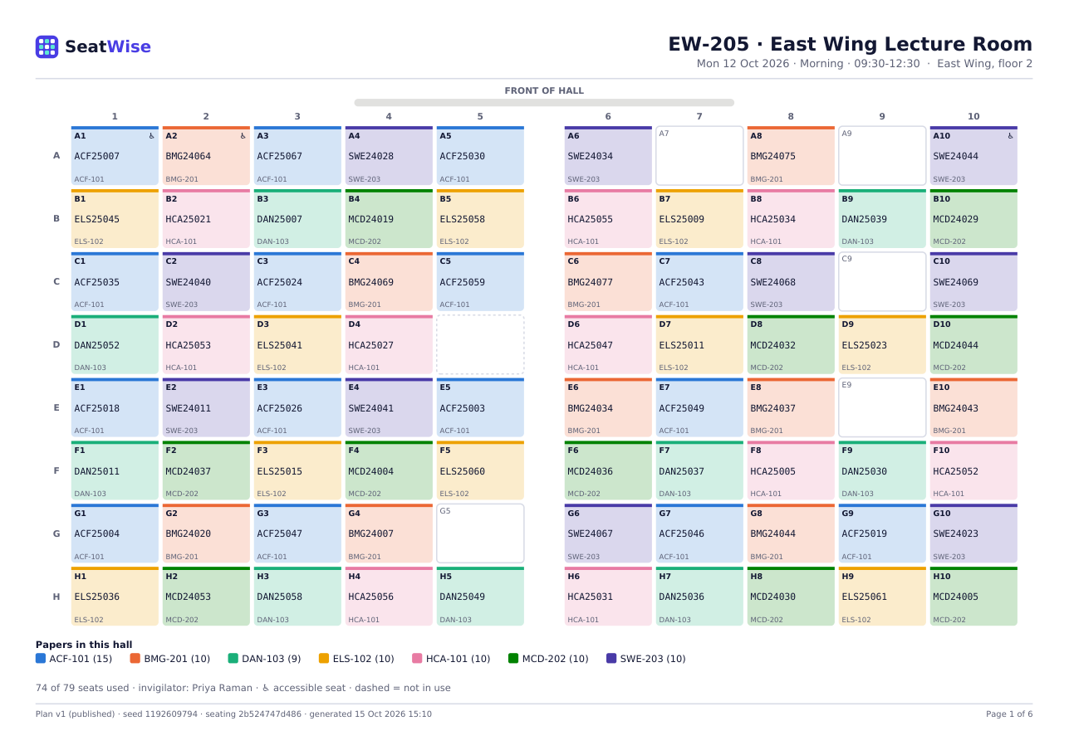
Fig. 8.15: Generated seating chart (PDF, hall EW-205)

8.2 Engine Performance (Benchmark Results)
Because nothing is trained, the usual measures of a learned model (accuracy, precision, recall, F1, a confusion matrix) do not exist for SeatWise, and we do not report invented substitutes. The engine is evaluated by benchmarking: it is run on seeded synthetic sittings, every plan is validated independently, and the results are compared with the three ways in which seating is usually done. The run engine-benchmark-20260921 took place on 21 September 2026 on a 12-thread Intel desktop with Windows 11, Python 3.11.9 and OR-Tools 9.15.6755. It covers 8 scenarios, 4 methods and 3 seeds (11, 12, 13), plus predictability over 6 seeds (21 to 26) and budget tuning on two scenarios.
Table 8.1: Measures used in the benchmark
Measure | Meaning | Target
Same-paper neighbour pairs | Neighbouring seats (8 around each seat) whose candidates write the same paper | 0
Roll-gap violations | Neighbours whose roll numbers (same prefix) are closer than the gap | 0
Accessible seats missed | Candidates needing an accessible seat who are not on one | 0
Hard rules met | Share of plans with all of the above at 0 and everyone seated | 100%
Solve time | Wall-clock seconds from request to a validated plan | seconds
Same-department pairs | Neighbours from one department (a preference, minimised) | low
Roll-to-seat correlation | Spearman correlation between roll order and seat order | about 0
Repeated neighbour pairs | Share of neighbour pairs that recur when the plan is regenerated with another seed | as low as random
Front-row bias | Largest gap between a department's share of front-row seats and its share of candidates | small

The three baselines are sequential (roll-number order, row by row, the classic spreadsheet plan), round-robin (papers interleaved in a repeating cycle, the usual improved manual plan) and random shuffle (a random permutation with no rules).

8.2.1 Headline results
Table 8.2: Headline benchmark results
Result | Value
Plans meeting every hard rule (SeatWise) | 24 of 24 (100%); baselines: 0 of 72
Same-paper neighbours, SeatWise | 0 in every run
Same-paper neighbours, sequential seating (600 candidates) | 1,253
Solve time, 600 candidates (mean) | 2.36 s
Solve time, 2,000 candidates (mean) | 4.77 s
Slowest SeatWise run in the benchmark | 6.14 s (4-neighbour mode)
Roll-to-seat correlation | 0.065 (sequential 1.000)
Neighbour pairs repeated with a new seed | 1.0% (sequential and round-robin 100%)

8.2.2 SeatWise in every scenario
Table 8.3: SeatWise results by scenario (mean of 3 seeds)
Scenario | Candidates | Solve (s) | Same-paper | Roll-gap | Accessible missed | Same-dept pairs | Halls | Seats filled
xs-150 | 150 | 1.25 | 0 | 0 | 0 | 23 | 3 | 71%
s-300 | 300 | 2.03 | 0 | 0 | 0 | 7 | 5 | 82%
m-600 | 600 | 2.36 | 0 | 0 | 0 | 109 | 9 | 96%
l-1000 | 1,000 | 2.55 | 0 | 0 | 0 | 190 | 12 | 96%
xl-2000 | 2,000 | 4.77 | 0 | 0 | 0 | 597 | 28 | 97%
m-600-adj4 | 600 | 6.02 | 0 | 0 | 0 | 12 | 9 | 96%
m-600-gap0 | 600 | 2.31 | 0 | 0 | 0 | 108 | 9 | 96%
m-600-gap10 | 600 | 2.42 | 0 | 0 | 0 | 104 | 9 | 96%

8.2.3 Baselines in every scenario
Table 8.4: Violations left by the baselines (mean of 3 seeds; every baseline run failed at least one hard rule)
Scenario | Same-paper: seq. | round-robin | random | Roll-gap: seq. | round-robin | random | Accessible missed (seq.)
xs-150 | 307 | 41 | 116 | 122 | 44 | 21 | 3
s-300 | 648 | 63 | 171 | 231 | 56 | 21 | 3
m-600 | 1,253 | 281 | 265 | 453 | 198 | 23 | 6
l-1000 | 1,954 | 607 | 376 | 755 | 408 | 21 | 11
xl-2000 | 3,299 | 511 | 490 | 1,528 | 351 | 18 | 16
m-600-adj4 | 704 | 216 | 145 | 453 | 166 | 12 | 6
m-600-gap0 | 1,253 | 281 | 265 | 0 | 0 | 0 | 6
m-600-gap10 | 1,253 | 281 | 265 | 921 | 252 | 48 | 6

The baselines fill halls in the order given, so they sometimes use one more hall than SeatWise's compact strategy. In the gap-0 scenario the baselines have no roll-gap violations because the rule is switched off, but they still leave same-paper neighbours and accessible-seat misses.
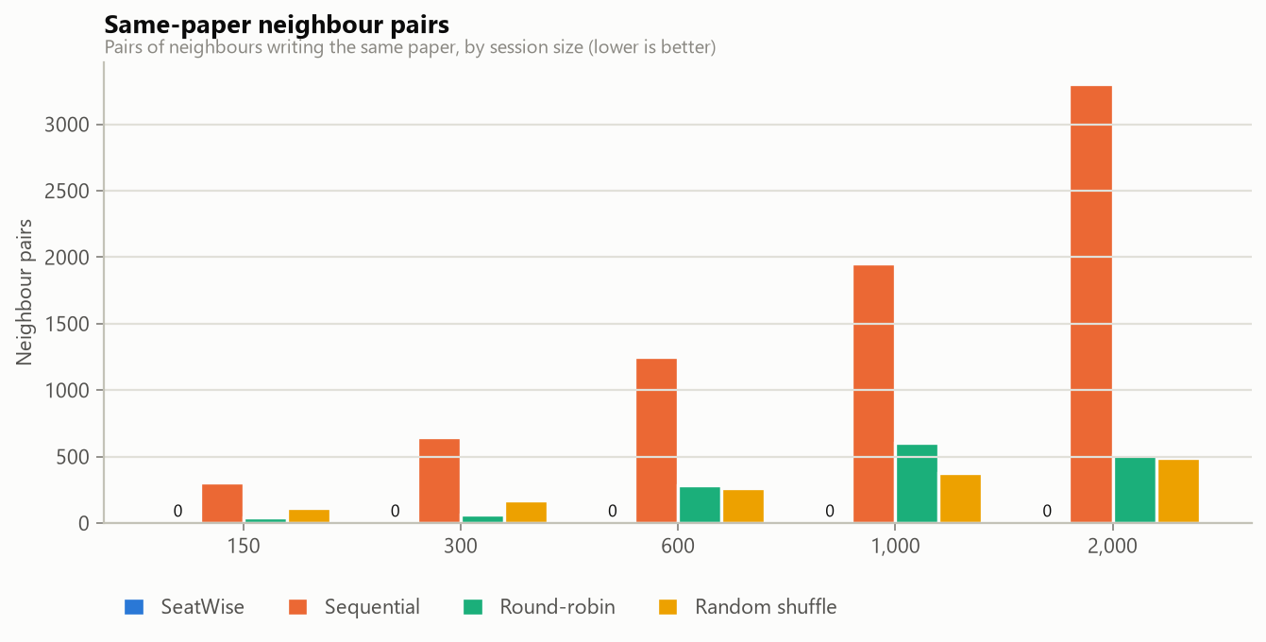
Fig. 8.16: Same-paper neighbour pairs by method and sitting size
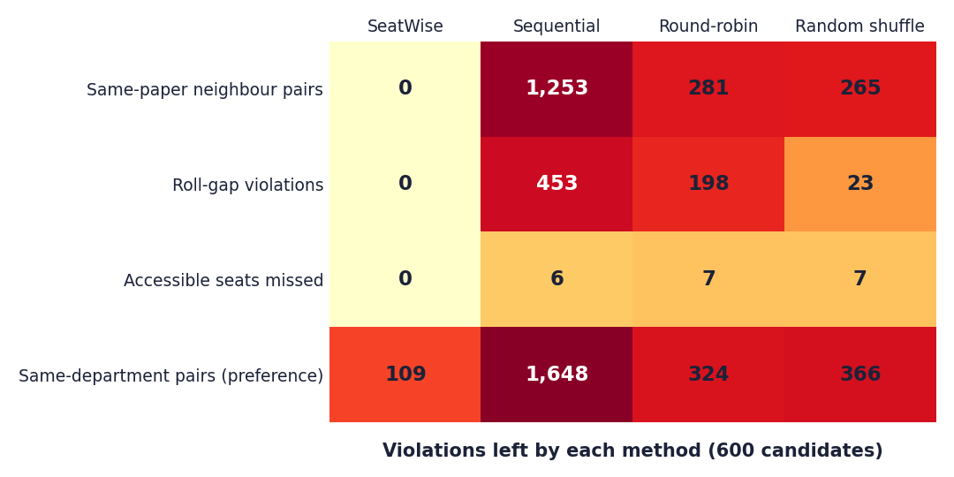
Fig. 8.17: Violations left by each method at 600 candidates (the equivalent of a confusion matrix for an optimisation engine)
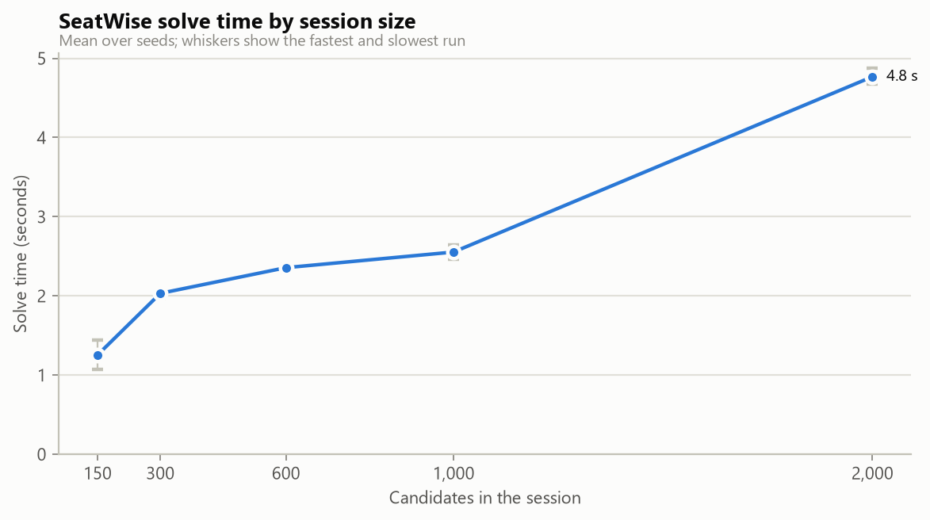
Fig. 8.18: Solve time by sitting size

8.2.4 Unpredictability and fairness
Table 8.5: Unpredictability of each method (600 candidates, 6 seeds)
Method | Roll-to-seat correlation | Repeated neighbour pairs | Front-row bias (percentage points)
SeatWise | 0.065 | 1.0% | 4.7
Sequential | 1.000 | 100% | 12.4
Round-robin | 0.213 | 100% | 3.4
Random shuffle | 0.034 | 1.0% | 1.6

SeatWise is as unpredictable as a pure random shuffle: neighbours almost never repeat, and roll order says nothing about the seat. Unlike the shuffle it keeps every rule. Its front-row bias is small but higher than a shuffle's, because a paper occupies one colour class per hall and only two of the four classes include the front row; which paper gets which class is itself random, so the bias shrinks as more plans are drawn.
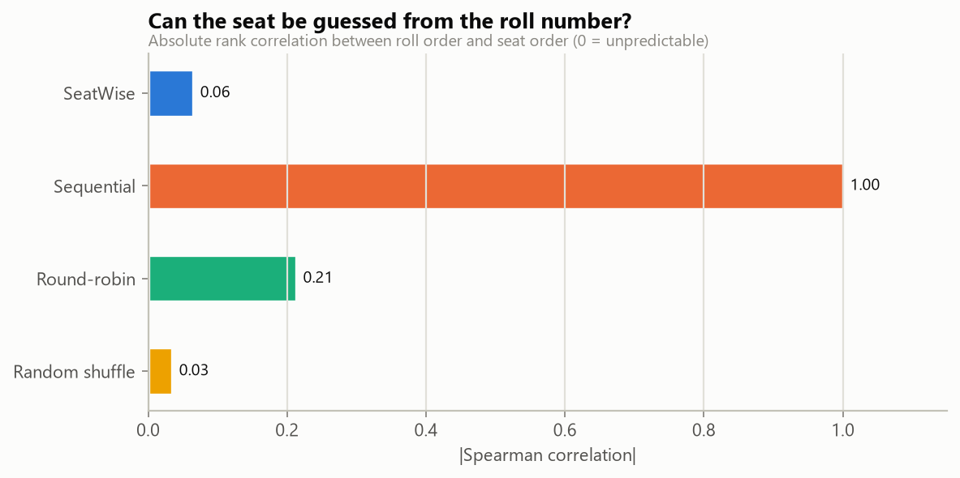
Fig. 8.19: Roll-to-seat correlation by method
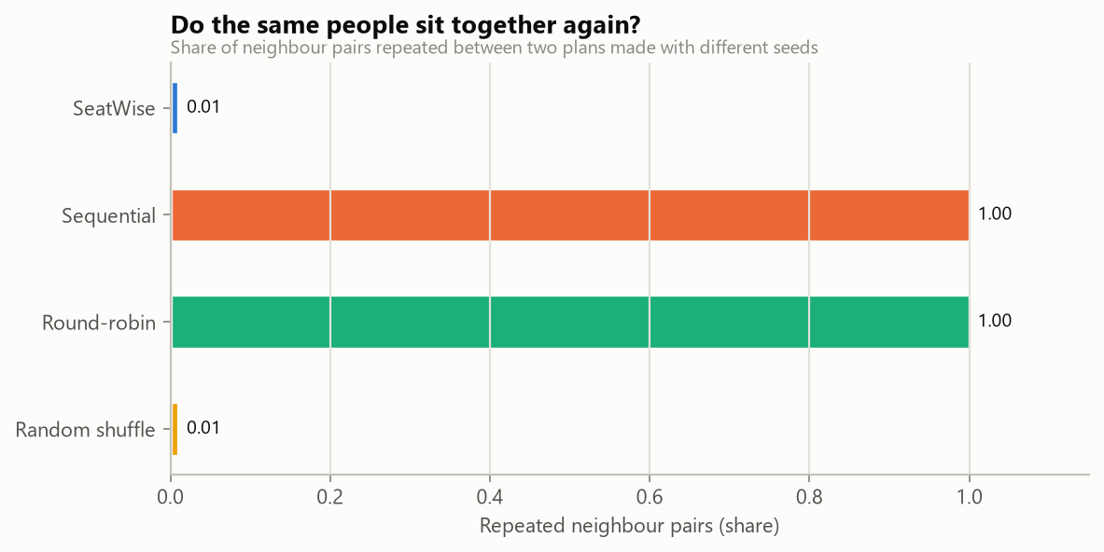
Fig. 8.20: Neighbour pairs repeated across seeds
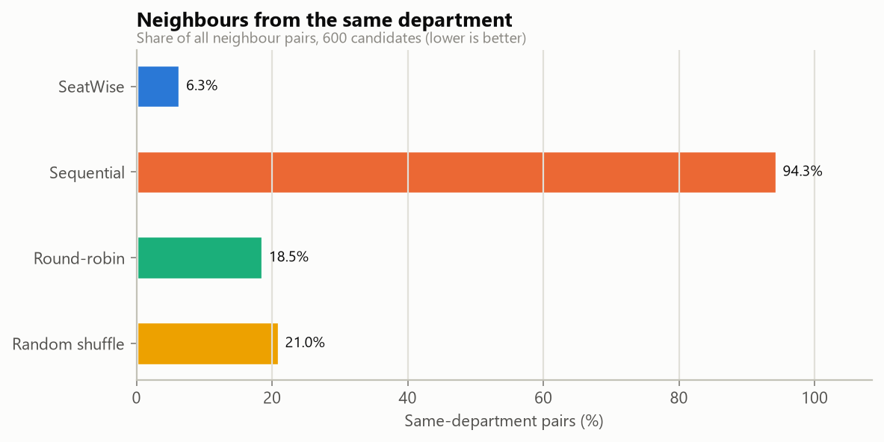
Fig. 8.21: Department mix by method
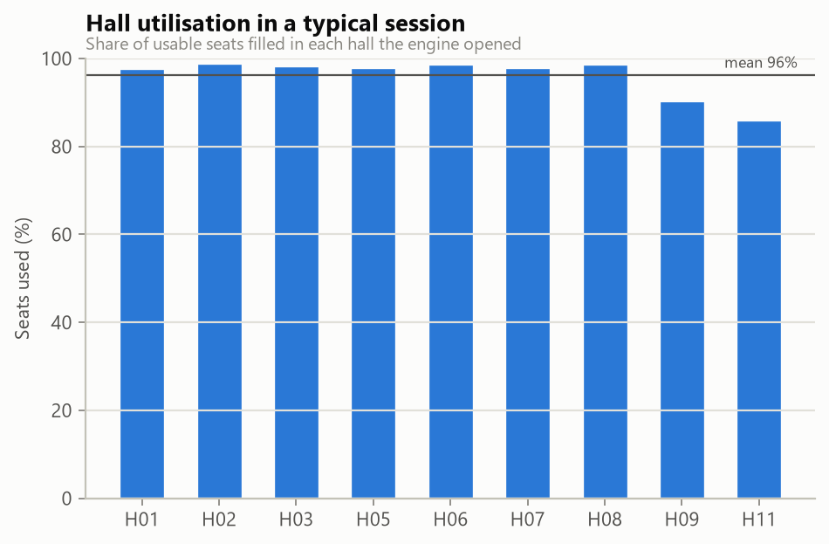
Fig. 8.22: Hall utilisation by method

8.2.5 Observations
- Correctness is structural. Stage A confines each paper to one colour class per hall, and seats of one class are never neighbours, so same-paper neighbours are impossible before Stage B starts. This is why no run has any.
- Four-neighbour adjacency is slower (6.0 s against 2.4 s for 600 candidates) because its two classes each cover half the hall, so Stage B has twice as many seat choices per candidate; it also gives far fewer same-department neighbours (12 against 109).
- Scaling is close to linear in the number of halls: halls are solved in parallel and most of the time goes to the deterministic per-hall budget.
- Reproducibility. Re-running with the stored seed reproduces the plan exactly; the Verify action and the test suite both check this.
- Department mix is a preference, not a rule: SeatWise leaves 109 same-department pairs at 600 candidates against 1,648 for sequential seating.

8.3 Product Measurements
The product was also measured through its own interface and API on 15 October 2026. Three sittings of the sample timetable were planned with random seeds, each solved in about two seconds, with no rule violated.
Table 8.6: Plans generated in the demonstration scenario
Sitting | Candidates | Halls | Same-paper pairs | Conflicts avoided vs roll order | Solve (s)
Mon 12 Oct 2026 Morning | 451 | 6 | 0 | 1,099 | 2.1
Mon 12 Oct 2026 Afternoon | 457 | 7 | 0 | 1,175 | 1.8
Tue 13 Oct 2026 Morning | 451 | 7 | 0 | 1,105 | 2.2

For plan 1 the scorecard recorded 451 candidates in 6 halls with 92% of their seats filled, 0 same-paper neighbours, 0 roll-gap violations, no accessible seat missed and 1 same-department neighbour pair; the roll-order baseline for the same sitting had 1,099 same-paper pairs, 342 roll-gap violations and 7 accessible-seat misses. Stage A took 1.15 s and Stage B 0.97 s of the 2.1 s. API response times are in Chapter 7.

8.4 Comparison with the Base Paper
The comparison is qualitative, and the datasets differ. The base paper [1] reports no accuracy, no timing and no dataset: its only quantitative statement is a requirement that a batch of 100 students be allocated in under 3 seconds. SeatWise has not been run on the base paper's data, and the base paper's system was not available to us to run on ours, so a numerical head-to-head is not possible. What we can do is compare the two on what they do, and compare SeatWise with the closest proxy for the base paper's method that we could measure, our round-robin baseline, which interleaves papers in a repeating cycle much as the zipper interleaves two subject lists. The round-robin baseline is not a re-implementation of the base paper.
Table 8.7: SeatWise compared with the base paper
Aspect | Base paper [1] | SeatWise
Reported performance | Target: 100 students in under 3 s; no measurement reported | 2.4 s at 600 candidates; 4.8 s at 2,000 (measured)
Rules guaranteed | Subject alternation in a line; optional branch rule; blocked seats | No same-paper neighbours in 8 or 4 directions; roll gap; accessible seats; capacity
Violations at 600 candidates (our benchmark) | Not measured. Closest proxy, round-robin: 281 same-paper pairs, 198 roll-gap violations | 0 and 0 in every run
Predictability | Fixed pattern (the proxy repeats 100% of neighbour pairs) | 1.0% repeated pairs; correlation 0.065
Reproducibility and audit | Not described | Seed, fingerprints, Verify, audit trail
Live editing | Future work (drag and drop) | Implemented, with live rule checks
Attendance | Future work | Implemented (tablet register, scan, lock)
Tests | Not described | 58 automated tests; benchmark

In short: where the base paper stops at generating and displaying a seating pattern, SeatWise guarantees the rules, measures its own behaviour and covers the examination-day workflow. Whether those advantages matter to a real examination cell is something only a pilot can show.

8.5 Sample Inputs and Outputs

8.5.1 Sample inputs
These are the first rows of the committed sample files.
Table 8.8: courses.csv
course_code | course_name | department_code | department_name
ACF-101 | Principles of Accounting | ACF | Accounting & Finance
ACF-102 | Business Mathematics | ACF | Accounting & Finance

Table 8.9: candidates.csv (e-mail and date of birth columns omitted)
roll_no | full_name | department_code | course_codes | needs_accessible_seat
ACF24001 | Camila Kaur | ACF | ACF-201;ACF-202;ACF-203 | no
ACF24002 | Gabriel Rao | ACF | ACF-201;ACF-202;ACF-204 | no

Table 8.10: halls.csv
hall_code | hall_name | building | floor | rows | columns | blocked_seats | accessible_seats | aisles
MB-G01 | Main Hall A | Main Building | Ground | 10 | 12 | E6;E7 | A1;A12 | 4;8
MB-101 | Room 101 | Main Building | 1 | 8 | 8 |  |  | 4

Table 8.11: timetable.csv
session_date | start_time | end_time | course_code | paper_group
2026-10-12 | 09:30 | 12:30 | ACF-101
2026-10-12 | 09:30 | 12:30 | BMG-201

8.5.2 Sample outputs
Plan scorecard (plan 1, seed 1192609794, engine 1.0.0, per-hall budget 0.15):
Table 8.12: Scorecard of a generated plan
Measure | SeatWise plan | Roll-order baseline for the same sitting
Candidates seated | 451 in 6 halls (92% of their seats) | 451
Same-paper neighbour pairs | 0 | 1,099
Roll-gap violations | 0 | 342
Accessible seats missed | 0 | 7
Same-department neighbour pairs | 1 | 1,194
Solve time | 2,118 ms (Stage A 1,151 ms, Stage B 965 ms, 1 attempt, 0 retries) | -

Refused seat move. This move is not allowed: HCA25059 would sit next to HCA25037 (A2) - both write HCA-101. (HTTP 409.)
Public lookup response (excerpt for BMG24003): the name is shortened to "Julia M.", and each published seat is returned with the sitting, the course (BMG-201, Marketing Management), the hall (MB-G01, Main Hall A, 10 rows by 12 columns, blocked seats E6 and E7, accessible seats A1 and A12, aisles after columns 4 and 8) and the seat (A1, row 0, column 0, accessible).

8.6 Analysis of Successful and Failure Cases

8.6.1 Successful cases
- Every one of 24 benchmark plans, in scenarios from 150 to 2,000 candidates, with 8 or 4 neighbours and roll gaps of 0, 5 and 10, met every hard rule.
- Three real sittings of the sample timetable were planned in 1.8 to 2.2 s each with no violation, and each plan reproduced exactly when verified.
- An illegal manual move was refused with a precise reason, and a legal move was applied, audited and re-fingerprinted.
- The end-to-end scenario (import, plan, export, lookup, attendance) passed in 11.4 s.

8.6.2 Failure and boundary cases
Table 8.13: Failure and boundary cases
Case | What happened | Assessment
Two small halls for a 457-candidate sitting | 422: 457 candidates but only 72 usable seats in the selected halls. Select halls with at least 385 more seats. The reply also named every paper larger than the halls' per-paper ceiling (for example 73 candidates but at most 18) | Correct refusal with an actionable reason; no plan was stored
Five large halls with too few seats | 422: 457 candidates but only 424 usable seats. Select halls with at least 33 more seats. | Correct; the pre-check catches it before any solving
Import file with errors | Status failed with four row-level errors (duplicate roll number, unknown department, unknown course, invalid yes or no) | Correct; nothing was imported
Front-row bias | SeatWise places departments on the front row less evenly than a random shuffle (4.7 against 1.6 percentage points) | A real weakness of the colour-class construction; documented
Four-neighbour mode | Solve time 6.0 s against 2.4 s for 600 candidates; the slowest benchmark run was 6.14 s | Acceptable for interactive use, but the slowest mode
Tight budget | A per-hall budget of 0.1 was slower overall (3.72 s) than 0.15 (2.63 s) because some halls were re-solved | Handled by the retry strategy; the tuned budget avoids it

8.7 Discussion of Limitations
- Synthetic data. Every number in this chapter comes from seeded synthetic sittings; real institutions' data may differ in paper sizes, hall shapes and roll-number formats.
- One machine, one run. The benchmark ran once on one desktop with three seeds per scenario. We did not study variation between machines, and we did not measure memory or concurrent use.
- No user study. The usability of the seat map, the attendance screen and the lookup page was not tested with real users.
- No accuracy-style metrics. Because nothing is trained, accuracy, F1 and confusion matrices do not exist; the benchmark measures rule violations and speed instead.
- Base-paper comparison is qualitative. The base paper reports no measurements; the round-robin baseline is a proxy, not a re-implementation.
- Front-row bias and 4-neighbour speed are known weaknesses, described above.

8.8 Objectives versus Outcomes
Table 8.14: Objectives against outcomes
Objective | Outcome | Evidence | Status
1 Automate seat allocation from uploaded data | Four file kinds imported and validated; plans generated in seconds | 1,020 rows imported; 2.4 s at 600 candidates | Met
2 Satisfy capacity, subject and roll-number constraints with optimisation | CP-SAT engine; every hard rule met | 24 of 24 benchmark plans; 3 of 3 demo plans | Met on synthetic data
3 Enforce anti-cheating spacing and randomise | 0 same-paper neighbours; seeded random choice | Correlation 0.065; 1.0% repeated pairs | Met, with a front-row bias of 4.7 points
4 Exportable charts and hall-wise reports | Five exports | Charts, sheets, slips (PDF); hall lists, attendance (Excel); tests | Met
5 Real-time seat lookup and attendance | Public lookup with QR slip; tablet register with lock | Scenario and tests; screens captured | Met in testing; no real-user trial
6 Reduce time and errors of manual preparation | Plan in seconds; rules guaranteed | 2.4 s; roll-order seating leaves 1,253 violations | Met for generation time and rule errors; time saved in a real cell not measured
Added: reproducible and auditable plans | Seeds, three hashes, Verify, audit trail | Verify reproduced exactly; tests | Met
Added: evaluate against manual methods | Benchmark with three baselines | 8 scenarios x 3 seeds | Met, with the limits above

CHAPTER 9
CONCLUSION

9.1 Summary of the Work
This project set out to replace the slow, error-prone and predictable preparation of examination seating with an intelligent, constraint-satisfying system. The result is SeatWise, a web application whose core is a two-stage OR-Tools CP-SAT engine: Stage A shares candidates between halls and gives each paper one colour class of the hall's seat grid, and Stage B lays out the seats of each hall with roll-number spacing, accessible seats and department mixing, using seeded random objectives so that the returned plan is a random member of the valid plans. An independent validator checks every plan before it is stored, and every plan records its seed and three SHA-256 fingerprints so that it can be reproduced and verified. Around the engine are a validated import, a seat map with live, explained editing, PDF and Excel outputs, QR seat slips, a public seat lookup, a tablet attendance register, analytics and an audit trail.

9.2 Objectives Achieved and Main Contributions
All six objectives of the project definition were achieved on the evidence available: seating is automated from uploaded data; capacity, subject and roll-number constraints are satisfied; spacing is enforced and seating is randomised; charts and hall-wise reports can be exported; seat lookup and attendance work in real time; and plan preparation takes seconds. Two added objectives, reproducibility and an honest evaluation, were also met. The qualifications are stated below. The main contributions are listed in the section on novelty and key contributions.

9.3 Key Findings
- Confining each paper to one colour class of a hall's seat grid makes same-paper neighbours impossible by construction, for any number of papers and for diagonal neighbours.
- On the benchmark, all 24 SeatWise plans met every hard rule, while none of the 72 baseline runs did. At 600 candidates roll-order seating leaves 1,253 same-paper pairs, round-robin 281 and a random shuffle 265; SeatWise leaves none.
- A 600-candidate sitting is seated in 2.4 s and a 2,000-candidate sitting in 4.8 s on a 12-thread desktop.
- Seeded randomisation within the valid set is as unpredictable as a random shuffle (correlation 0.065; 1.0% repeated pairs).
- The price of the construction is a front-row bias of 4.7 percentage points, and four-neighbour mode is slower (6.0 s).
- A deterministic budget, one worker per hall and SHA-256 sub-seeds make plans reproducible, which lets Verify prove that a plan was not hand-picked.
- 58 automated tests pass, and an end-to-end scenario of import, planning, export, lookup and attendance completes in 11.4 s.

9.4 Practical Applications
- Examination cells of colleges and universities preparing internal, semester and supplementary sittings.
- Schools and coaching institutes with multiple papers in one hall, where mixing papers is the usual anti-malpractice measure.
- Entrance and recruitment examinations that need fair, unpredictable and auditable seating, with a public seat lookup instead of notice boards.
- Any setting with grid seating and separation rules, such as lab slots or staggered sessions, by changing the rules rather than the engine.

9.5 Known Limitations
The evidence is from synthetic data, from one machine and from automated and scripted testing; no real examination cell or invigilator has used the system, so user acceptance is unknown. The front-row bias and the slower four-neighbour mode are known weaknesses of the design. The base paper reports no measurements, so the comparison with it is qualitative. There is no trained model, so accuracy-style metrics do not apply. These limitations are described in Chapters 1, 7 and 8 and shape the future work below.

CHAPTER 10
FUTURE SCOPE

10.1 Improvements
- Pilot and user study. Run the engine on a real, anonymised sitting, compare it with the cell's manual plan, and gather feedback from invigilators and the examination cell on the seat map, attendance screen and lookup page.
- Reduce the front-row bias. Rotate or randomise which colour classes include the front row, or add a fairness term to Stage A, and re-measure.
- Speed up four-neighbour mode. Tune the per-hall budget separately for each adjacency mode, or reduce the Stage B model by symmetry breaking.
- Better benchmarks. Repeat the benchmark on several machines, add larger and irregular halls, and publish the scenario generator as a reusable dataset.
- Front-end tests. Add component and end-to-end tests for the seat map and attendance screens.

10.2 Additional Features
- E-mail or SMS seat notifications and an installable mobile app, which the base paper also names as future work.
- Invigilator rostering that balances load and avoids conflicts of interest, beyond the current even assignment.
- Further objectives in the optimiser, such as seat visibility and distance between candidates, as in the genetic approach of Kashyap et al. [6].
- Support for combined seating of several examination types in one hall and for last-minute substitutions with minimal change to an existing plan.
- Attendance with face recognition, only after a privacy and consent review.

10.3 Scalability and Deployment
- Move from SQLite to a server database (PostgreSQL) and run the API behind HTTPS and a reverse proxy.
- Container images for repeatable installation and, optionally, cloud hosting for several institutions with separate workspaces.
- Run the engine as a background job with a queue so that very large sittings do not hold an HTTP request open.
- A security review: dependency audit, penetration test, and stricter password and session policies for a shared deployment.

10.4 Further Research
- Learn from real malpractice reports which neighbour patterns matter most, and weight the constraints accordingly.
- Study the trade-off between guaranteed separation and fairness of seat positions with exact or approximate fairness constraints.
- Compare CP-SAT with mixed-integer programming and local search on the same benchmark.
- Combine seating with timetabling so that the choice of papers per sitting is optimised for separability.

REFERENCES
[1] P. Yukth, I. S. Mahmood, K. H. Shashank, S. G. Thejus and M. S. Darshini, "Exam Seating Arrangement System," International Journal of Research Publication and Reviews (IJRPR), vol. 6, no. 12, pp. 2093-2105, Dec. 2025.
[2] "Automated examination seating arrangement and hall allocation system," International Journal of AI, Electrical, Civil and Mechanical Engineering, 2026.
[3] "An intelligent machine learning-based system for automated examination hall seating arrangement in universities," in Proc. 2026 Int. Conf. AI-Driven Solutions for Sustainable Smart Cities: Challenges and Opportunities (ADSSSC), 2026.
[4] S. O. Adetona and F. A. Akintoye, "Design and implementation of an examination seating arrangement application to curb examination malpractice," ABUAD Journal of Engineering Research and Development (AJERD), vol. 6, no. 2, pp. 143-156, Dec. 2023.
[5] "Automated seating arrangement for conducting examination," in Proc. 2025 Int. Conf. Multi-Agent Systems for Collaborative Intelligence (ICMSCI), 2025.
[6] Kashyap et al., "Exam seating allocation to prevent malpractice using genetic multi-optimization algorithm," Springer, 2021, doi: 10.1007/978-981-16-0419-5_11.
[7] K. Jitha and A. Fathima, "Web application based exam hall seating management system," in Proc. IEEE Int. Conf. Applied Artificial Intelligence and Computing (ICAAIC), 2022 (as described in [1]).
[8] M. Patel, "Smart seating system for universities," in Proc. IEEE Int. Conf. Computing, Communication and Automation, 2021 (as described in [1]).
[9] "Automated students examination seat allocation using linear congruential generator," International Journal of Computer Trends and Technology (IJCTT), 2021 (as described in [1]).
[10] "AI powered automated exam hall allocation and management system," International Journal of Science and Research (IJSART), 2025 (as described in [1]).
[11] D. J. A. Welsh and M. B. Powell, "An upper bound for the chromatic number of a graph and its application to timetabling problems," The Computer Journal, vol. 10, no. 1, pp. 85-86, 1967.
[12] R. Qu, E. K. Burke, B. McCollum, L. T. G. Merlot and S. Y. Lee, "A survey of search methodologies and automated system development for examination timetabling," Journal of Scheduling, vol. 12, no. 1, pp. 55-89, 2009.
[13] F. Rossi, P. van Beek and T. Walsh, Eds., Handbook of Constraint Programming. Amsterdam, The Netherlands: Elsevier, 2006.
[14] L. Perron and V. Furnon, "OR-Tools," Google. [Online]. Available: https://developers.google.com/optimization
[15] M. Jones, J. Bradley and N. Sakimura, "JSON Web Token (JWT)," RFC 7519, Internet Engineering Task Force, May 2015.
[16] N. Provos and D. Mazieres, "A future-adaptable password scheme," in Proc. USENIX Annual Technical Conference, 1999.
[17] S. Ramirez, "FastAPI documentation." [Online]. Available: https://fastapi.tiangolo.com
[18] M. Bayer, "SQLAlchemy," in The Architecture of Open Source Applications, vol. 2, A. Brown and G. Wilson, Eds., 2012.
[19] Meta Platforms, "React documentation." [Online]. Available: https://react.dev
Note: sources [2], [3] and [5] are listed from the batch literature survey; their abstracts could not be retrieved, so they are not described in the text. Sources [7]-[10] are described as the base paper [1] describes them.

APPENDIX A
IMPORTANT CODE
The listings are copied verbatim from the delivered source (backend/app); comments are those of the original code. The seat graph, Stage B, the engine loop, plan storage and the swap check are listed in Chapter 6.

A.1 Roll numbers and the roll-gap rule
Listing: rolls.py
"""Roll numbers: natural ordering and the roll-gap rule.

A roll number is split into a prefix and its trailing number
(``ACF24017`` -> ``("ACF", 24017)``). Only roll numbers with the same prefix
are compared; the distance is the difference of the numbers.
"""
from __future__ import annotations

import re
from collections import defaultdict
from collections.abc import Sequence

_ROLL = re.compile(r"^(.*?)(\d+)$")

def parse_roll(roll_no: str) -> tuple[str, int | None]:
text = roll_no.strip().upper()
match = _ROLL.match(text)
return (match.group(1), int(match.group(2))) if match else (text, None)

def roll_sort_key(roll_no: str) -> tuple[str, int, str]:
prefix, number = parse_roll(roll_no)
return prefix, -1 if number is None else number, roll_no

def roll_distance(a: str, b: str) -> int | None:
"""Distance between two roll numbers, or None when they cannot be compared."""
pa, na = parse_roll(a)
pb, nb = parse_roll(b)
if pa != pb or na is None or nb is None:
return None
return abs(na - nb)

def violates_gap(a: str, b: str, gap: int) -> bool:
if gap <= 1:
return False
distance = roll_distance(a, b)
return distance is not None and distance < gap

def close_pairs(roll_numbers: Sequence[str], gap: int) -> list[tuple[int, int]]:
"""Index pairs (i, j), i < j, whose roll numbers are closer than ``gap``."""
if gap <= 1:
return []
by_prefix: dict[str, list[tuple[int, int]]] = defaultdict(list)
for index, roll in enumerate(roll_numbers):
prefix, number = parse_roll(roll)
if number is not None:
by_prefix[prefix].append((number, index))
pairs: list[tuple[int, int]] = []
for items in by_prefix.values():
items.sort()
for pos, (number, index) in enumerate(items):
nxt = pos + 1
while nxt < len(items) and items[nxt][0] - number < gap:
other = items[nxt][1]
pairs.append((min(index, other), max(index, other)))
nxt += 1
return sorted(pairs)

A.2 Pre-checks
Listing: prechecks.py
"""Fast feasibility checks with plain-language reasons and suggestions."""
from __future__ import annotations

from collections import Counter

from app.services.engine.graph import paper_ceiling
from app.services.engine.types import EngineCandidate, EngineHall, Rules

def precheck(candidates: list[EngineCandidate], halls: list[EngineHall], rules: Rules) -> list[str]:
reasons: list[str] = []
if not candidates:
return ["There are no candidates registered for this session."]
if not halls:
return ["No halls are selected. Choose at least one hall."]

duplicates = [k for k, n in Counter(c.key for c in candidates).items() if n > 1]
if duplicates:
reasons.append(f"Candidates appear more than once: {', '.join(duplicates[:5])}.")

seats = sum(h.capacity for h in halls)
if len(candidates) > seats:
reasons.append(
f"{len(candidates)} candidates but only {seats} usable seats in the selected halls. "
f"Select halls with at least {len(candidates) - seats} more seats.")

needs = sum(c.needs_accessible for c in candidates)
accessible = sum(len(h.accessible_seats) for h in halls)
if needs > accessible:
reasons.append(
f"{needs} candidates need an accessible seat but the selected halls have {accessible}. "
"Select more halls or mark more accessible seats in the hall layouts.")

ceiling = sum(paper_ceiling(h, rules.adjacency) for h in halls)
for paper, count in sorted(Counter(c.paper for c in candidates).items(), key=lambda kv: -kv[1]):
if count > ceiling:
hint = " or switch to 4-neighbour adjacency" if rules.adjacency == 8 else ""
reasons.append(
f"Paper {paper} has {count} candidates, but the selected halls can seat at most {ceiling} "
f"of them without two neighbours writing it. Select more halls{hint}.")
return reasons

A.3 Stage A: greedy packing and the two passes (excerpt)
Listing: stage_a.py: greedy_pack
def greedy_pack(sizes: Counter, halls: list[EngineHall], class_seats: dict, class_access: dict,
capacity: dict[str, int], rng: np.random.Generator) -> dict | None:
"""Best-fit packing: each paper, largest first, repeatedly takes the emptiest colour class
of a hall it is not in yet. Returns None when it cannot place everyone."""
rem = {h.key: dict(class_seats[h.key]) for h in halls}
rem_acc = {h.key: dict(class_access[h.key]) for h in halls}
room = {h.key: capacity[h.key] for h in halls}
by_paper: dict[str, list[list]] = defaultdict(list)
for g, size in sorted(sizes.items()):
by_paper[g[0]].append([g, size])
n: dict[tuple[str, GroupKey], int] = {}
cls: dict[tuple[str, str], int] = {}
acc: dict[tuple[str, str, int], int] = {}
for paper in sorted(by_paper, key=lambda p: (-sum(s for _, s in by_paper[p]), p)):
pending = sorted(by_paper[paper], key=lambda gs: not gs[0][2]) # accessible needs first
left = sum(s for _, s in pending)
need_acc = sum(s for g, s in pending if g[2])
while left:
# While candidates who need accessible seats are waiting, prefer classes that have them;
# a class without any only helps if it can take everyone else.
options = []
for h in rem:
if (h, paper) in cls:
continue
for k in rem[h]:
space = min(rem[h][k], room[h])
has_acc = rem_acc[h][k] > 0
if space <= 0 or (need_acc and not has_acc and left - need_acc <= 0):
continue
options.append((bool(need_acc) and has_acc, space, rng.random(), h, k))
if not options:
return None
_, space, _, key, k = max(options)
placed = 0
for item in pending:
g, size = item
if size == 0 or placed >= space:
continue
take = min(size, space - placed)
if g[2]:
take = min(take, rem_acc[key][k])
rem_acc[key][k] -= take
need_acc -= take
if take:
acc[key, paper, k] = acc.get((key, paper, k), 0) + take
if take:
n[key, g] = n.get((key, g), 0) + take
item[1] -= take
placed += take
cls[key, paper] = k
rem[key][k] -= placed
room[key] -= placed
left -= placed
if placed == 0:
return None
return {"n": n, "class": cls, "acc": acc}

Listing: stage_a.py: the two passes
# Pass 1: the best allocation.
model.Minimize(primary)
solver = _solver(seed, budget)
status = solver.Solve(model)
if status not in (cp_model.OPTIMAL, cp_model.FEASIBLE):
return None
best = int(solver.ObjectiveValue())
status_name = solver.StatusName(status).lower()

# Pass 2: among allocations that are just as good, follow seeded random weights,
# so which class (and hall) a paper gets cannot be predicted.
model.ClearObjective()
model.ClearHints()
model.Add(primary <= best)
keys = sorted(z)
weights = rng.integers(0, 1000, size=len(keys))
model.Maximize(cp_model.LinearExpr.WeightedSum([z[k] for k in keys], [int(v) for v in weights]))
for var in [*n.values(), *z.values(), *m.values(), *a.values(), *top_paper.values(), *top_dept.values(),
*w.values(), peak]:
model.AddHint(var, solver.Value(var))
solver2 = _solver(seed + 1, budget / 2)
status2 = solver2.Solve(model)
final = solver2 if status2 in (cp_model.OPTIMAL, cp_model.FEASIBLE) else solver

counts: dict[str, dict[GroupKey, int]] = {}
paper_class: dict[str, dict[str, int]] = {}
for h in halls:
per_group = {g: int(final.Value(n[h.key, g])) for g in groups}
per_group = {g: v for g, v in per_group.items() if v}
if not per_group:
continue
counts[h.key] = per_group
present = sorted({g[0] for g in per_group})
paper_class[h.key] = {p: next(k for k in classes if final.BooleanValue(z[h.key, p, k])) for p in present}
return HallAllocation(counts=counts, paper_class=paper_class, status=status_name,
ms=round((time.perf_counter() - started) * 1000))

A.4 Independent validator (excerpt)
Listing: validator.py: neighbour checks
for hall in halls:
occupied = occupied_by_hall.get(hall.key, {})
if not occupied:
continue
stats = Counter()
for seat, cand_key in occupied.items():
me = by_key[cand_key]
for other_seat in seat_neighbours(hall, rules.adjacency).get(seat, []):
if other_seat <= seat or other_seat not in occupied:
continue
other = by_key[occupied[other_seat]]
stats["neighbour_pairs"] += 1
if me.paper == other.paper:
stats["same_paper_pairs"] += 1
note("same_paper", hall.key, [seat, other_seat], [me.key, other.key],
f"both write {me.paper}")
if violates_gap(me.roll_no, other.roll_no, rules.roll_gap):
stats["roll_gap_violations"] += 1
note("roll_gap", hall.key, [seat, other_seat], [me.key, other.key],
f"roll numbers {roll_distance(me.roll_no, other.roll_no)} apart (minimum {rules.roll_gap})")
if me.department == other.department:
stats["same_department_pairs"] += 1
papers = Counter(by_key[k].paper for k in occupied.values())
departments = Counter(by_key[k].department for k in occupied.values())
card.halls_used += 1
card.seats_in_used_halls += hall.capacity
card.neighbour_pairs += stats["neighbour_pairs"]
card.same_paper_pairs += stats["same_paper_pairs"]
card.roll_gap_violations += stats["roll_gap_violations"]
card.same_department_pairs += stats["same_department_pairs"]
card.per_hall.append({
"hall": hall.key,
"seats": hall.capacity,
"placed": len(occupied),
"utilisation": round(len(occupied) / hall.capacity, 4) if hall.capacity else 0.0,
"papers": dict(sorted(papers.items())),
"departments": dict(sorted(departments.items())),
"same_paper_pairs": stats["same_paper_pairs"],
"roll_gap_violations": stats["roll_gap_violations"],
"same_department_pairs": stats["same_department_pairs"],
"neighbour_pairs": stats["neighbour_pairs"],
})

A.5 Password hashing and tokens
Listing: security.py
"""Password hashing and login tokens."""
from __future__ import annotations

from datetime import datetime, timedelta, timezone

import jwt
from passlib.context import CryptContext

from app.core.config import get_settings

_pwd = CryptContext(schemes=["bcrypt"], deprecated="auto")
ALGORITHM = "HS256"

def hash_password(password: str) -> str:
return _pwd.hash(password)

def verify_password(password: str, password_hash: str) -> bool:
try:
return _pwd.verify(password, password_hash)
except ValueError:
return False

def create_access_token(user_id: int, role: str) -> tuple[str, datetime]:
settings = get_settings()
expires = datetime.now(timezone.utc) + timedelta(minutes=settings.jwt_expire_minutes)
token = jwt.encode({"sub": str(user_id), "role": role, "exp": expires}, settings.jwt_secret, algorithm=ALGORITHM)
return token, expires

def decode_access_token(token: str) -> dict:
return jwt.decode(token, get_settings().jwt_secret, algorithms=[ALGORITHM])

APPENDIX B
INSTALLATION AND USER GUIDE

B.1 Requirements
Table B.1: Installation requirements
Item | Version | How to get it
Windows | 10 or 11 (64-bit) | -
Python | 3.11 | python.org, Windows installer (64-bit); tick Add python.exe to PATH
Node.js | LTS (20 or newer) | nodejs.org, LTS installer
Git | any | Only needed to download or update the code
Disk space | about 1.5 GB | -
Internet | first setup only | Packages are downloaded once; SeatWise itself runs offline

B.2 Set up, start and stop
1. Open the product folder (the one that contains setup.bat and run.bat).
2. Double-click setup.bat. It checks Python and Node.js, creates the venv environment, installs the backend packages, creates .env with a random login secret, installs the web packages, creates the database data\app.db with the demo accounts and prints a checklist; every line should say OK. It is safe to run again.
3. Double-click run.bat. It starts the API on port 8113 and the web app on port 5113, waits until both answer and opens http://localhost:5113. The API documentation is at http://localhost:8113/docs.
4. Sign in with a demo account (below). Keep the two server windows open while you use SeatWise.
5. Double-click stop.bat (or close the two windows) to stop SeatWise.
Table B.2: Demo accounts (change the demo password before sharing the PC)
Account | Email | Password
Exam controller (administrator) | admin@seatwise.local | SeatWise@2026
Invigilator | invigilator@seatwise.local | SeatWise@2026
More invigilators | inv01@seatwise.local ... inv09@seatwise.local | SeatWise@2026

B.3 A five-minute tour
1. Sign in as the exam controller and open Import data. Under Templates & samples download the sample workbook, drop it on the upload area, and click Import 1,020 rows once validation has passed.
2. Open Sittings & plans, choose a sitting and click Generate plan. It is solved in a few seconds with 0 same-paper neighbours. Click Publish; repeat for two more sittings.
3. Click Seat maps. Drag a candidate onto a red seat: the move is blocked and the reason shown; drop on a green seat to swap. Open Exports and download the seating charts (PDF) and hall lists (Excel).
4. Sign out and open Find my seat on the home page, enter a candidate ID and download the QR slip. Sign in as the invigilator, open Attendance, type or scan that ID and mark attendance.
The same scenario can be checked automatically with venv\Scripts\python scripts\demo_scenario.py.

B.4 User guide by role
Table B.3: Tasks by role
Role | Main tasks and where to find them
Exam controller | Import data: choose what to import, add and update or replace, upload; read the report; import. Sittings & plans: choose rules, halls and a seed; Generate; Verify; Publish; assign invigilators. Seat maps: pick up a candidate, read green and red seats, drop. Exports: five downloads. Analytics, Audit trail, Team, Settings.
Invigilator | Attendance: open a hall, scan a slip or type a roll number, tap Present or Absent, Mark remaining absent, Submit to lock the register. Open the hall map read-only; print the chart or sheet of the assigned hall.
Candidate | Find my seat: enter the candidate ID (for example ACF24017), read the hall, seat and map, download the QR slip. No account is needed; only published plans appear.

B.5 Tablets, phones and useful commands
Invigilators can take attendance on a tablet and candidates can look up seats on phones over the same Wi-Fi: find the PC's IPv4 address with ipconfig, open http://<address>:5113 on the device, allow Node.js on private networks when Windows asks, and set PUBLIC_BASE_URL in .env to the same address before printing slips so that the QR codes open it. Camera scanning works only on localhost or HTTPS; over a plain network address use a hand-held scanner or type the ID.
Listing: useful commands
venv\Scripts\python scripts\check_env.py --network :: check the machine and .env
cd backend && ..\venv\Scripts\python -m pytest :: backend tests
cd frontend && npm run build :: type check and production build
venv\Scripts\python -m ml.benchmark :: engine benchmark (about 7 minutes)
venv\Scripts\python -m ml.benchmark --quick :: smoke run
venv\Scripts\python scripts\init_db.py --reset :: start with a fresh database

APPENDIX C
ADDITIONAL SCREENS
Screens that are described in Chapter 8 are not repeated. All are captures of the running application with real data.
Invigilators request an account with name, work e-mail and a password of at least eight characters; the account waits for administrator approval.
The three steps of an import: what is being imported (everything, courses, halls, candidates or timetable), how it is applied (add and update, or replace), and the upload area, with the list of recent imports below.
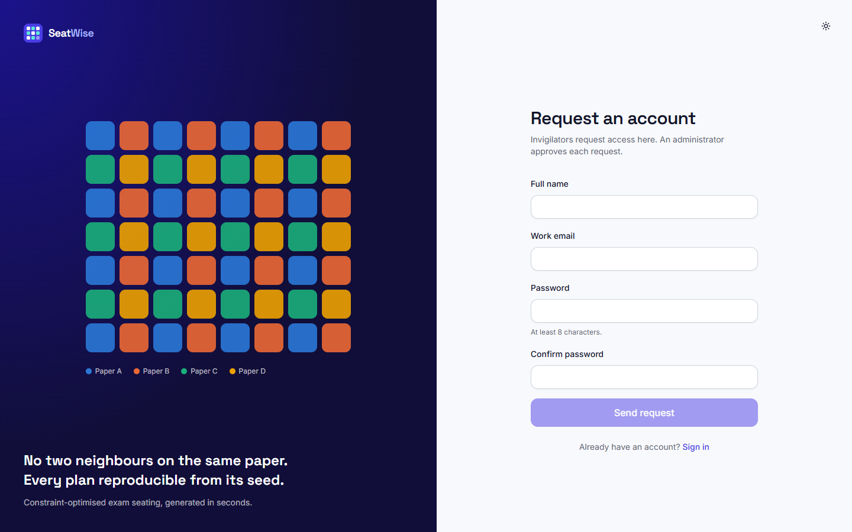  Fig. C.1: Request an account | 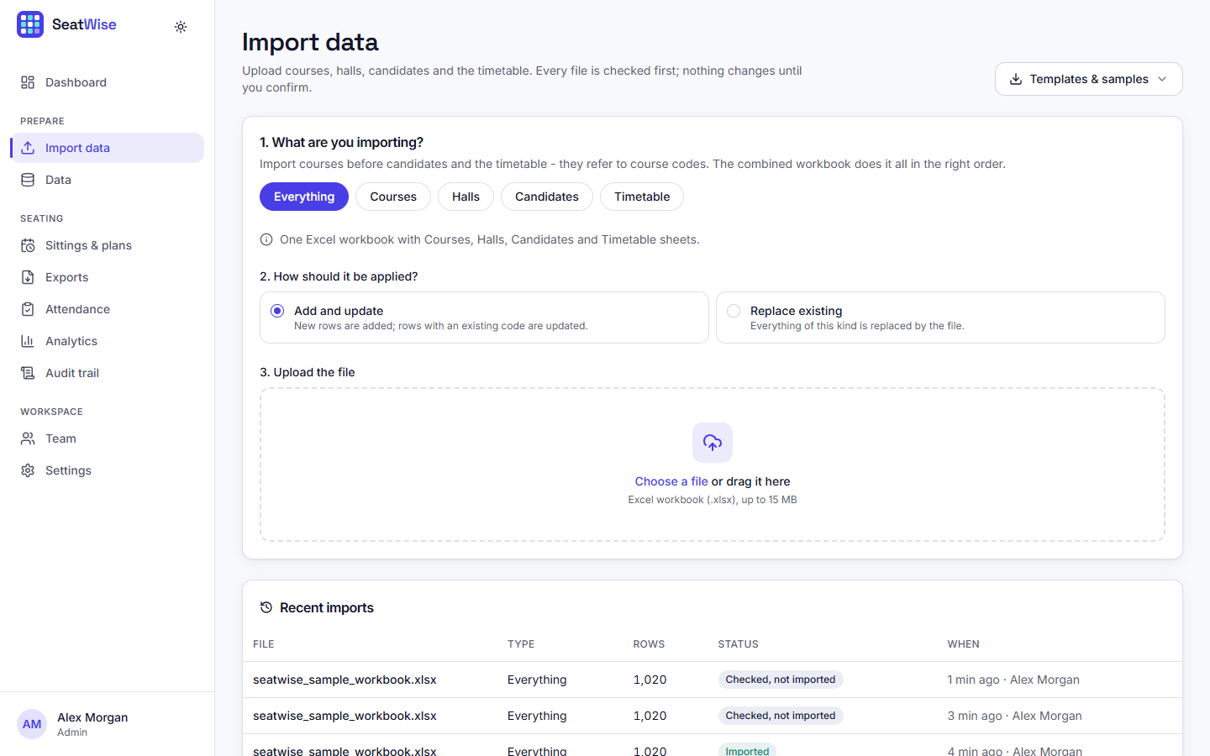  Fig. C.2: Import page before upload

The candidate tab lists the 908 imported candidates with roll number, name, department and courses, a search box and a department filter; further tabs show courses, halls and the timetable.
Hall MB-G01 (Main Hall A) with 105 of 118 seats used and 8 papers. Seats are tinted by paper, aisles are gaps, hatched seats are blocked and the wheelchair mark shows accessible seats. The side panel shows that every rule is met in this hall.
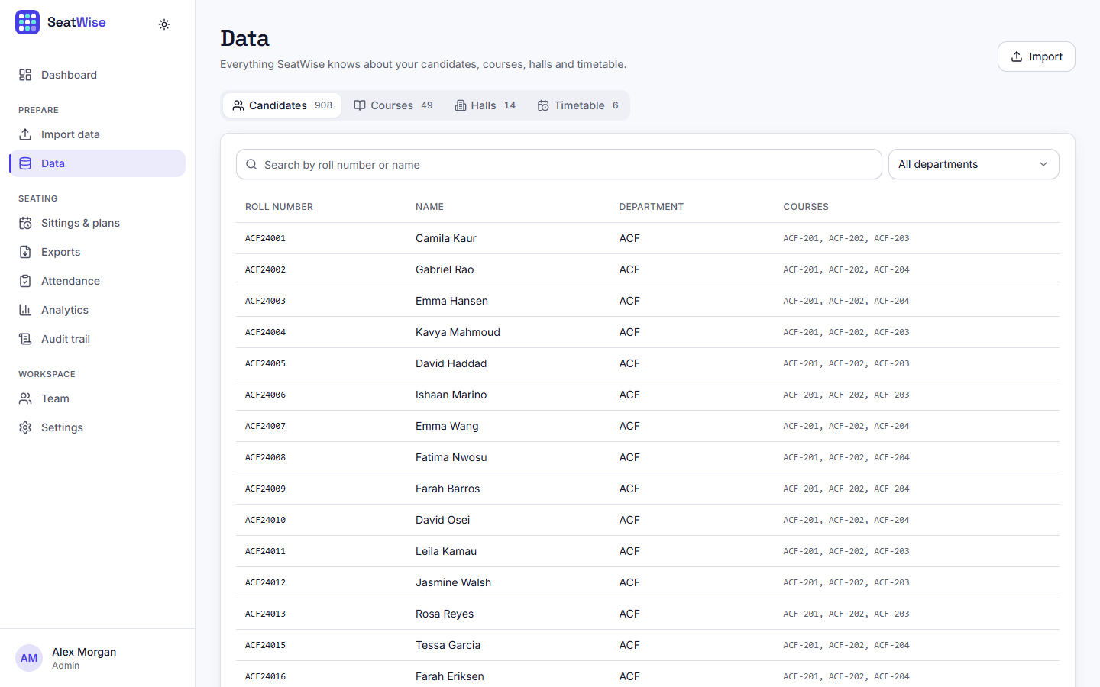  Fig. C.3: Data page: candidates | 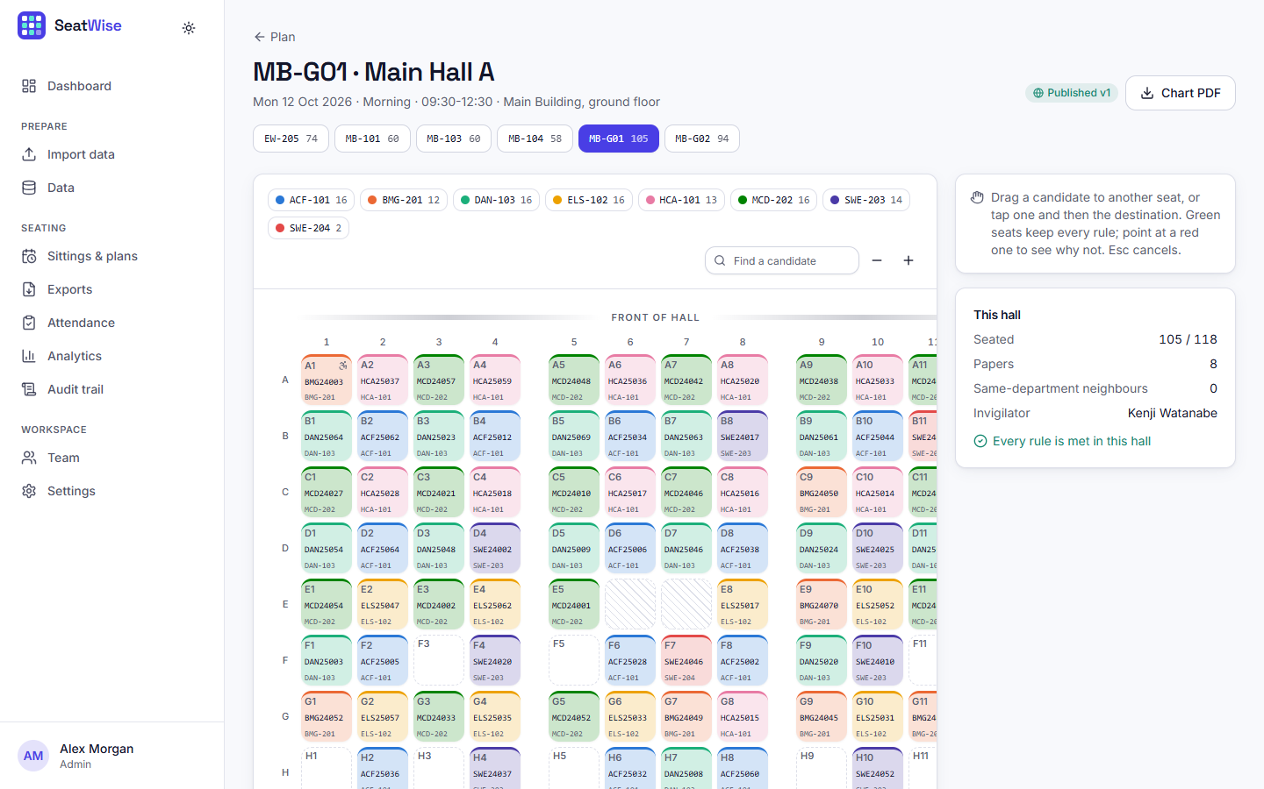  Fig. C.4: Seat map of a hall

For the selected plan the page shows same-paper neighbours (0, with 1,105 avoided), solve time, seats filled, and neighbour pairs, a bar chart that compares SeatWise with roll-order seating for each rule, and seats filled per hall.
Accounts of the administrator and the invigilators with role, status and last sign-in; new people can be added and requests approved.
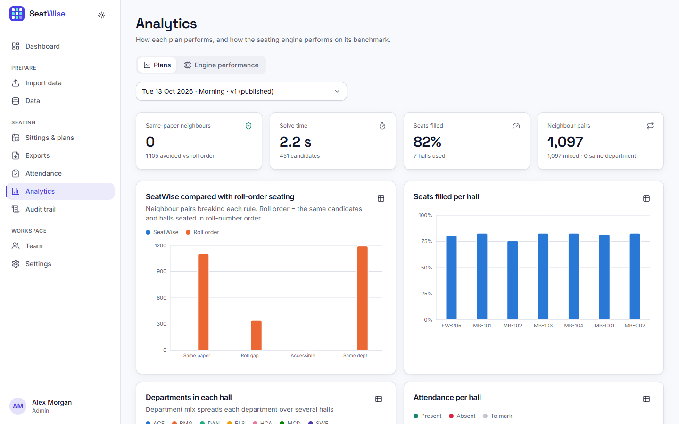  Fig. C.5: Analytics: plan figures | 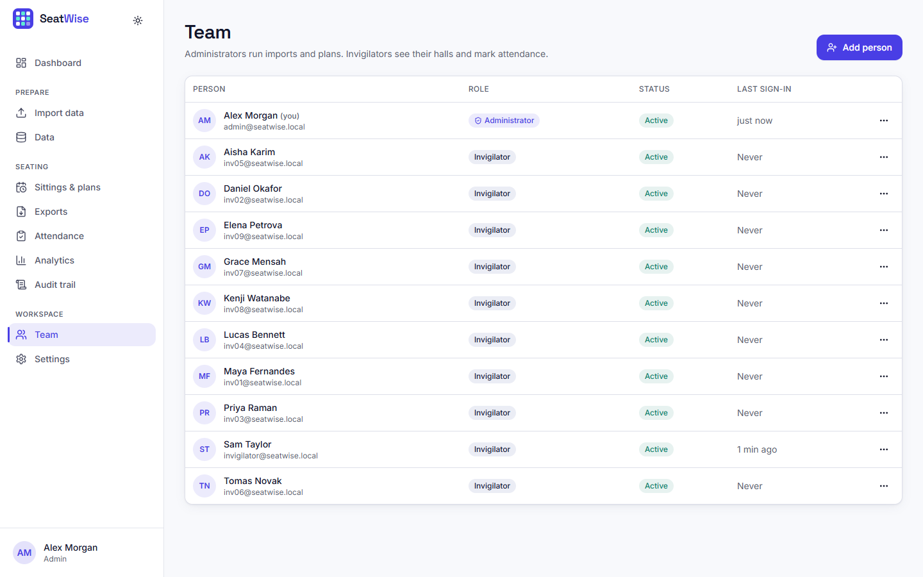  Fig. C.6: Team page

The default rules used to pre-fill new plans: 8 or 4 neighbours, the roll-number gap (5), department mix, compact or balanced hall usage, and the number of accessible seats per hall when a hall lists none (2).
The public page where a candidate enters a candidate ID.
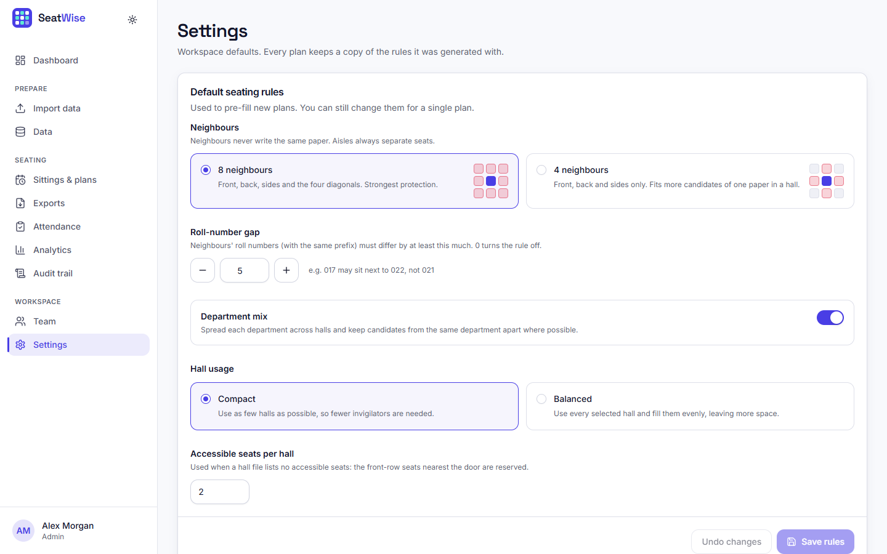  Fig. C.7: Settings: default seating rules | 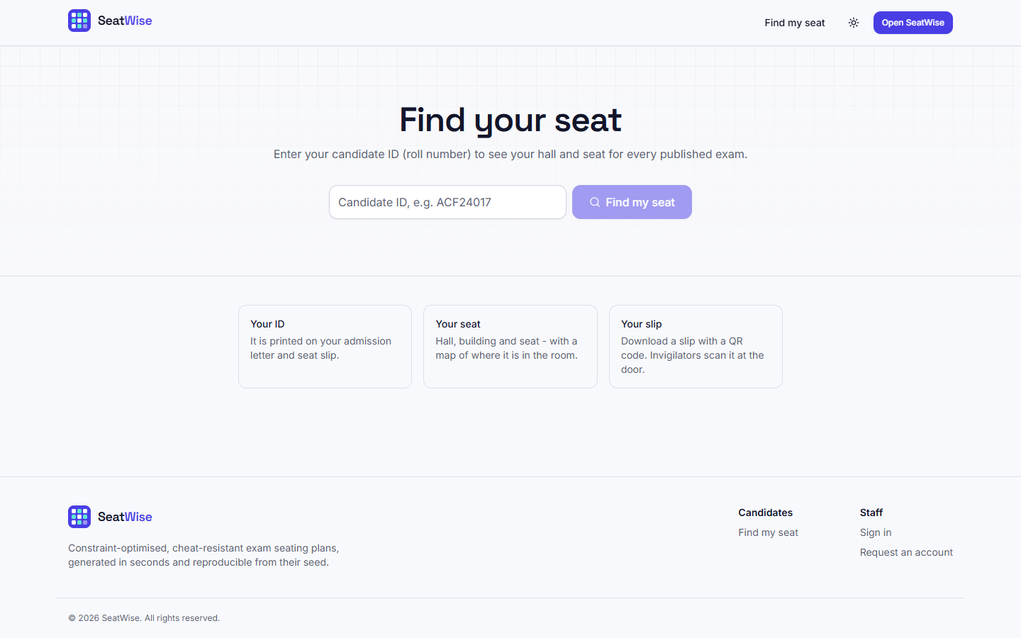  Fig. C.8: Find my seat

The same plan page in the dark theme; light, dark and system themes are available everywhere.
The invigilator sees the halls to supervise, grouped by sitting, with progress bars: EW-205 is in progress (57 present, 3 absent, 14 to mark) and the others have not started.
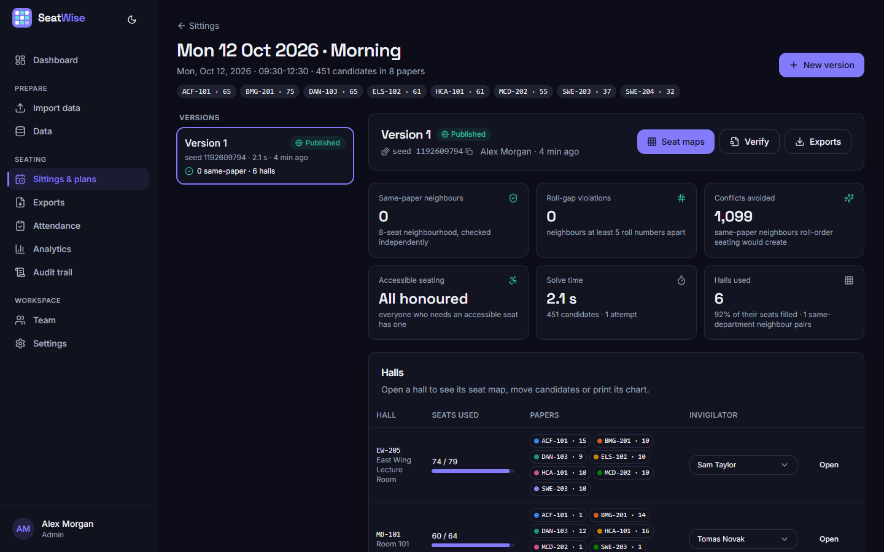  Fig. C.9: Plan page in the dark theme | 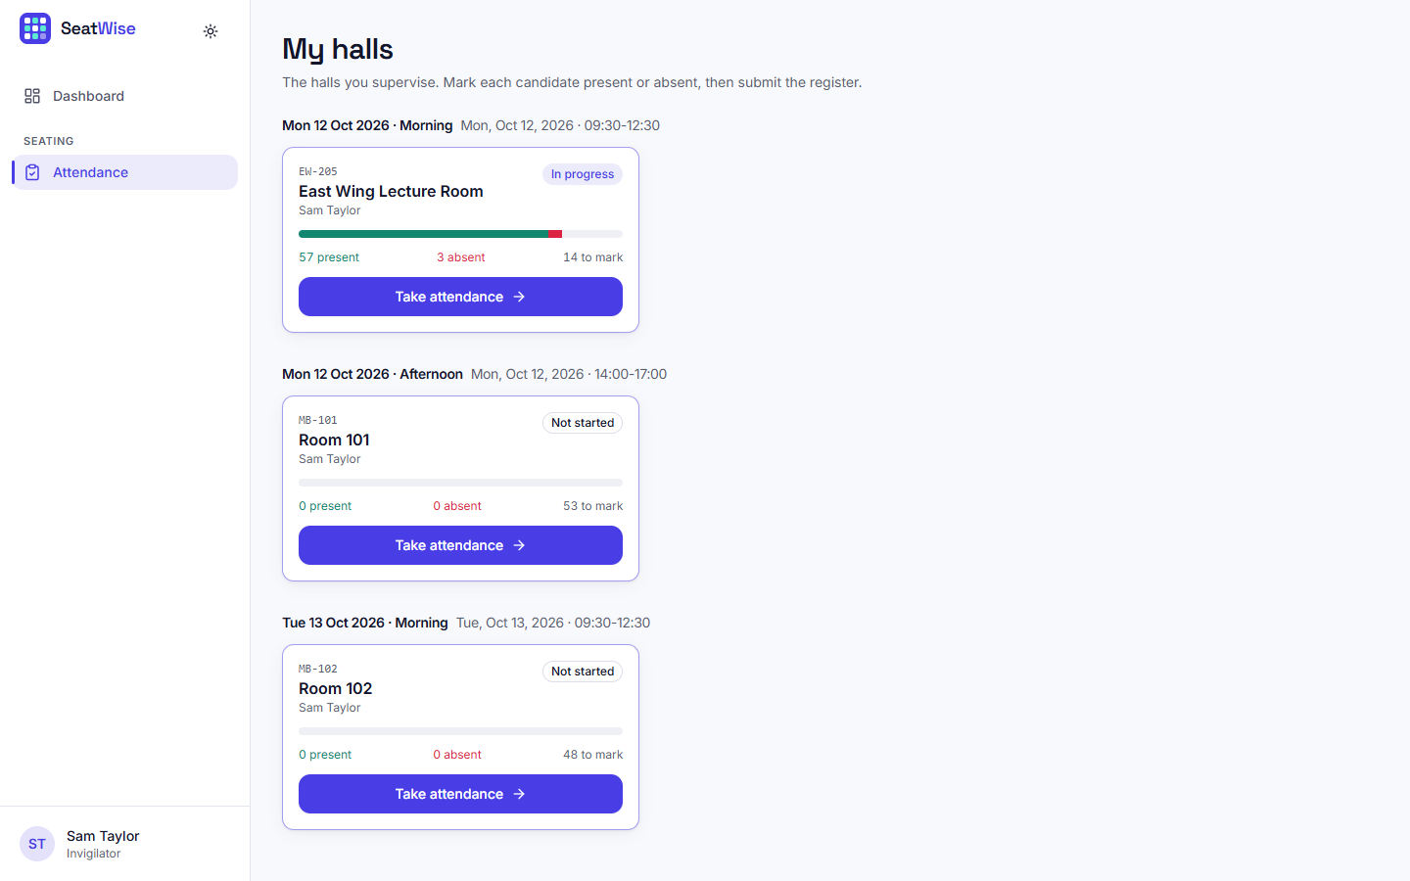  Fig. C.10: My halls (invigilator)

The same register as a seat map: present candidates are green, absent red; tapping a seat cycles present, absent and cleared.
Per hall: the papers and their candidate counts, instructions for the invigilator, and a seat-by-seat list with Present and Signature columns.
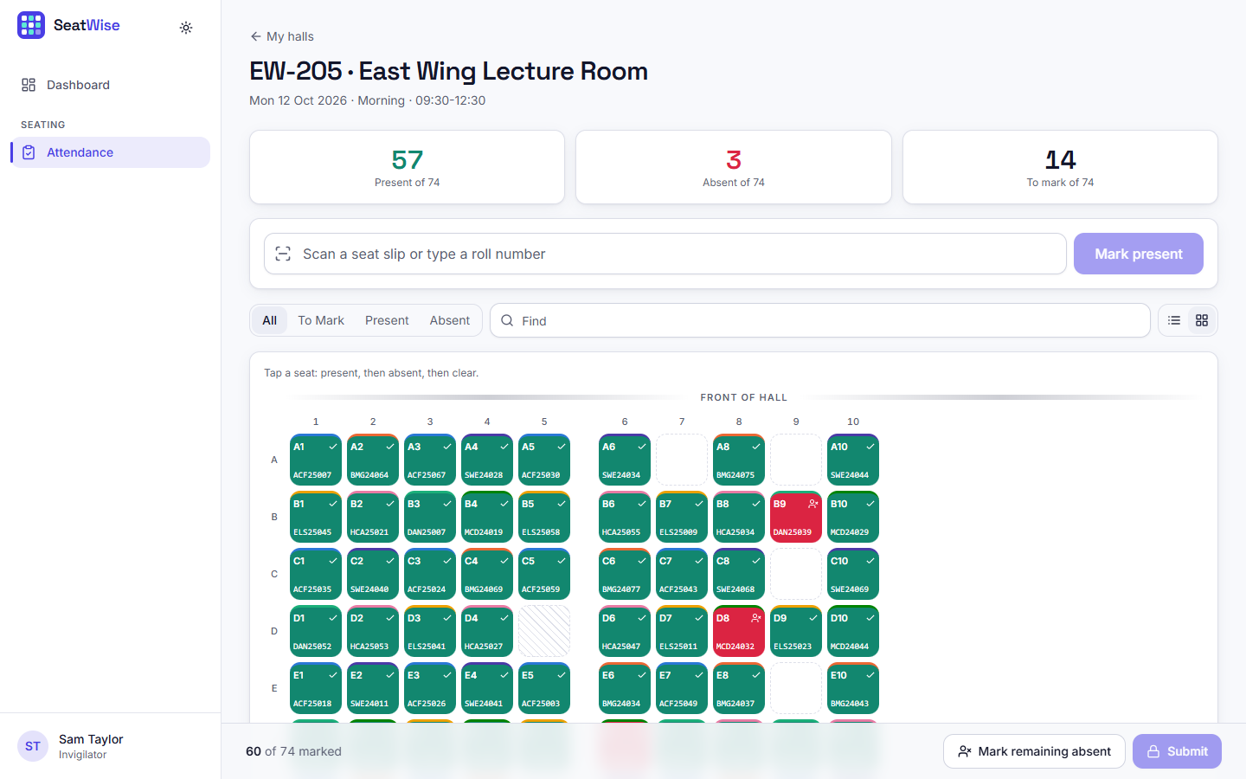  Fig. C.11: Tablet attendance: seat-map view | 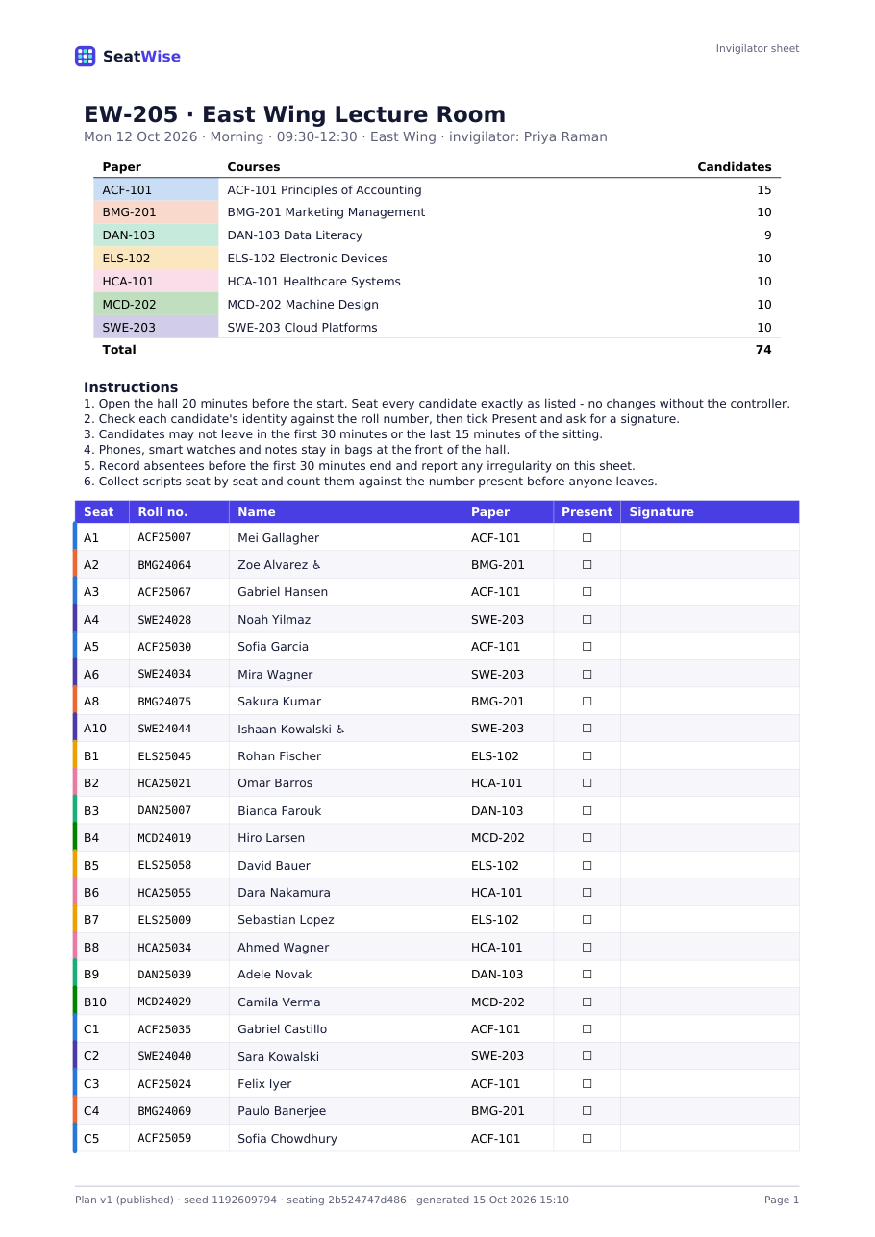  Fig. C.12: Generated invigilator sheet (PDF)

Six slips per page with name, roll number, course, time, hall, building, seat and a QR code that opens the candidate's lookup page.
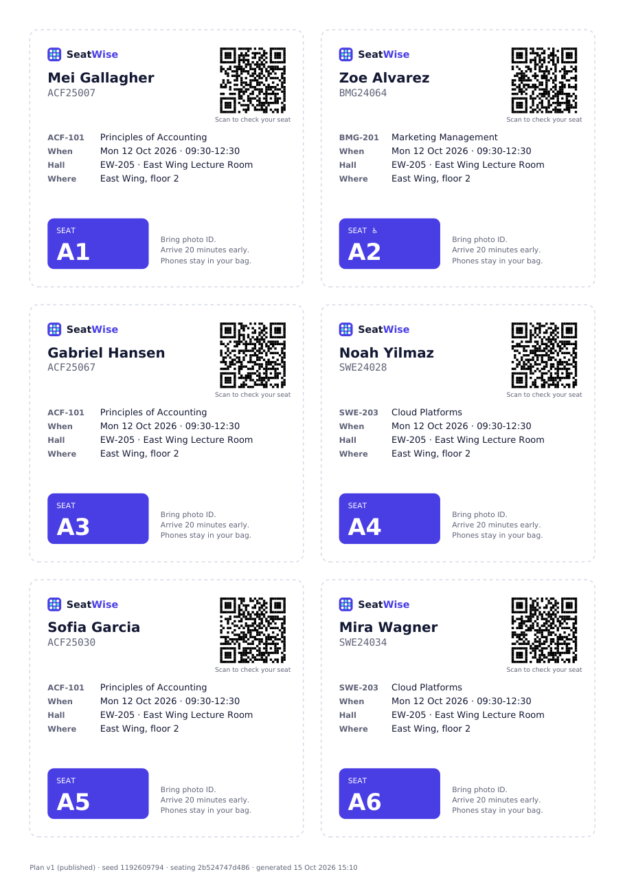
Fig. C.13: Generated seat slips with QR codes (PDF)

